Katrina Lifeline Database
Please fill out carefully and completely!
Total Number of Puppies:7
Total Number of Adult Dogs:2
Total Number of Carriers/Crates Used:4
Date Prepared:2/06/09
Your Information - Person completing this form
Name:
Address:
Phone number:
Email:
Sending Shelter/Organization Information - Where were the animal(s) taken from?
Name:
Address:
Phone number:
Email:
Website:
Receiving Shelter/Organization Information - Where are the animal(s) going?
Note: if going to North Shore Animal League leave this part blank
Name:
Address:
Phone Number:
Email:
Website:
Puppy or Dog Information
#1
Paste Photo Here → |  | 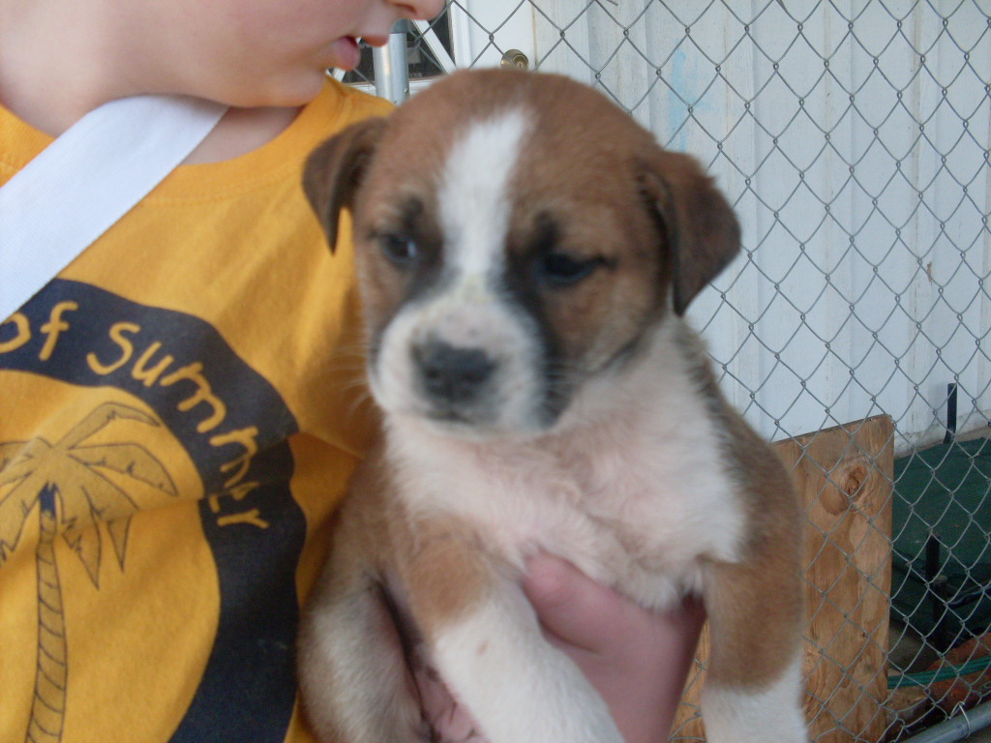
NSAL Adoption Number:
Shelter/Rescue Admit Date: |  | Jan. 29, 2009
Number of Pups in Litter: |  | 7
Sex: |  | F
Age: |  | 9 weeks
Color: |  | Brown w/ white blaze and socks
Weight: |  | 5 lbs.
Flea Dip Date:
Worming Date(s): |  | 1/29/09
(State if too young) | Bordatella Vacc Date:
(State if too young) | DHLPP Vacc Date: | 1/29/09
(State if too young) | Rabies Vacc Date:
Other Treatments or Notes: |  | Too young
#2
Paste Photo Here → |  | 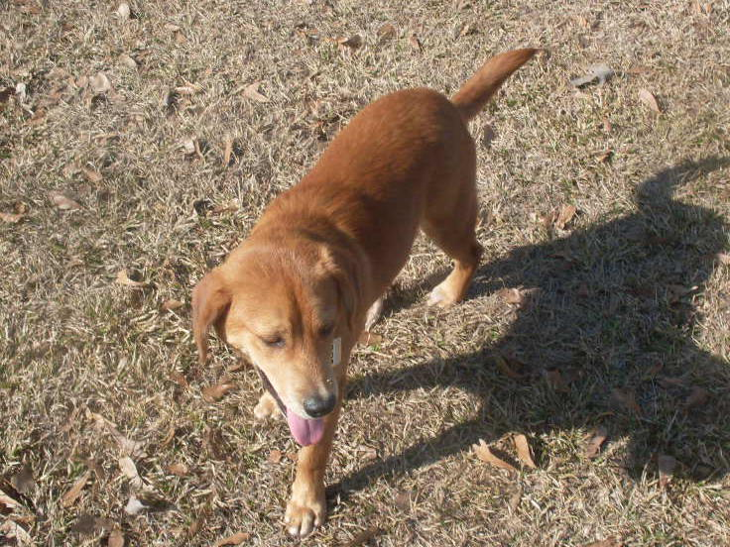
NSAL Adoption Number:
Shelter/Rescue Admit Date: |  | 1/03/09
Number of Pups in Litter: |  | n/a
Sex: |  | male
Age: |  | 7 months
Color: |  | red
Weight: |  | 25 lbs.
Flea Dip Date:
Worming Date(s): |  | 1/15/09
(State if too young) | Bordatella Vacc Date:
(State if too young) | DHLPP Vacc Date: | 1/23/09
(State if too young) | Rabies Vacc Date: | 1/23/09
Other Treatments or Notes: |  | Neutered on 1/23/09, heartworm neg.
#3
Paste Photo Here →
NSAL Adoption Number:
Shelter/Rescue Admit Date: |  | 1/29/09
Number of Pups in Litter: |  | 7
Sex: |  | F
Age: |  | 9 weeks
Color: |  | Mostly brown w/black muzzle and white chest
Weight: |  | 5 lbs.
Flea Dip Date:
Worming Date(s): |  | 1/29/09
(State if too young) | Bordatella Vacc Date:
(State if too young) | DHLPP Vacc Date: | 1/29/09
(State if too young) | Rabies Vacc Date: | Too young
Other Treatments or Notes:
#4
Paste Photo Here → |  | 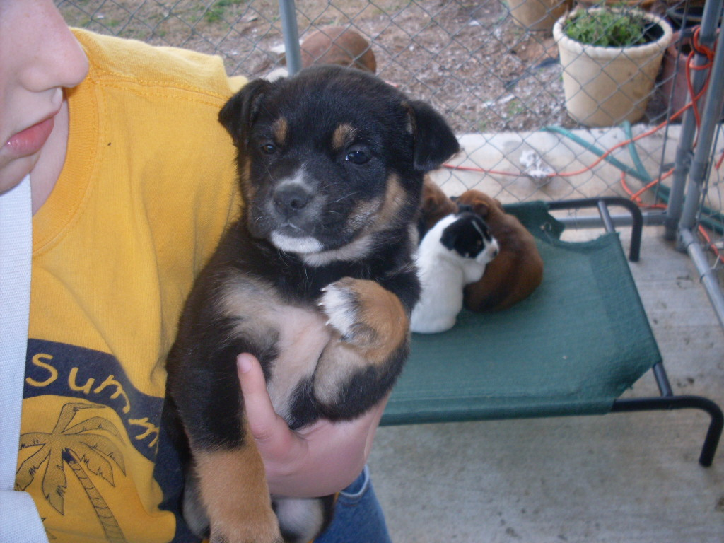
NSAL Adoption Number:
Shelter/Rescue Admit Date: |  | 1/29/09
Number of Pups in Litter: |  | 7
Sex: |  | F
Age: |  | 9 weeks
Color: |  | Mostly black w/white and tan
Weight: |  | 5 lbs.
Flea Dip Date:
Worming Date(s): |  | 1/29/09
(State if too young) | Bordatella Vacc Date:
(State if too young) | DHLPP Vacc Date: | 1/29/09
(State if too young) | Rabies Vacc Date: | Too young
Other Treatments or Notes:
#5
Paste Photo Here → |  | 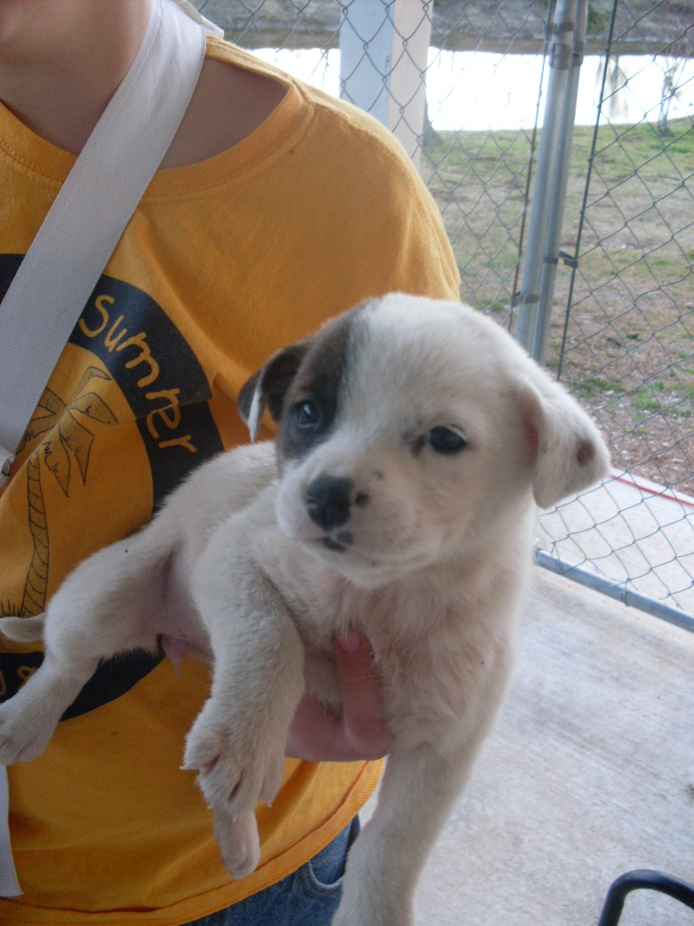
NSAL Adoption Number:
Shelter/Rescue Admit Date: |  | 1/29/09
Number of Pups in Litter: |  | 7
Sex: |  | F
Age: |  | 9 weeks
Color: |  | White w/patch in one eye and ear
Weight: |  | 5 lbs.
Flea Dip Date:
Worming Date(s): |  | 1/29/09
(State if too young) | Bordatella Vacc Date:
(State if too young) | DHLPP Vacc Date: | 1/29/09
(State if too young) | Rabies Vacc Date: | Too young
Other Treatments or Notes:
#6
Paste Photo Here → |  | 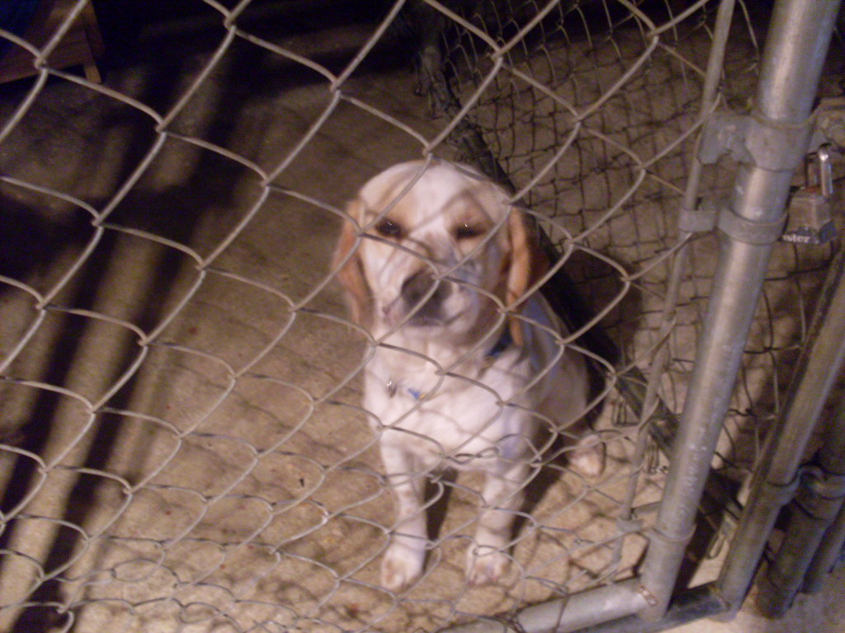
NSAL Adoption Number:
Shelter/Rescue Admit Date: |  | 1/16/09
Number of Pups in Litter: |  | n/a
Sex: |  | female
Age: |  | 8 months
Color: |  | White w/ tan spots
Weight: |  | 20 lbs.
Flea Dip Date:
Worming Date(s):
(State if too young) | Bordatella Vacc Date:
(State if too young) | DHLPP Vacc Date: | 1/27/09
(State if too young) | Rabies Vacc Date: | 1/27/09
Other Treatments or Notes: |  | Heartworm neg.
#7
Paste Photo Here → |  | 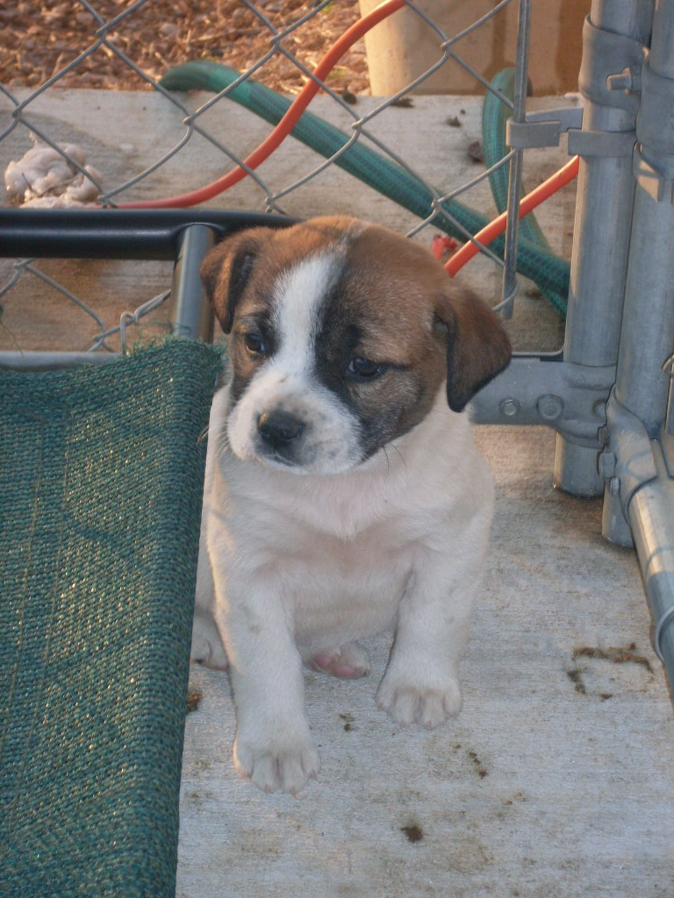
NSAL Adoption Number:
Shelter/Rescue Admit Date: |  | 1/29/2009
Number of Pups in Litter: |  | 7
Sex: |  | M
Age: |  | 9 weeks
Color: |  | White w/ brown mask
Weight: |  | 5 lbs.
Flea Dip Date:
Worming Date(s): |  | 1/29/09
(State if too young) | Bordatella Vacc Date:
(State if too young) | DHLPP Vacc Date: | 1/29/09
(State if too young) | Rabies Vacc Date: | Too young
Other Treatments or Notes:
#8
Paste Photo Here → |  | 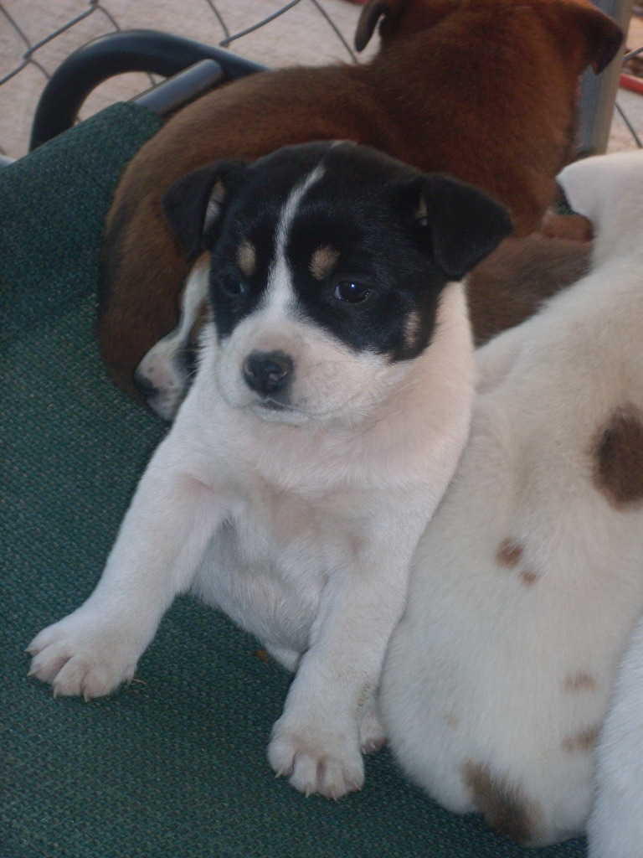
NSAL Adoption Number:
Shelter/Rescue Admit Date: |  | 1/29/09
Number of Pups in Litter: |  | 7
Sex: |  | M
Age: |  | 9 weeks
Color: |  | White w/black mask
Weight: |  | 5 lbs.
Flea Dip Date:
Worming Date(s): |  | 1/29/09
(State if too young) | Bordatella Vacc Date:
(State if too young) | DHLPP Vacc Date: | 1/29/09
(State if too young) | Rabies Vacc Date: | Too young
Other Treatments or Notes:
#9
Paste Photo Here → |  | 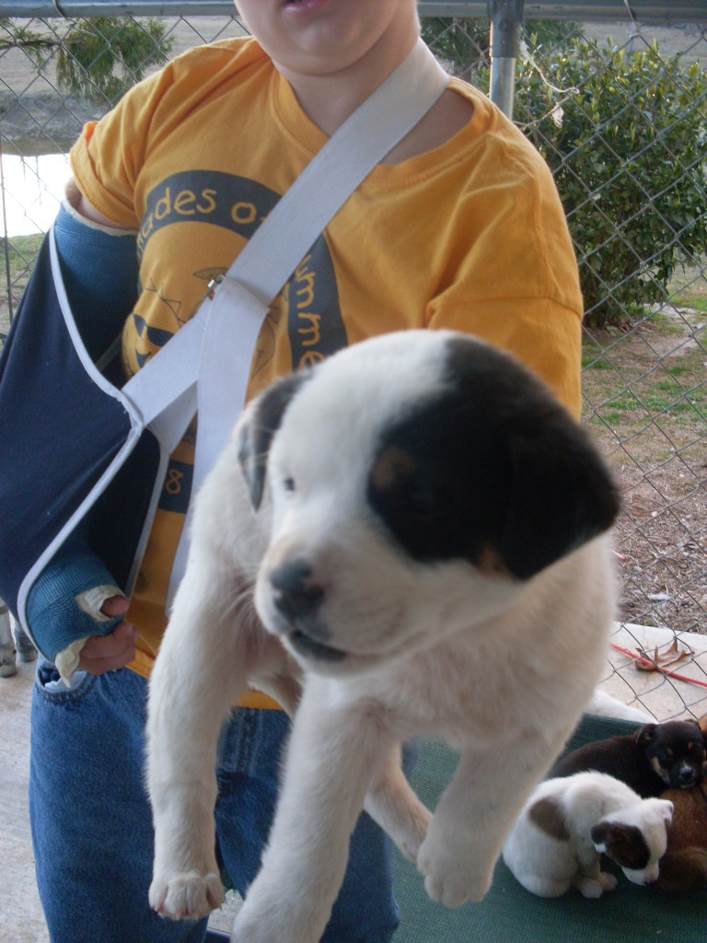
NSAL Adoption Number:
Shelter/Rescue Admit Date: |  | 1/29/09
Number of Pups in Litter: |  | 7
Sex: |  | M
Age: |  | 9 weeks
Color: |  | White w/black spot on eye and ears
Weight: |  | 5 lbs.
Flea Dip Date:
Worming Date(s): |  | 1/29/09
(State if too young) | Bordatella Vacc Date:
(State if too young) | DHLPP Vacc Date: | 1/29/09
(State if too young) | Rabies Vacc Date: | Too young
Other Treatments or Notes:
Katrina Lifeline Database
Please fill out carefully and completely!
Total Number of Puppies: 4
Total Number of Adult Dogs:
Total Number of Carriers/Crates Used: 2
Date Prepared: 1/24/2009
Your Information - Person completing this form
Name:
Address:
Phone number:
Email:
Sending Shelter/Organization Information - Where were the animal(s) taken from?
Name:
Address:
Phone number:
Email:
Website:
Receiving Shelter/Organization Information - Where are the animal(s) going?
Note: if going to North Shore Animal League leave this part blank
Name:
Address:
Phone Number:
Email:
Website:
Puppy or Dog Information
#1
Paste Photo Here → |  | 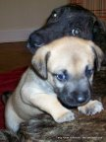
NSAL Adoption Number:
Shelter/Rescue Admit Date:
Number of Pups in Litter: |  | 5
Sex: |  | Female
Age: |  | 8 Weeks, born December1,2008
Color: |  | Fawn with black markings
Weight: |  | 10lbs
Flea Dip Date:
Worming Date(s): |  | 12/22,1/14/09,1/15/09,1/16/09
(State if too young) | Bordatella Vacc Date:
(State if too young) | DHLPP Vacc Date: | 01/19/2009
(State if too young) | Rabies Vacc Date: | Too young
Other Treatments or Notes: |  | Treated with Metro for intestinal protozoans 1/23/09,1/24/09 and 1/25/09. Samantha is very playful and affectionate. She is the smallest of her litter.
#2
Paste Photo Here → |  | 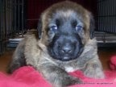
NSAL Adoption Number:
Shelter/Rescue Admit Date:
Number of Pups in Litter: |  | 5
Sex: |  | Male
Age: |  | 8 Weeks
Color: |  | Brindle, medium coat
Weight: |  | 13lbs
Flea Dip Date:
Worming Date(s): |  | 12/22/08, 1/14/2009,1/15/09, 1/16/09
(State if too young) | Bordatella Vacc Date:
(State if too young) | DHLPP Vacc Date: | 1/19/09
(State if too young) | Rabies Vacc Date: | Too young
Other Treatments or Notes: |  | Bear was born December first. He’s the most passive puppy of the litter. He’s has a very calm temperament. He was also treated with metro for an intestinal parasite on 1/23/09 1/24/09 and 1/25/09
#3
Paste Photo Here → |  | 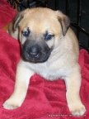
NSAL Adoption Number:
Shelter/Rescue Admit Date:
Number of Pups in Litter: |  | 5
Sex: |  | Male
Age: |  | 8 Weeks
Color: |  | Fawn with black Muzzle
Weight: |  | 13 lbs
Flea Dip Date:
Worming Date(s): |  | 12/22/08,1/14/09,1/15/09,1/16/09
(State if too young) | Bordatella Vacc Date:
(State if too young) | DHLPP Vacc Date: | 1/19/09
(State if too young) | Rabies Vacc Date: | Too young
Other Treatments or Notes: |  | Treated 1/23 1/24 and 1/25 with metro for intestinal parasite. Jasper was born December 1st and is the largest of his litter. Very laid back personality.
#4

 | Katrina Lifeline Database
 | Please fill out carefully and completely!
Total Number of Puppies: 3
Total Number of Adult Dogs:
Total Number of Carriers/Crates Used: 1
Date Prepared: 1/28/09
 | Your Information - Person completing this form
 | Name:
 | Address:
 | Phone number:
 | Email:
 | Sending Shelter/Organization Information - Where were the animal(s) taken from?
 | Name:
 | Address:
 | Phone number:
 | Email:
 | Website:
 | Receiving Shelter/Organization Information - Where are the animal(s) going?
 | Note: if going to North Shore Animal League leave this part blank
 | Name:
 | Address:
 | Phone Number:
 | Email:
 | Website:
 | Puppy or Dog Information
 | #1
 | Paste Photo Here → |  |  | 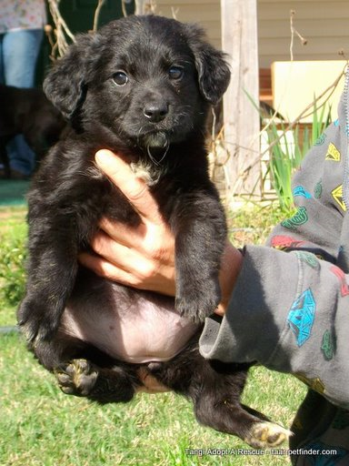 “Magnolia aka Maggie”
 | NSAL Adoption Number:
 | Shelter/Rescue Admit Date: |  |  | 1/1/09
 | Number of Pups in Litter: |  |  | 3
 | Sex: |  |  | F
 | Age: |  |  | 8-9wks
 | Color: |  |  | Blk w/wht chest and back paws-fluffy
 | Weight: |  |  | 6.6#
 | Flea Dip Date: |  |  | 1/2/09
 | Worming Date(s): |  |  | 1/2/09-1/5/09 Panacure
 | (State if too young) |  | Bordatella Vacc Date:
 |  |  | DHLPP Vacc Date: | 1/14/09
 |  |  | Rabies Vacc Date:
 | Other Treatments or Notes: |  |  | Coccidia-treated w/Albon 1/2/09-1/10/09  Retreating-1/20/09-1/29/09
 | #2
 | Paste Photo Here → |  |  | 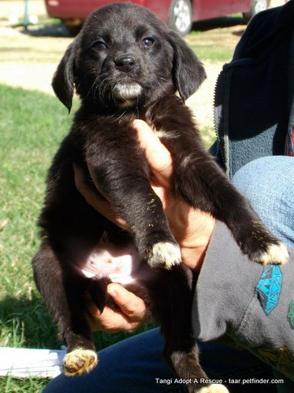 “Puppy’s Name Here”
 | NSAL Adoption Number:
 | Shelter/Rescue Admit Date:
 | Number of Pups in Litter:
 | Sex:
 | Age:
 | Color:
 | Weight:
 | Flea Dip Date:
 | Worming Date(s):
 | (State if too young) |  | Bordatella Vacc Date:
 |  |  | DHLPP Vacc Date:
 |  |  | Rabies Vacc Date:
 | Other Treatments or Notes: |  |  | No longer available
 | #3
 | Paste Photo Here → |  |  | 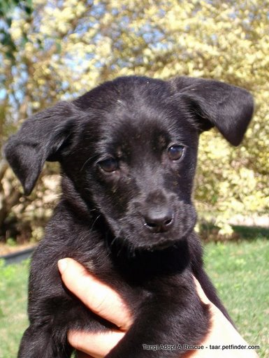 “Jayla”
 | NSAL Adoption Number:
 | Shelter/Rescue Admit Date: |  |  | 1/1/09
 | Number of Pups in Litter: |  |  | 3
 | Sex: |  |  | F
 | Age: |  |  | 8-9wks
 | Color: |  |  | Blk
 | Weight: |  |  | 5.5#
 | Flea Dip Date: |  |  | 1/2/09,
 | Worming Date(s): |  |  | 1/2/09-1/5/09 Panacure
 | (State if too young) |  | Bordatella Vacc Date:
 |  |  | DHLPP Vacc Date: | 1/14/09
 |  |  | Rabies Vacc Date:
 | Other Treatments or Notes: |  |  | Coccidia-treated w/ Albon 1/2/09-1/10/09  Retreating 1/20/09-1/29/09
Katrina Lifeline Database
Please fill out carefully and completely!
Total Number of Puppies:0
Total Number of Adult Dogs: 1
Total Number of Carriers/Crates Used:
Date Prepared: 2/4/09
Your Information - Person completing this form
Name:
Address:
Phone number:
Email:
Sending Shelter/Organization Information - Where were the animal(s) taken from?
Name:
Address:
Phone number:
Email:
Website:
Receiving Shelter/Organization Information - Where are the animal(s) going?
Note: if going to North Shore Animal League leave this part blank
Name:
Address:
Phone Number:
Email:
Website:
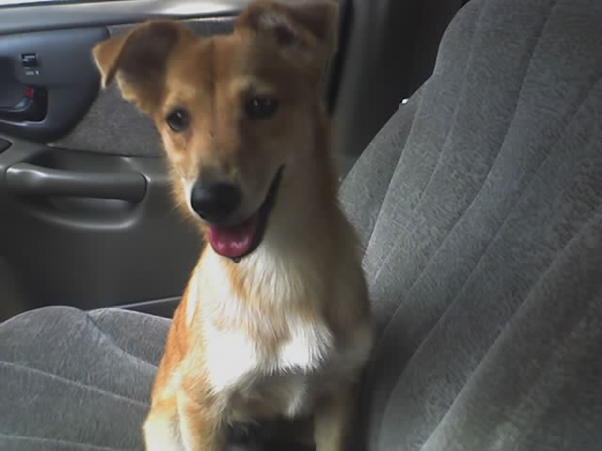
Puppy or Dog Information
#1
Paste Photo Here →
NSAL Adoption Number:
Shelter/Rescue Admit Date:
Number of Pups in Litter:
Sex: |  |  |  |  | F/S
Age: |  |  |  |  | Approximately 2yrs
Color: |  |  |  |  | Tan and white markings
Weight: |  |  |  |  | 18 pounds
Flea Dip Date: |  |  |  |  | 2/4/09
Worming Date(s): |  |  |  |  | 7/17/08, 8/28/08
(State if too young) |  | Bordatella Vacc Date: |  |  | 1/29/09
 |  | DHLPP Vacc Date: |  |  | 7/17/08, 8/28/08
 |  | Rabies Vacc Date: |  |  | 7/17/08
Other Treatments or Notes: |  |  |  |  | Was turned over d/t owners declining health

