Katrina Lifeline Database
Please fill out carefully and completely!
Total Number of Puppies:20
Total Number of Adult Dogs:4
Total Number of Carriers/Crates Used:10
Date Prepared:12-6-08
Your Information - Person completing this form
Name:
Address:
Phone number:
Email:
Name:
Address:
Phone number:
Email:
Website:
Receiving Shelter/Organization Information - Where are the animal(s) going?
Note: if going to North Shore Animal League leave this part blank
Name:
Address:
Phone Number:
Email:
Website:
Puppy or Dog Information
#1
Paste Photo Here → |  |  |  |  |  |  |  |  |  |  |  | 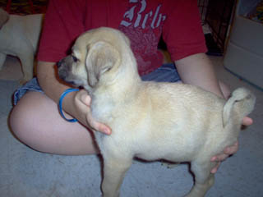
NSAL Adoption Number:
Shelter/Rescue Admit Date: |  |  |  |  |  |  |  |  |  |  |  | 11-17-08
Number of Pups in Litter: |  |  |  |  |  |  |  |  |  |  |  | 9
Sex: |  |  |  |  |  |  |  |  |  |  |  | M
Age: |  |  |  |  |  |  |  |  |  |  |  | 8WKS
Color: |  |  |  |  |  |  |  |  |  |  |  | FAWN
Weight: |  |  |  |  |  |  |  |  |  |  |  | 6LBS
Flea Dip Date:
Worming Date(s): |  |  |  |  |  |  |  |  |  |  |  | 11-17-08
(State if too young) |  |  |  |  |  |  | Bordatella Vacc Date:
 |  |  |  |  |  |  | DHLPP Vacc Date: |  |  |  |  | 12-5-08
 |  |  |  |  |  |  | Rabies Vacc Date: |  |  |  |  | TOO YOUNG
Other Treatments or Notes:
#2
Paste Photo Here → |  |  |  |  |  |  |  |  |  |  |  | 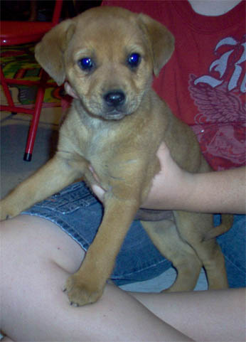
NSAL Adoption Number:
Shelter/Rescue Admit Date: |  |  |  |  |  |  |  |  |  |  |  | 11-17-08
Number of Pups in Litter: |  |  |  |  |  |  |  |  |  |  |  | 9
Sex: |  |  |  |  |  |  |  |  |  |  |  | M
Age: |  |  |  |  |  |  |  |  |  |  |  | 8WKS
Color: |  |  |  |  |  |  |  |  |  |  |  | RED & BLACK
Weight: |  |  |  |  |  |  |  |  |  |  |  | 6LBS
Flea Dip Date:
Worming Date(s): |  |  |  |  |  |  |  |  |  |  |  | 11-17-08
(State if too young) |  |  |  |  |  |  | Bordatella Vacc Date:
 |  |  |  |  |  |  | DHLPP Vacc Date: |  |  |  |  | 12-5-08
 |  |  |  |  |  |  | Rabies Vacc Date:
Other Treatments or Notes: |  |  |  |  |  |  |  |  |  |  |  | TOO YOUNG
#3
Paste Photo Here → |  |  |  |  |  |  |  |  |  |  |  | 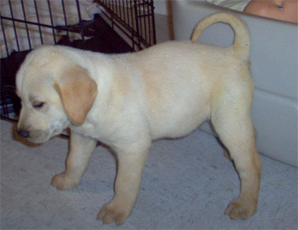
NSAL Adoption Number:
Shelter/Rescue Admit Date: |  |  |  |  |  |  |  |  |  |  |  | 11-17-08
Number of Pups in Litter: |  |  |  |  |  |  |  |  |  |  |  | 9
Sex: |  |  |  |  |  |  |  |  |  |  |  | M
Age: |  |  |  |  |  |  |  |  |  |  |  | 8WKS
Color: |  |  |  |  |  |  |  |  |  |  |  | YELLOW
Weight: |  |  |  |  |  |  |  |  |  |  |  | 6LBS
Flea Dip Date:
Worming Date(s): |  |  |  |  |  |  |  |  |  |  |  | 11-17-08
(State if too young) |  |  |  |  |  |  | Bordatella Vacc Date:
 |  |  |  |  |  |  | DHLPP Vacc Date: |  |  |  |  | 12-5-08
 |  |  |  |  |  |  | Rabies Vacc Date: |  |  |  |  | TOO YOUNG
Other Treatments or Notes:
#4
Paste Photo Here → |  |  |  |  |  |  |  |  |  |  |  | 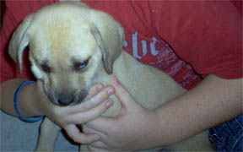
NSAL Adoption Number:
Shelter/Rescue Admit Date: |  |  |  |  |  |  |  |  |  |  |  | 11-17-08
Number of Pups in Litter: |  |  |  |  |  |  |  |  |  |  |  | 9
Sex: |  |  |  |  |  |  |  |  |  |  |  | F
Age: |  |  |  |  |  |  |  |  |  |  |  | 8WKS
Color: |  |  |  |  |  |  |  |  |  |  |  | FAWN
Weight: |  |  |  |  |  |  |  |  |  |  |  | 6LBS
Flea Dip Date:
Worming Date(s): |  |  |  |  |  |  |  |  |  |  |  | 11-17-08
(State if too young) |  |  |  |  |  |  | Bordatella Vacc Date:
 |  |  |  |  |  |  | DHLPP Vacc Date: |  |  |  |  | 12-05-08
 |  |  |  |  |  |  | Rabies Vacc Date: |  |  |  |  | TOO YOUNG
Other Treatments or Notes:
#5
Paste Photo Here → |  |  |  |  |  |  |  |  |  |  |  | 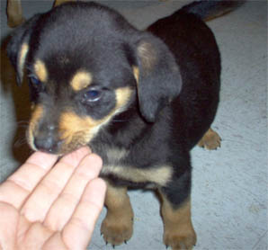
NSAL Adoption Number:
Shelter/Rescue Admit Date: |  |  |  |  |  |  |  |  |  |  |  | 11-17-08
Number of Pups in Litter: |  |  |  |  |  |  |  |  |  |  |  | 9
Sex: |  |  |  |  |  |  |  |  |  |  |  | F
Age: |  |  |  |  |  |  |  |  |  |  |  | 8WKS
Color: |  |  |  |  |  |  |  |  |  |  |  | BLACK & TAN
Weight: |  |  |  |  |  |  |  |  |  |  |  | 6LBS
Flea Dip Date:
Worming Date(s): |  |  |  |  |  |  |  |  |  |  |  | 11-17-08
(State if too young) |  |  |  |  |  |  | Bordatella Vacc Date:
 |  |  |  |  |  |  | DHLPP Vacc Date: |  |  |  |  | 12-05-08
 |  |  |  |  |  |  | Rabies Vacc Date: |  |  |  |  | TOO YOUNG
Other Treatments or Notes:
#6
Paste Photo Here → |  |  |  |  |  |  |  |  |  |  |  | 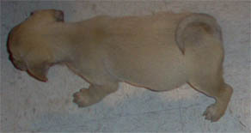
NSAL Adoption Number:
Shelter/Rescue Admit Date: |  |  |  |  |  |  |  |  |  |  |  | 11-17-08
Number of Pups in Litter: |  |  |  |  |  |  |  |  |  |  |  | 9
Sex: |  |  |  |  |  |  |  |  |  |  |  | F
Age: |  |  |  |  |  |  |  |  |  |  |  | 8WKS
Color: |  |  |  |  |  |  |  |  |  |  |  | RED
Weight: |  |  |  |  |  |  |  |  |  |  |  | 6LBS
Flea Dip Date:
Worming Date(s): |  |  |  |  |  |  |  |  |  |  |  | 11-17-08
(State if too young) |  |  |  |  |  |  | Bordatella Vacc Date:
 |  |  |  |  |  |  | DHLPP Vacc Date: |  |  |  |  | 12-05-08
 |  |  |  |  |  |  | Rabies Vacc Date: |  |  |  |  | TOO YOUNG
Other Treatments or Notes:
#7
Paste Photo Here → |  |  |  |  |  |  |  |  |  |  |  | 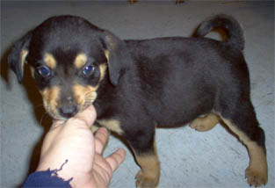
NSAL Adoption Number:
Shelter/Rescue Admit Date: |  |  |  |  |  |  |  |  |  |  |  | 11-17-08
Number of Pups in Litter: |  |  |  |  |  |  |  |  |  |  |  | 9
Sex: |  |  |  |  |  |  |  |  |  |  |  | M
Age: |  |  |  |  |  |  |  |  |  |  |  | 8WKS
Color: |  |  |  |  |  |  |  |  |  |  |  | BLACK & TAN
Weight: |  |  |  |  |  |  |  |  |  |  |  | 6LBS
Flea Dip Date:
Worming Date(s): |  |  |  |  |  |  |  |  |  |  |  | 11-17-08
(State if too young) |  |  |  |  |  |  | Bordatella Vacc Date:
 |  |  |  |  |  |  | DHLPP Vacc Date: |  |  |  |  | 12-05-08
 |  |  |  |  |  |  | Rabies Vacc Date: |  |  |  |  | TOO YOUNG
Other Treatments or Notes:
#8
Paste Photo Here → |  |  |  |  |  |  |  |  |  |  |  | 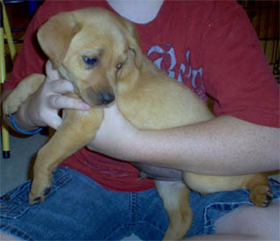
NSAL Adoption Number:
Shelter/Rescue Admit Date:
Number of Pups in Litter: |  |  |  |  |  |  |  |  |  |  |  | 9
Sex: |  |  |  |  |  |  |  |  |  |  |  | M
Age: |  |  |  |  |  |  |  |  |  |  |  | 8WKS
Color: |  |  |  |  |  |  |  |  |  |  |  | RED
Weight: |  |  |  |  |  |  |  |  |  |  |  | 6LBS
Flea Dip Date:
Worming Date(s): |  |  |  |  |  |  |  |  |  |  |  | 11-17-08
(State if too young) |  |  |  |  |  |  | Bordatella Vacc Date:
 |  |  |  |  |  |  | DHLPP Vacc Date: |  |  |  |  | 12-05-08
 |  |  |  |  |  |  | Rabies Vacc Date: |  |  |  |  | TOO YOUNG
Other Treatments or Notes:
#9
Paste Photo Here → |  |  |  |  |  |  |  |  |  |  |  | 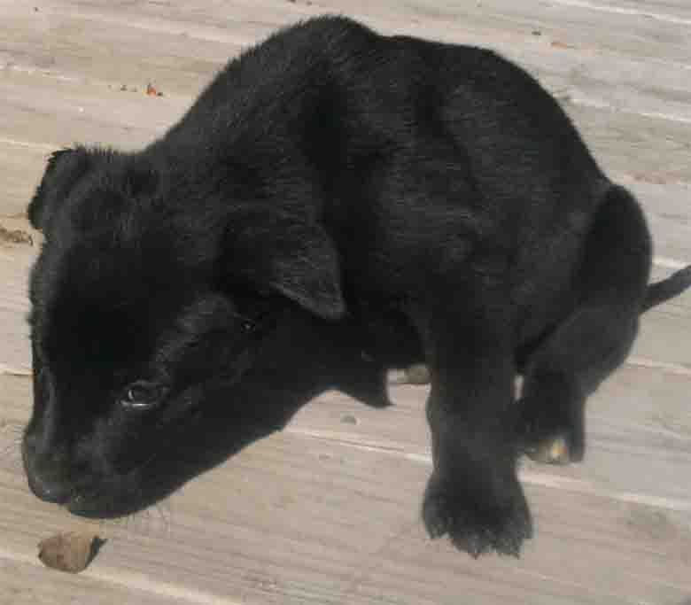
NSAL Adoption Number:
Shelter/Rescue Admit Date: |  |  |  |  |  |  |  |  |  |  |  | 12-2-08
Number of Pups in Litter: |  |  |  |  |  |  |  |  |  |  |  | 3
Sex: |  |  |  |  |  |  |  |  |  |  |  | M
Age: |  |  |  |  |  |  |  |  |  |  |  | 10WKS
Color: |  |  |  |  |  |  |  |  |  |  |  | BLACK
Weight: |  |  |  |  |  |  |  |  |  |  |  | 6LBS
Flea Dip Date:
Worming Date(s): |  |  |  |  |  |  |  |  |  |  |  | 12-2-08
(State if too young) |  |  |  |  |  |  | Bordatella Vacc Date:
 |  |  |  |  |  |  | DHLPP Vacc Date: |  |  |  |  | 12-05-08
 |  |  |  |  |  |  | Rabies Vacc Date: |  |  |  |  | TOO YOUNG
Other Treatments or Notes:
#10
Paste Photo Here → |  |  |  |  |  |  |  |  |  |  |  | 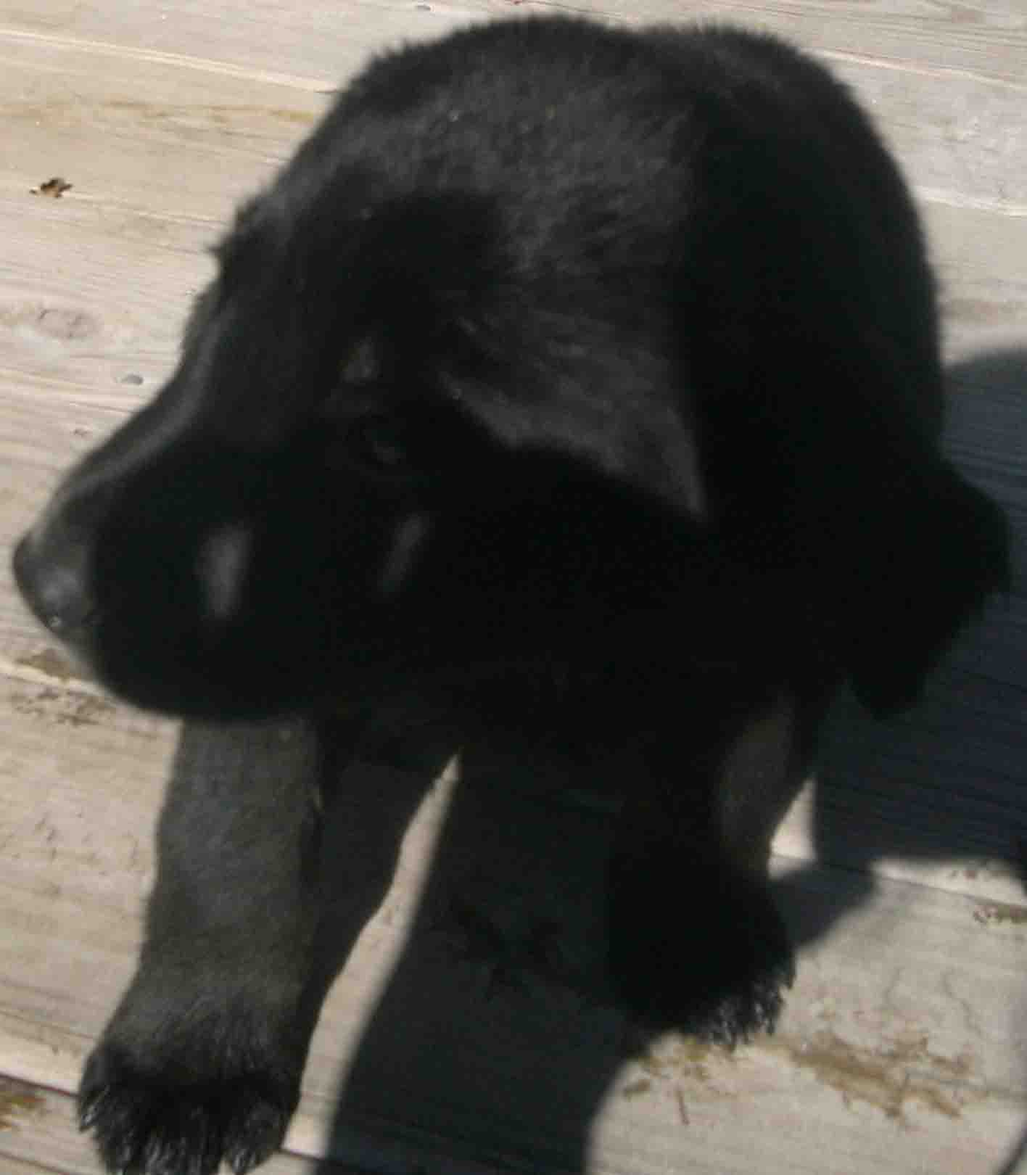
NSAL Adoption Number:
Shelter/Rescue Admit Date: |  |  |  |  |  |  |  |  |  |  |  | 12-2-08
Number of Pups in Litter: |  |  |  |  |  |  |  |  |  |  |  | 3
Sex: |  |  |  |  |  |  |  |  |  |  |  | F
Age: |  |  |  |  |  |  |  |  |  |  |  | 10WKS
Color: |  |  |  |  |  |  |  |  |  |  |  | BLACK
Weight: |  |  |  |  |  |  |  |  |  |  |  | 6LBS
Flea Dip Date:
Worming Date(s): |  |  |  |  |  |  |  |  |  |  |  | 12-2-08
(State if too young) |  |  |  |  |  |  | Bordatella Vacc Date:
 |  |  |  |  |  |  | DHLPP Vacc Date: |  |  |  |  | 12-05-08
 |  |  |  |  |  |  | Rabies Vacc Date: |  |  |  |  | TOO YOUNG
Other Treatments or Notes:
#11
Paste Photo Here → |  |  |  |  |  |  |  |  |  |  |  | 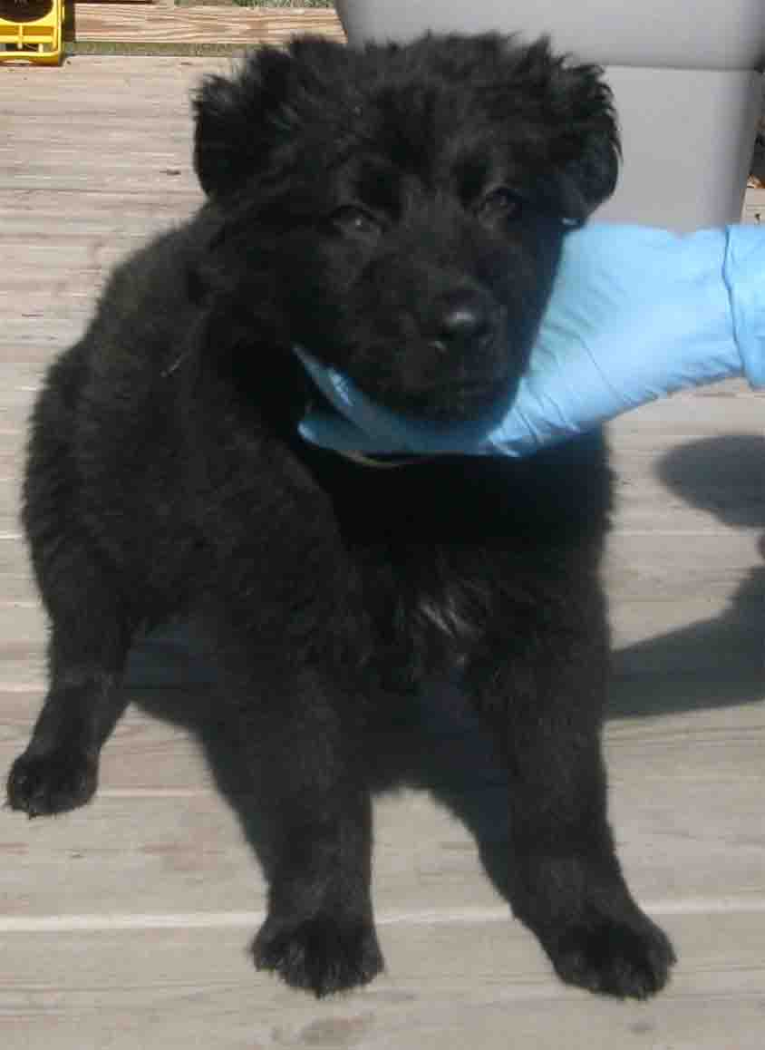
NSAL Adoption Number:
Shelter/Rescue Admit Date: |  |  |  |  |  |  |  |  |  |  |  | 12-02-08
Number of Pups in Litter: |  |  |  |  |  |  |  |  |  |  |  | 3
Sex: |  |  |  |  |  |  |  |  |  |  |  | M
Age: |  |  |  |  |  |  |  |  |  |  |  | 10WKS
Color: |  |  |  |  |  |  |  |  |  |  |  | BLACK
Weight: |  |  |  |  |  |  |  |  |  |  |  | 6LBS
Flea Dip Date:
Worming Date(s):
(State if too young) |  |  |  |  |  |  | Bordatella Vacc Date:
 |  |  |  |  |  |  | DHLPP Vacc Date: |  |  |  |  | 12-05-08
 |  |  |  |  |  |  | Rabies Vacc Date: |  |  |  |  | TOO YOUNG
Other Treatments or Notes:
#12
Paste Photo Here → |  |  |  |  |  |  |  |  |  |  |  | 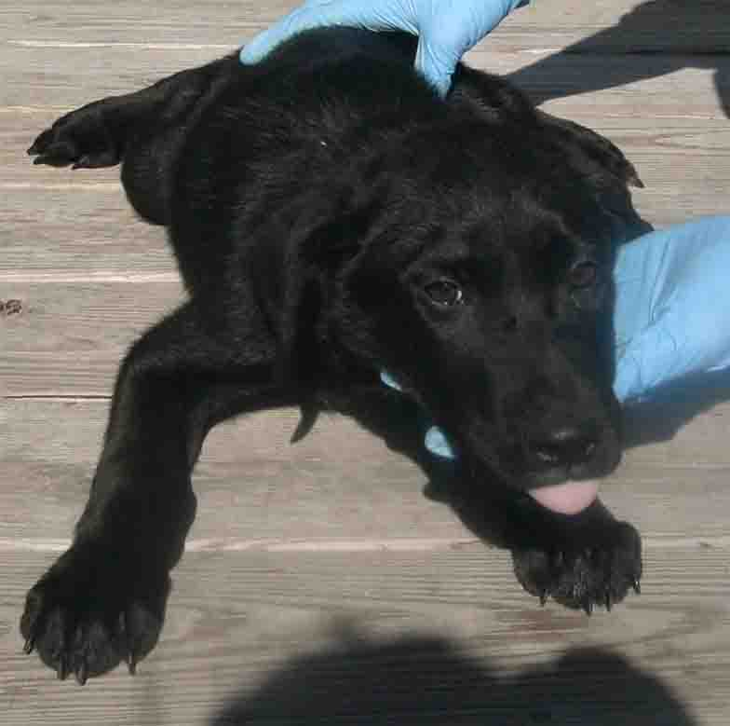
NSAL Adoption Number:
Shelter/Rescue Admit Date: |  |  |  |  |  |  |  |  |  |  |  | 11-26-08
Number of Pups in Litter: |  |  |  |  |  |  |  |  |  |  |  | 3
Sex: |  |  |  |  |  |  |  |  |  |  |  | F
Age: |  |  |  |  |  |  |  |  |  |  |  | 12WKS
Color: |  |  |  |  |  |  |  |  |  |  |  | BLACK/WHITE
Weight: |  |  |  |  |  |  |  |  |  |  |  | 8LBS
Flea Dip Date:
Worming Date(s):
(State if too young) |  |  |  |  |  |  | Bordatella Vacc Date:
 |  |  |  |  |  |  | DHLPP Vacc Date:
 |  |  |  |  |  |  | Rabies Vacc Date:
Other Treatments or Notes:
Puppy or Dog Information
#13
Paste Photo Here → |  |  |  |  |  |  |  |  |  |  |  | 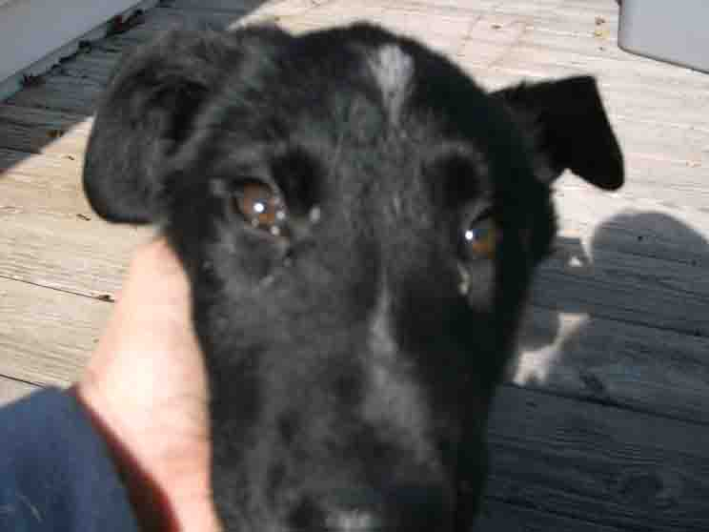
NSAL Adoption Number:
Shelter/Rescue Admit Date: |  |  |  |  |  |  |  |  |  |  |  | 11-26-08
Number of Pups in Litter: |  |  |  |  |  |  |  |  |  |  |  | 3
Sex: |  |  |  |  |  |  |  |  |  |  |  | M
Age: |  |  |  |  |  |  |  |  |  |  |  | 10WKS
Color: |  |  |  |  |  |  |  |  |  |  |  | BLACK/WHITE
Weight: |  |  |  |  |  |  |  |  |  |  |  | 7LBS
Flea Dip Date:
Worming Date(s): |  |  |  |  |  |  |  |  |  |  |  | 11-26-08
(State if too young) |  |  |  |  |  |  | Bordatella Vacc Date:
 |  |  |  |  |  |  | DHLPP Vacc Date: |  |  |  |  | 12-05-08
 |  |  |  |  |  |  | Rabies Vacc Date: |  |  |  |  | TOO YOUNG
Other Treatments or Notes:
#14
Paste Photo Here → |  |  |  |  |  |  |  |  |  |  |  | 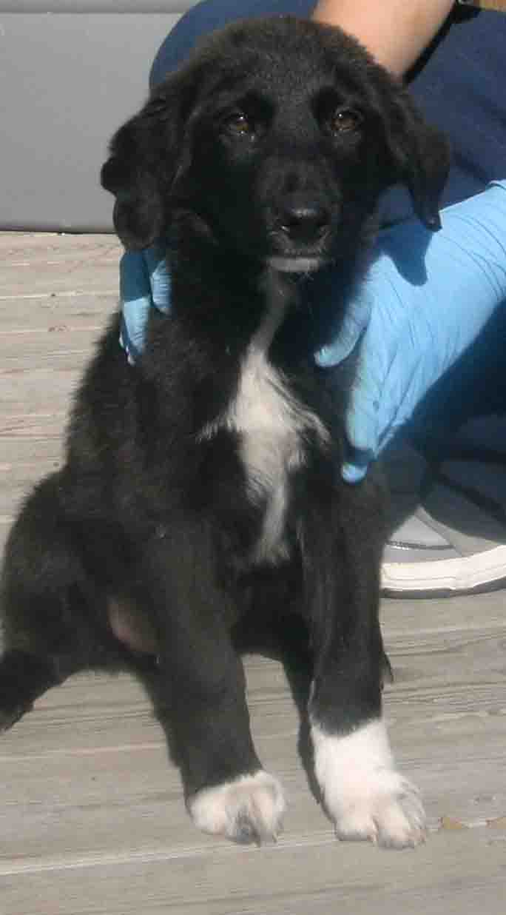
NSAL Adoption Number:
Shelter/Rescue Admit Date: |  |  |  |  |  |  |  |  |  |  |  | 11-26-08
Number of Pups in Litter: |  |  |  |  |  |  |  |  |  |  |  | 3
Sex: |  |  |  |  |  |  |  |  |  |  |  | F
Age: |  |  |  |  |  |  |  |  |  |  |  | 10WKS
Color: |  |  |  |  |  |  |  |  |  |  |  | BLACK/WHITE
Weight: |  |  |  |  |  |  |  |  |  |  |  | 7LBS
Flea Dip Date:
Worming Date(s): |  |  |  |  |  |  |  |  |  |  |  | 11-26-08
(State if too young) |  |  |  |  |  |  | Bordatella Vacc Date:
 |  |  |  |  |  |  | DHLPP Vacc Date: |  |  |  |  | 12-05-08
 |  |  |  |  |  |  | Rabies Vacc Date: |  |  |  |  | TOO YOUNG
Other Treatments or Notes:
#15
Paste Photo Here → |  |  |  |  |  |  |  |  |  |  |  | 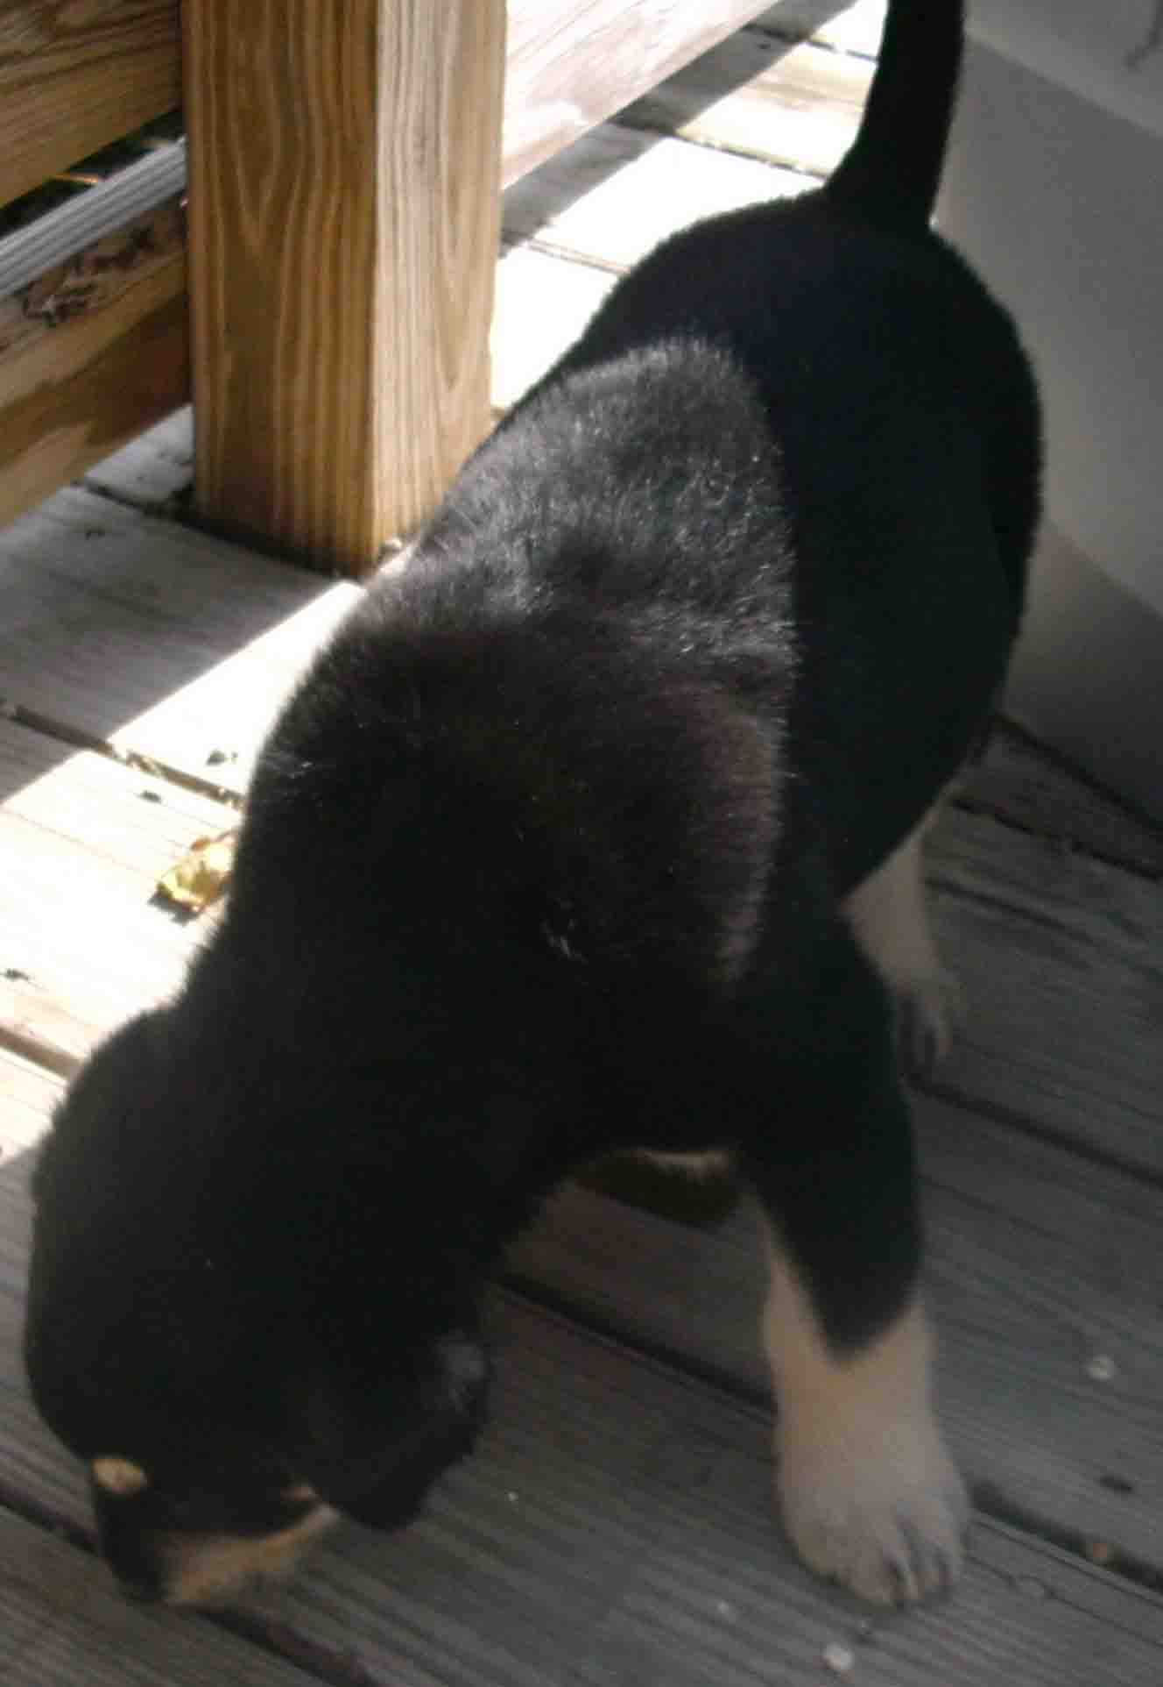
NSAL Adoption Number:
Shelter/Rescue Admit Date: |  |  |  |  |  |  |  |  |  |  |  | 12-2-08
Number of Pups in Litter: |  |  |  |  |  |  |  |  |  |  |  | 3
Sex: |  |  |  |  |  |  |  |  |  |  |  | M
Age: |  |  |  |  |  |  |  |  |  |  |  | 8WKS
Color: |  |  |  |  |  |  |  |  |  |  |  | BLACK/TAN
Weight: |  |  |  |  |  |  |  |  |  |  |  | 6LBS
Flea Dip Date:
Worming Date(s): |  |  |  |  |  |  |  |  |  |  |  | 12-2-08
(State if too young) |  |  |  |  |  |  | Bordatella Vacc Date:
 |  |  |  |  |  |  | DHLPP Vacc Date: |  |  |  |  | 12-05-08
 |  |  |  |  |  |  | Rabies Vacc Date: |  |  |  |  | TOO YOUNG
Other Treatments or Notes:
#
#16
Paste Photo Here → |  |  |  |  |  |  |  |  |  |  |  | 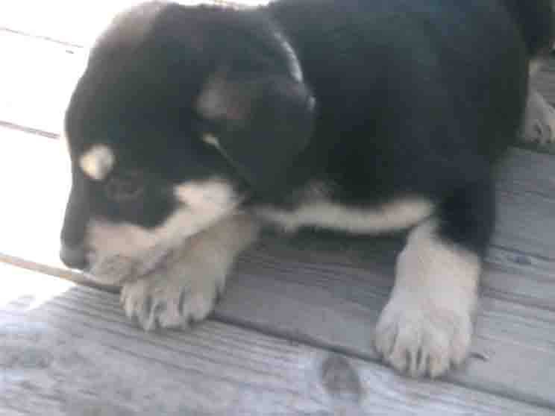
NSAL Adoption Number:
Shelter/Rescue Admit Date: |  |  |  |  |  |  |  |  |  |  |  | 12-2-08
Number of Pups in Litter: |  |  |  |  |  |  |  |  |  |  |  | 3
Sex: |  |  |  |  |  |  |  |  |  |  |  | F
Age: |  |  |  |  |  |  |  |  |  |  |  | 8WKS
Color: |  |  |  |  |  |  |  |  |  |  |  | BLACK/TAN
Weight: |  |  |  |  |  |  |  |  |  |  |  | 6LBS
Flea Dip Date:
Worming Date(s): |  |  |  |  |  |  |  |  |  |  |  | 12-2-08
(State if too young) |  |  |  |  |  |  | Bordatella Vacc Date:
 |  |  |  |  |  |  | DHLPP Vacc Date: |  |  |  |  | 12-05-08
 |  |  |  |  |  |  | Rabies Vacc Date: |  |  |  |  | TOO YOUNG
Other Treatments or Notes:
#17
Paste Photo Here → |  |  |  |  |  |  |  |  |  |  |  | 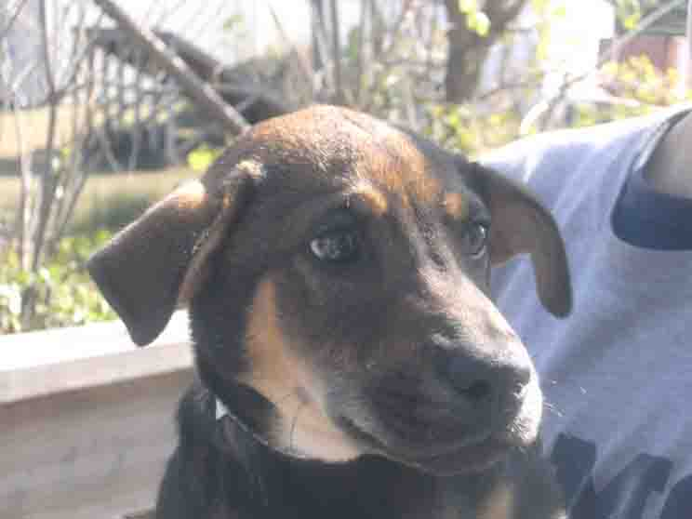
NSAL Adoption Number:
Shelter/Rescue Admit Date: |  |  |  |  |  |  |  |  |  |  |  | 10-24-08
Number of Pups in Litter: |  |  |  |  |  |  |  |  |  |  |  | 1
Sex: |  |  |  |  |  |  |  |  |  |  |  | F
Age: |  |  |  |  |  |  |  |  |  |  |  | 10WKS
Color: |  |  |  |  |  |  |  |  |  |  |  | BROWN/BLACK
Weight: |  |  |  |  |  |  |  |  |  |  |  | 8LBS
Flea Dip Date:
Worming Date(s): |  |  |  |  |  |  |  |  |  |  |  | 11-12-08
(State if too young) |  |  |  |  |  |  | Bordatella Vacc Date:
 |  |  |  |  |  |  | DHLPP Vacc Date: |  |  |  |  | 11-03- 08&12-05-08
 |  |  |  |  |  |  | Rabies Vacc Date: |  |  |  |  | TOO YOUNG
Other Treatments or Notes:
#18
Paste Photo Here →SMALL DOG |  |  |  |  |  |  |  |  |  |  |  | 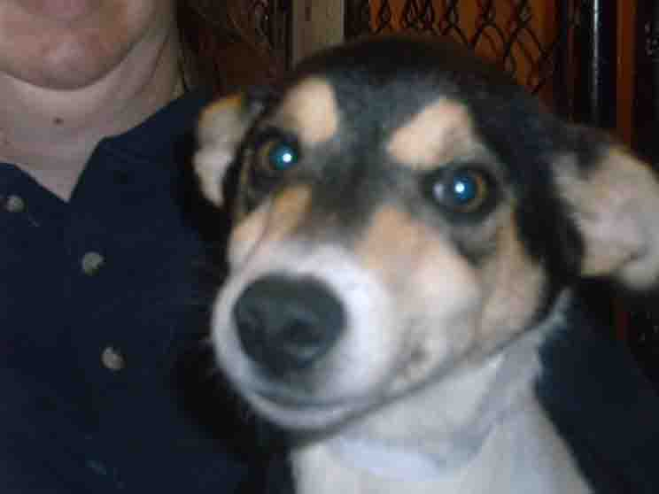
NSAL Adoption Number:
Shelter/Rescue Admit Date: |  |  |  |  |  |  |  |  |  |  |  | 12-2-08
Number of Pups in Litter: |  |  |  |  |  |  |  |  |  |  |  | 1
Sex: |  |  |  |  |  |  |  |  |  |  |  | M
Age: |  |  |  |  |  |  |  |  |  |  |  | 6MO OR UNDER
Color: |  |  |  |  |  |  |  |  |  |  |  | TRI-BLACK/TAN
Weight: |  |  |  |  |  |  |  |  |  |  |  | 19LBS
Flea Dip Date:
Worming Date(s): |  |  |  |  |  |  |  |  |  |  |  | 12-2-08
(State if too young) |  |  |  |  |  |  | Bordatella Vacc Date:
 |  |  |  |  |  |  | DHLPP Vacc Date: |  |  |  |  | 12-5-08
 |  |  |  |  |  |  | Rabies Vacc Date: |  |  |  |  | 12-08-08
Other Treatments or Notes:
#19
Paste Photo Here → |  |  |  |  |  |  |  |  |  |  |  | 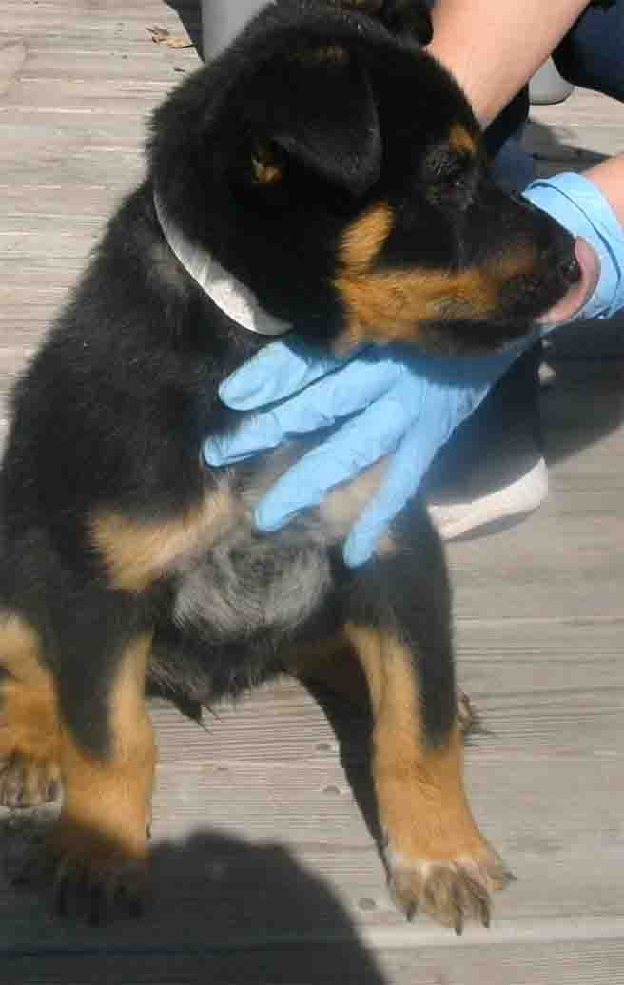
NSAL Adoption Number:
Shelter/Rescue Admit Date: |  |  |  |  |  |  |  |  |  |  |  | 12-3-08
Number of Pups in Litter: |  |  |  |  |  |  |  |  |  |  |  | 3
Sex: |  |  |  |  |  |  |  |  |  |  |  | M
Age: |  |  |  |  |  |  |  |  |  |  |  | 10 WKS
Color: |  |  |  |  |  |  |  |  |  |  |  | TAN/BLACK
Weight: |  |  |  |  |  |  |  |  |  |  |  | 8 LBS
Flea Dip Date:
Worming Date(s): |  |  |  |  |  |  |  |  |  |  |  | 12-03-08
(State if too young) |  |  |  |  |  |  | Bordatella Vacc Date:
 |  |  |  |  |  |  | DHLPP Vacc Date: |  |  |  |  | 12-5-08
 |  |  |  |  |  |  | Rabies Vacc Date: |  |  |  |  | TOO YOUNG
Other Treatments or Notes:
#20
Paste Photo Here → SMALL DOG |  |  |  |  |  |  |  |  |  |  | 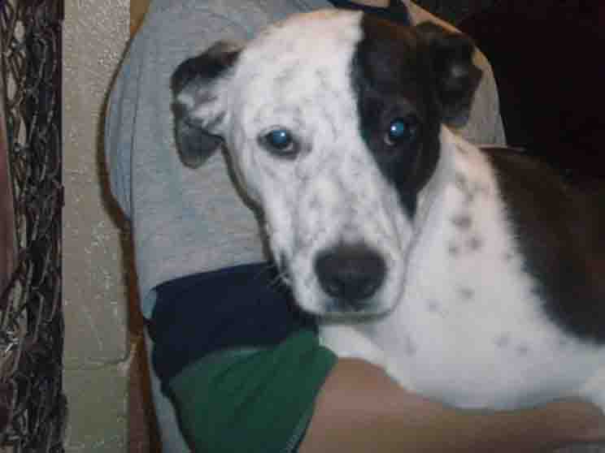
NSAL Adoption Number:
Shelter/Rescue Admit Date: |  |  |  |  |  |  |  |  |  |  | 11-12-08
Number of Pups in Litter: |  |  |  |  |  |  |  |  |  |  | 1
Sex: |  |  |  |  |  |  |  |  |  |  | M
Age: |  |  |  |  |  |  |  |  |  |  | 6MO
Color: |  |  |  |  |  |  |  |  |  |  | WHITE/BLACK
Weight: |  |  |  |  |  |  |  |  |  |  | 19LBS
Flea Dip Date:
Worming Date(s): |  |  |  |  |  |  |  |  |  |  | 11-12-08
(State if too young) |  |  | Bordatella Vacc Date:
 |  |  | DHLPP Vacc Date: |  |  |  |  |  |  |  | 12-05-08
 |  |  | Rabies Vacc Date: |  |  |  |  |  |  |  | 10/08
Other Treatments or Notes: |  |  |  |  |  |  |  |  |  |  | NEUTERED/”ELVIS”
#21
Paste Photo Here → SMALL DOG |  |  |  |  |  |  |  |  |  |  |  | 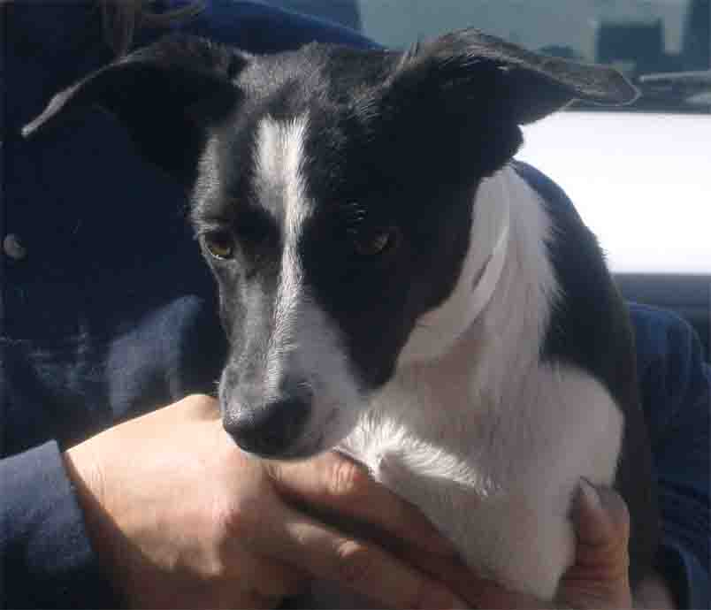
NSAL Adoption Number:
Shelter/Rescue Admit Date: |  |  |  |  |  |  |  |  |  |  |  | 10-7-08
Number of Pups in Litter: |  |  |  |  |  |  |  |  |  |  |  | 2
Sex: |  |  |  |  |  |  |  |  |  |  |  | F
Age: |  |  |  |  |  |  |  |  |  |  |  | 6MO or under
Color: |  |  |  |  |  |  |  |  |  |  |  | WHITE/BLACK
Weight: |  |  |  |  |  |  |  |  |  |  |  | 19LBS
Flea Dip Date:
Worming Date(s): |  |  |  |  |  |  |  |  |  |  |  | 10-15-08
(State if too young) |  |  |  |  |  |  | Bordatella Vacc Date:
 |  |  |  |  |  |  | DHLPP Vacc Date: |  |  |  |  | 10-7-08/12-6-08
 |  |  |  |  |  |  | Rabies Vacc Date: |  |  |  |  | 12-8-08
Other Treatments or Notes: |  |  |  |  |  |  |  |  |  |  |  | SPAYED/”SKITTLES”
#22
Paste Photo Here → SMALL DOG |  |  |  |  |  |  |  |  |  |  |  | 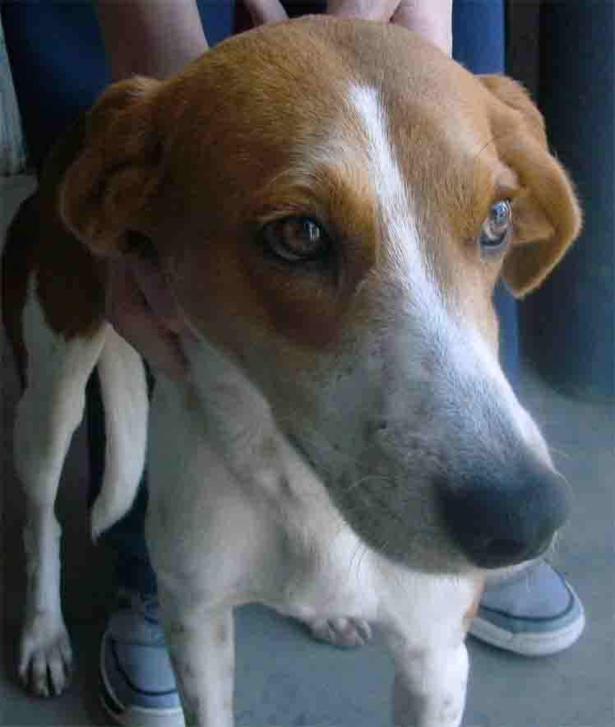
NSAL Adoption Number:
Shelter/Rescue Admit Date: |  |  |  |  |  |  |  |  |  |  |  | 11-19-08
Number of Pups in Litter: |  |  |  |  |  |  |  |  |  |  |  | 1
Sex: |  |  |  |  |  |  |  |  |  |  |  | F
Age: |  |  |  |  |  |  |  |  |  |  |  | 1YR
Color: |  |  |  |  |  |  |  |  |  |  |  | TRI
Weight: |  |  |  |  |  |  |  |  |  |  |  | 25LBS
Flea Dip Date:
Worming Date(s): |  |  |  |  |  |  |  |  |  |  |  | 11-19-08
(State if too young) |  |  |  |  |  |  | Bordatella Vacc Date:
 |  |  |  |  |  |  | DHLPP Vacc Date: |  |  |  |  | 12-05-08
 |  |  |  |  |  |  | Rabies Vacc Date: |  |  |  |  | 12-08-08
Other Treatments or Notes: |  |  |  |  |  |  |  |  |  |  |  | HEARTWORM NEGATIVE ROSIE
#23
Paste Photo Here → |  |  |  |  |  |  |  |  |  |  |  | 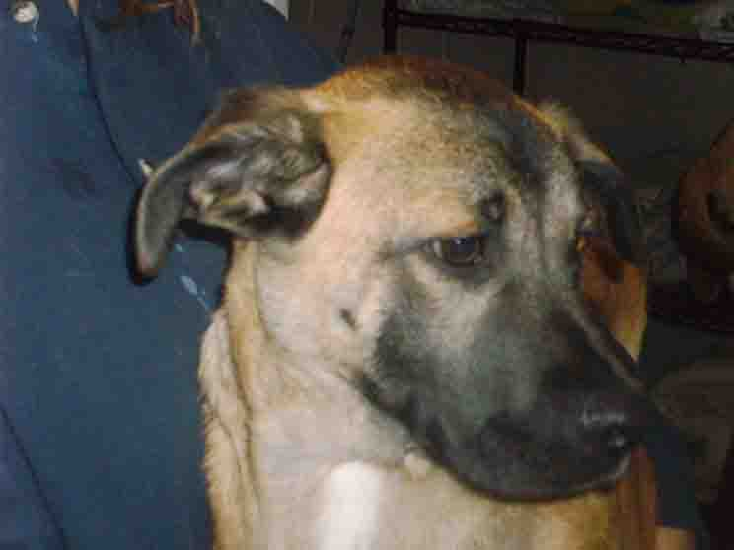
NSAL Adoption Number:
Shelter/Rescue Admit Date: |  |  |  |  |  |  |  |  |  |  |  | 11-05-08
Number of Pups in Litter: |  |  |  |  |  |  |  |  |  |  |  | 5
Sex: |  |  |  |  |  |  |  |  |  |  |  | M
Age: |  |  |  |  |  |  |  |  |  |  |  | 12WKS
Color: |  |  |  |  |  |  |  |  |  |  |  | TAN/BLACK MASK
Weight: |  |  |  |  |  |  |  |  |  |  |  | 12LBS
Flea Dip Date:
Worming Date(s): |  |  |  |  |  |  |  |  |  |  |  | 11-05-08
(State if too young) |  |  |  |  |  |  | Bordatella Vacc Date:
 |  |  |  |  |  |  | DHLPP Vacc Date: |  |  |  |  | 11-05-08
 |  |  |  |  |  |  | Rabies Vacc Date: |  |  |  |  | 12-08-08
Other Treatments or Notes:
Puppy or Dog Information
#24
Paste Photo Here → |  |  |  |  |  |  |  |  |  | 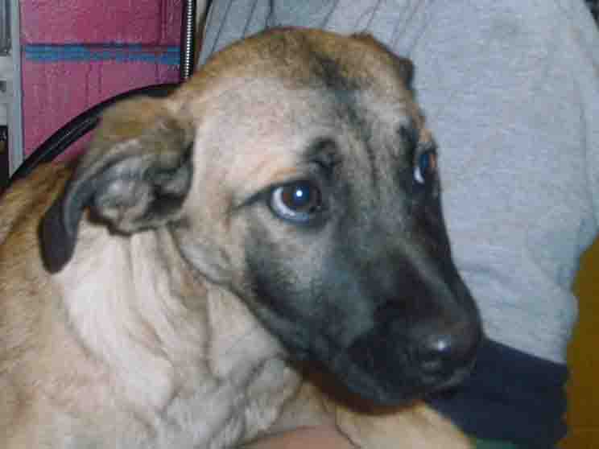
NSAL Adoption Number:
Shelter/Rescue Admit Date: |  |  |  |  |  |  |  |  |  | 11-05-08
Number of Pups in Litter: |  |  |  |  |  |  |  |  |  | 5
Sex: |  |  |  |  |  |  |  |  |  | F
Age: |  |  |  |  |  |  |  |  |  | 12WKS
Katrina Lifeline Database
Please fill out carefully and completely!
Total Number of Puppies: 9
Total Number of Adult Dogs: 0
Total Number of Carriers/Crates Used: 3
Date Prepared: 12/3/08
Your Information - Person completing this form
Name:
Address:
Phone number:
Email:
Sending Shelter/Organization Information - Where were the animal(s) taken from?
Name:
Address:
Phone number:
Email:
Website:
Receiving Shelter/Organization Information - Where are the animal(s) going?
Note: if going to North Shore Animal League leave this part blank
Name:
Address:
Phone Number:
Email:
Website:
Puppy or Dog Information
# 25
Paste Photo Here → |  |  |  |  |  |  |  |  | 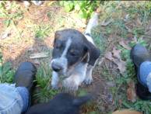
NSAL Adoption Number:
Shelter/Rescue Admit Date: |  |  |  |  |  |  |  |  | 11/7/08
Number of Pups in Litter: |  |  |  |  |  |  |  |  | 9
Sex: |  |  |  |  |  |  |  |  | M
Age: |  |  |  |  |  |  |  |  | 10wks
Color: |  |  |  |  |  |  |  |  | White, black spots
Weight: |  |  |  |  |  |  |  |  | 8#
Flea Dip Date: |  |  |  |  |  |  |  |  | 11/7
Worming Date(s): |  |  |  |  |  |  |  |  | 11/7, 12/1
(State if too young) |  |  |  | Bordatella Vacc Date: |  |  |  |  | 11/7
 |  |  |  | DHLPP Vacc Date: |  |  |  |  | 11/7, 11/27
 |  |  |  | Rabies Vacc Date: |  |  |  |  | TY
Other Treatments or Notes: |  |  |  |  |  |  |  |  | Paramite-11/11, 17, 24
#26
Paste Photo Here → |  |  |  |  |  |  |  |  | 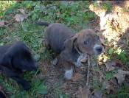
NSAL Adoption Number:
Shelter/Rescue Admit Date: |  |  |  |  |  |  |  |  | 11/7/08
Number of Pups in Litter: |  |  |  |  |  |  |  |  | 9
Sex: |  |  |  |  |  |  |  |  | M
Age: |  |  |  |  |  |  |  |  | 10wks
Color: |  |  |  |  |  |  |  |  | Brown, white paws
Weight: |  |  |  |  |  |  |  |  | 9#
Flea Dip Date: |  |  |  |  |  |  |  |  | 11/7
Worming Date(s): |  |  |  |  |  |  |  |  | 11/7, 12/1
(State if too young) |  |  |  | Bordatella Vacc Date: |  |  |  |  | 11/7
 |  |  |  | DHLPP Vacc Date: |  |  |  |  | 11/7, 27
 |  |  |  | Rabies Vacc Date: |  |  |  |  | TY
Other Treatments or Notes: |  |  |  |  |  |  |  |  | Paramite-11/11, 17, 24
#27
Paste Photo Here → |  |  |  |  |  |  |  |  | 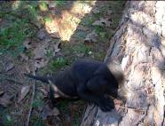
NSAL Adoption Number:
Shelter/Rescue Admit Date: |  |  |  |  |  |  |  |  | 11/7/08
Number of Pups in Litter: |  |  |  |  |  |  |  |  | 9
Sex: |  |  |  |  |  |  |  |  | M
Age: |  |  |  |  |  |  |  |  | 10wks
Color: |  |  |  |  |  |  |  |  | Black
Weight: |  |  |  |  |  |  |  |  | 14#
Flea Dip Date: |  |  |  |  |  |  |  |  | 11/7
Worming Date(s): |  |  |  |  |  |  |  |  | 11/7, 12/1
(State if too young) |  |  |  | Bordatella Vacc Date: |  |  |  |  | 11/7
 |  |  |  | DHLPP Vacc Date: |  |  |  |  | 11/7, 27
 |  |  |  | Rabies Vacc Date: |  |  |  |  | TY
Other Treatments or Notes: |  |  |  |  |  |  |  |  | Paramite-11/11, 17, 24
#28
Paste Photo Here → |  |  |  |  |  |  |  |  | 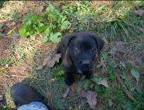
NSAL Adoption Number:
Shelter/Rescue Admit Date: |  |  |  |  |  |  |  |  | 11/7/08
Number of Pups in Litter: |  |  |  |  |  |  |  |  | 9
Sex: |  |  |  |  |  |  |  |  | F
Age: |  |  |  |  |  |  |  |  | 10wks
Color: |  |  |  |  |  |  |  |  | Black
Weight: |  |  |  |  |  |  |  |  | 8#
Flea Dip Date: |  |  |  |  |  |  |  |  | 11/7
Worming Date(s): |  |  |  |  |  |  |  |  | 11/7, 12/1
(State if too young) |  |  |  | Bordatella Vacc Date: |  |  |  |  | 11/7
 |  |  |  | DHLPP Vacc Date: |  |  |  |  | 11/7, 27
 |  |  |  | Rabies Vacc Date: |  |  |  |  | TY
Other Treatments or Notes: |  |  |  |  |  |  |  |  | Paramite-11/11, 17, 24
#29
Paste Photo Here →
NSAL Adoption Number:
Shelter/Rescue Admit Date: |  |  |  |  |  |  |  |  | 11/7/08
Number of Pups in Litter: |  |  |  |  |  |  |  |  | 9
Sex: |  |  |  |  |  |  |  |  | F
Age: |  |  |  |  |  |  |  |  | 10wks
Color: |  |  |  |  |  |  |  |  | Black, white patch chest
Weight: |  |  |  |  |  |  |  |  | 9#
Flea Dip Date: |  |  |  |  |  |  |  |  | 11/7
Worming Date(s): |  |  |  |  |  |  |  |  | 11/7, 12/1
(State if too young) |  |  |  | Bordatella Vacc Date: |  |  |  |  | 11/7
 |  |  |  | DHLPP Vacc Date: |  |  |  |  | 11/7, 27
 |  |  |  | Rabies Vacc Date: |  |  |  |  | TY
Other Treatments or Notes: |  |  |  |  |  |  |  |  | Paramite-11/11, 17, 24
#30
Paste Photo Here → |  |  |  |  |  |  |  |  | 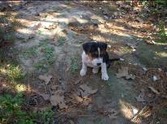
NSAL Adoption Number:
Shelter/Rescue Admit Date: |  |  |  |  |  |  |  |  | 11/7/08
Number of Pups in Litter: |  |  |  |  |  |  |  |  | 9
Sex: |  |  |  |  |  |  |  |  | F
Age: |  |  |  |  |  |  |  |  | 10wks
Color: |  |  |  |  |  |  |  |  | Tri
Weight: |  |  |  |  |  |  |  |  | 8#
Flea Dip Date: |  |  |  |  |  |  |  |  | 11/7
Worming Date(s): |  |  |  |  |  |  |  |  | 11/7, 12/1
(State if too young) |  |  |  | Bordatella Vacc Date: |  |  |  |  | 11/7
 |  |  |  | DHLPP Vacc Date: |  |  |  |  | 11/7, 27
 |  |  |  | Rabies Vacc Date: |  |  |  |  | TY
Other Treatments or Notes: |  |  |  |  |  |  |  |  | Paramite-11/11, 17, 24
#31
Paste Photo Here → |  |  |  |  |  |  |  |  | 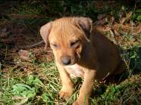
NSAL Adoption Number:
Shelter/Rescue Admit Date: |  |  |  |  |  |  |  |  | 11/7/08
Number of Pups in Litter: |  |  |  |  |  |  |  |  | 9
Sex: |  |  |  |  |  |  |  |  | F
Age: |  |  |  |  |  |  |  |  | 10wks
Color: |  |  |  |  |  |  |  |  | Red
Weight: |  |  |  |  |  |  |  |  | 10#
Flea Dip Date: |  |  |  |  |  |  |  |  | 11/7
Worming Date(s): |  |  |  |  |  |  |  |  | 11/7, 12/1
(State if too young) |  |  |  | Bordatella Vacc Date: |  |  |  |  | 11/7
 |  |  |  | DHLPP Vacc Date: |  |  |  |  | 11/7, 27
 |  |  |  | Rabies Vacc Date: |  |  |  |  | TY
Other Treatments or Notes: |  |  |  |  |  |  |  |  | Paramite-11/11, 17, 24
#32
Paste Photo Here → |  |  |  |  |  |  |  |  | 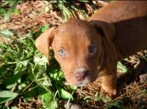
NSAL Adoption Number:
Shelter/Rescue Admit Date: |  |  |  |  |  |  |  |  | 11/7/08
Number of Pups in Litter: |  |  |  |  |  |  |  |  | 9
Sex: |  |  |  |  |  |  |  |  | F
Age: |  |  |  |  |  |  |  |  | 10wks
Color: |  |  |  |  |  |  |  |  | Red, blue eyes
Weight: |  |  |  |  |  |  |  |  | 8#
Flea Dip Date: |  |  |  |  |  |  |  |  | 11/7
Worming Date(s): |  |  |  |  |  |  |  |  | 11/7, 12/1
(State if too young) |  |  |  | Bordatella Vacc Date: |  |  |  |  | 11/7
 |  |  |  | DHLPP Vacc Date: |  |  |  |  | 11/7, 27
 |  |  |  | Rabies Vacc Date: |  |  |  |  | TY
Other Treatments or Notes: |  |  |  |  |  |  |  |  | Paramite-11/11, 17, 24
#33
Paste Photo Here → |  |  |  |  |  |  |  |  | 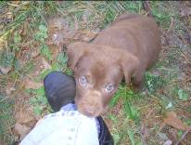
NSAL Adoption Number:
Shelter/Rescue Admit Date: |  |  |  |  |  |  |  |  | 11/7
Number of Pups in Litter: |  |  |  |  |  |  |  |  | 9
Sex: |  |  |  |  |  |  |  |  | M
Age: |  |  |  |  |  |  |  |  | 10wks
Color: |  |  |  |  |  |  |  |  | Brown, green eyes
Weight: |  |  |  |  |  |  |  |  | 12#
Flea Dip Date: |  |  |  |  |  |  |  |  | 11/7
Worming Date(s): |  |  |  |  |  |  |  |  | 11/7, 12/1
(State if too young) |  |  |  | Bordatella Vacc Date: |  |  |  |  | 11/7
 |  |  |  | DHLPP Vacc Date: |  |  |  |  | 11/7, 27
 |  |  |  | Rabies Vacc Date: |  |  |  |  | TY
Other Treatments or Notes: |  |  |  |  |  |  |  |  | Paramite-11/11, 17, 24
Katrina Lifeline Database
Please fill out carefully and completely!
Total Number of Puppies:
Total Number of Adult Dogs: one
Total Number of Carriers/Crates Used: one
Date Prepared: December 2, 2008
Your Information - Person completing this form
Name:
Address:
Phone number:
Email:
Sending Shelter/Organization Information - Where were the animal(s) taken from?
Name:
Address:
Phone number:
Email:
Website:
Receiving Shelter/Organization Information - Where are the animal(s) going?
Note: if going to North Shore Animal League leave this part blank
Name:
Address:
Phone Number:
Email:
Website:
Puppy or Dog Information
#34
Paste Photo Here → |  |  |  |  |  | 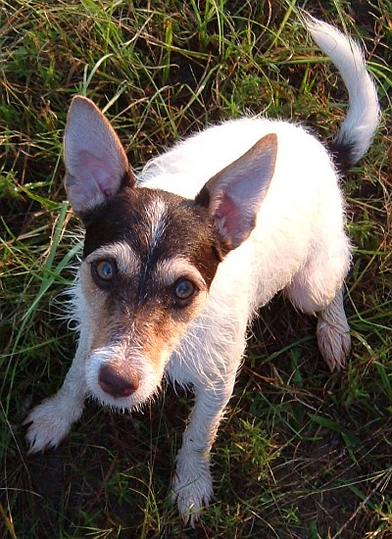
NSAL Adoption Number:
Shelter/Rescue Admit Date: |  |  |  |  |  | August 4th survivor. On Monday, August 4, 2008 approximately 184 dogs and cats were killed at the Tangipahoa Parish Animal Shelter.
Number of Pups in Litter:
Sex: |  |  |  |  |  | Neutered Male 10-9-2008
Age: |  |  |  |  |  | About 12 months or so now.
Color: |  |  |  |  |  | Tri colored; mostly with dark chocolate and tan markings.
Weight: |  |  |  |  |  | 11-12 pounds
Flea Dip Date: |  |  |  |  |  | Advantage 9-16-2008
Worming Date(s): |  |  |  |  |  | Heartworm test: Negative 8-20-2008; fecal test negative 8-20-2008
(State if too young) | Bordatella Vacc Date: |  |  |  |  | 8-20-2008
(State if too young) | DHLPP Vacc Date: |  |  |  |  | 8-20-2008 DA2PLCPV
(State if too young) | Rabies Vacc Date: |  |  |  |  | 8-20-2008 Tag # 8348
Other Treatments or Notes: |  |  |  |  |  | Ear mites 8-20-2008; Kennel cough 8-5-2008;  JumpingJack - Jack Russell Terrier, Fox Terrier [Mix]  More info and photos/video posted here: http://www.petfinder.com/petnote/displaypet.cgi?petid=11722728
Katrina Lifeline Database
Please fill out carefully and completely!
Total Number of Puppies:
Total Number of Adult Dogs: 7
Total Number of Carriers/Crates Used:
Date Prepared:
Your Information - Person completing this form
Name:
Address:
Phone number:
Email:
Sending Shelter/Organization Information - Where were the animal(s) taken from?
Name:
Address:
Phone number:
Email:
Website:
Receiving Shelter/Organization Information - Where are the animal(s) going?
Note: if going to North Shore Animal League leave this part blank
Name:
Address:
Phone Number:
Email:
Website:
Puppy or Dog Information
#35
Paste Photo Here → |  | 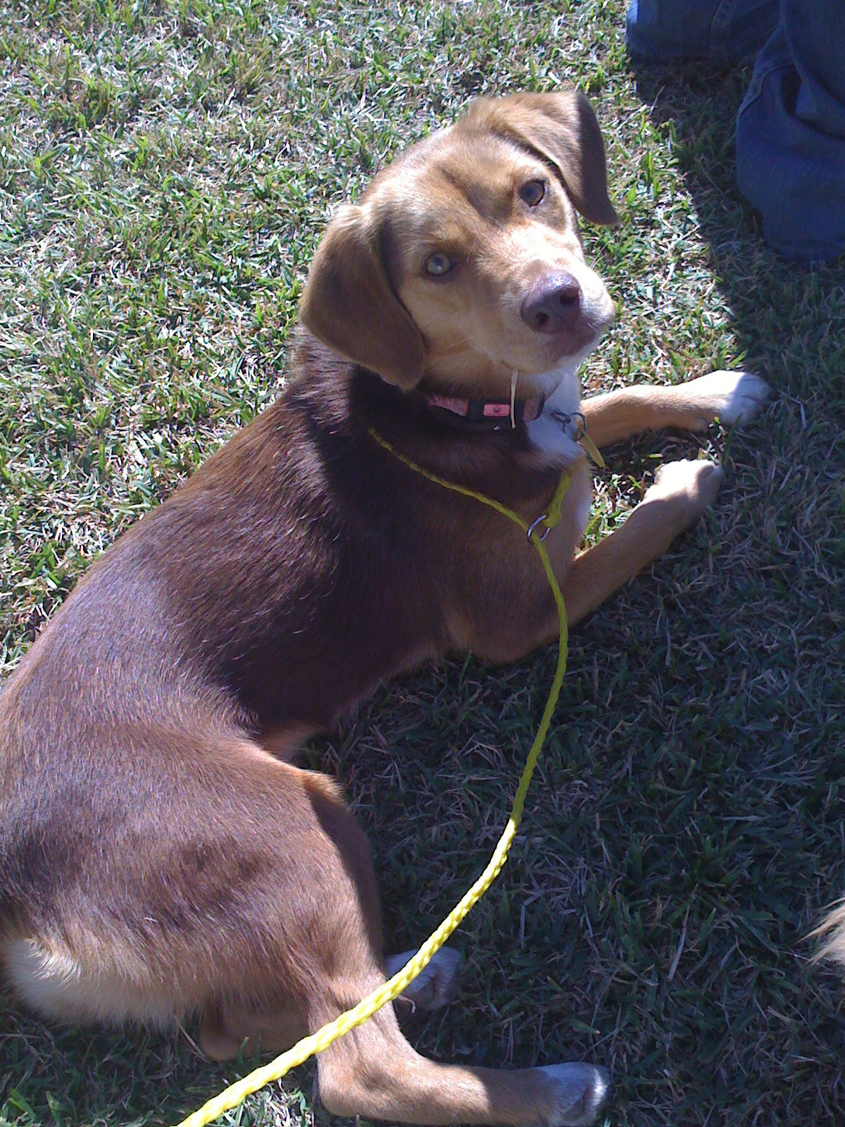
NSAL Adoption Number: |  | WO-10-13-02
Shelter/Rescue Admit Date: |  | 10-13-08
Number of Pups in Litter:
Sex: |  | Female
Age: |  | 10 mos
Color: |  | Brown/White
Weight: |  | 23.2
Flea Dip Date:
Worming Date(s): |  | 10-13-08
(State if too young) | Bordatella Vacc Date: | 10-13-08
(State if too young) | DHLPP Vacc Date: | 10-13-08
(State if too young) | Rabies Vacc Date: | 12-09-08
Other Treatments or Notes: |  | HW negative
Paste Photo Here →
NSAL Adoption Number:
Shelter/Rescue Admit Date:
Number of Pups in Litter:
Sex:
Age:
Color:
Weight:
Flea Dip Date:
Worming Date(s):
(State if too young) | Bordatella Vacc Date:
(State if too young) | DHLPP Vacc Date:
(State if too young) | Rabies Vacc Date:
Other Treatments or Notes:
#36
Paste Photo Here → |  | 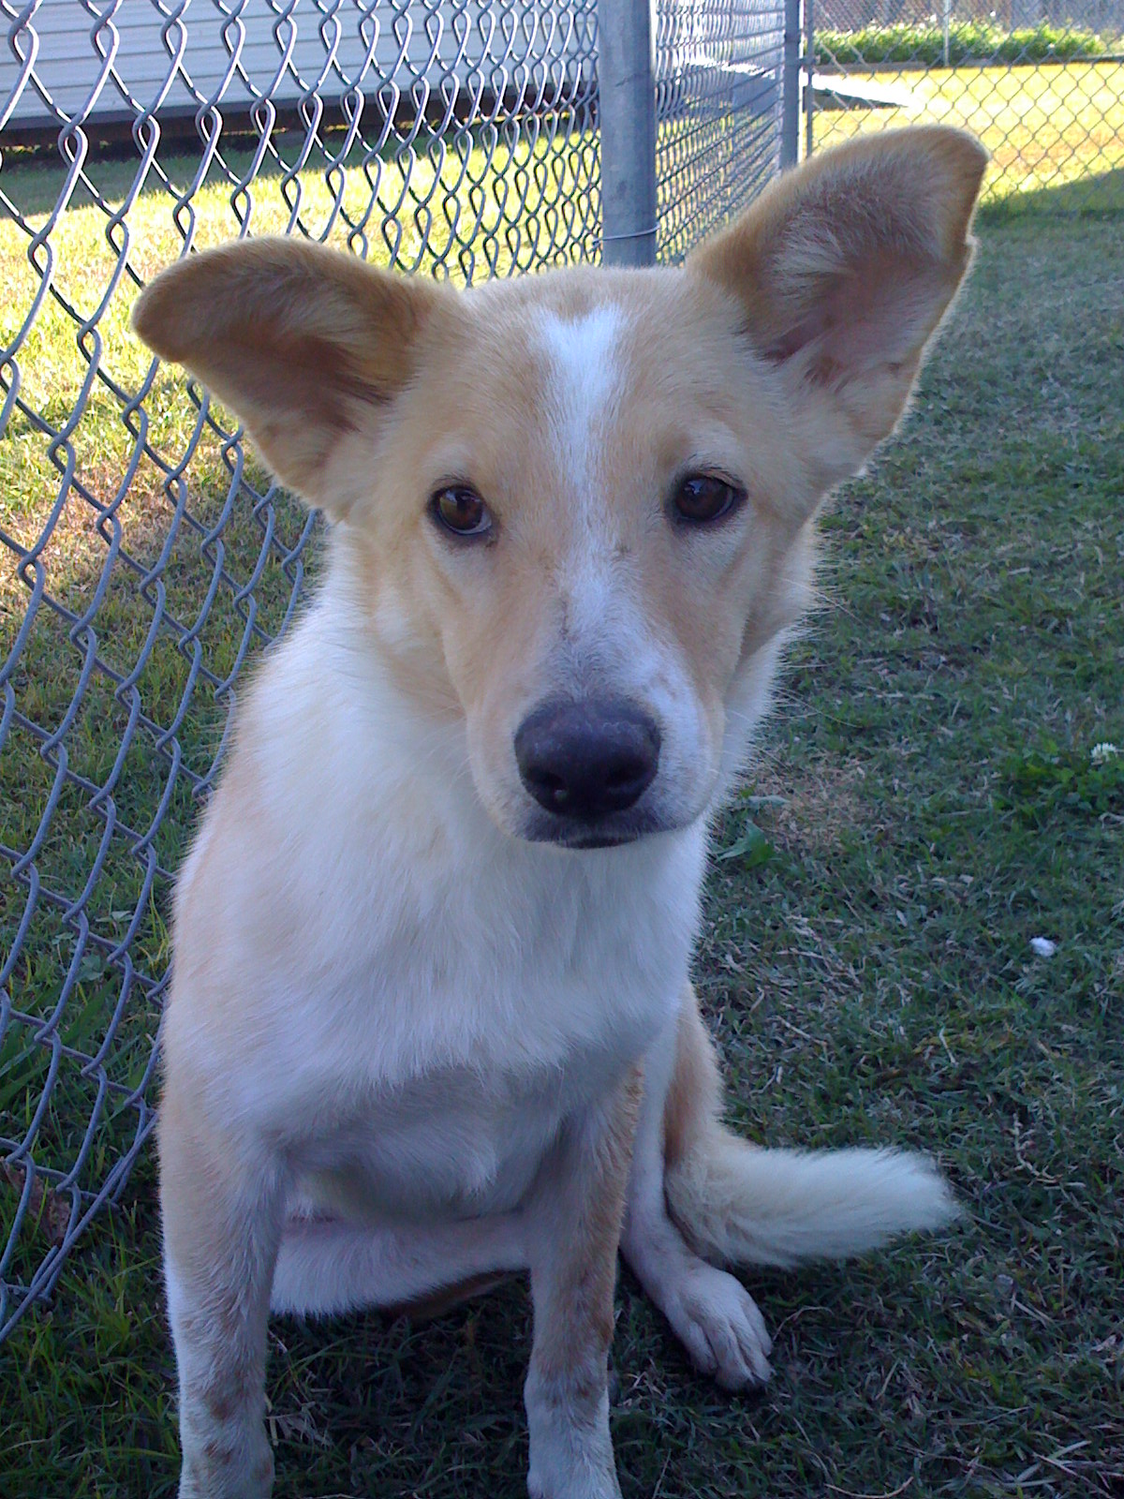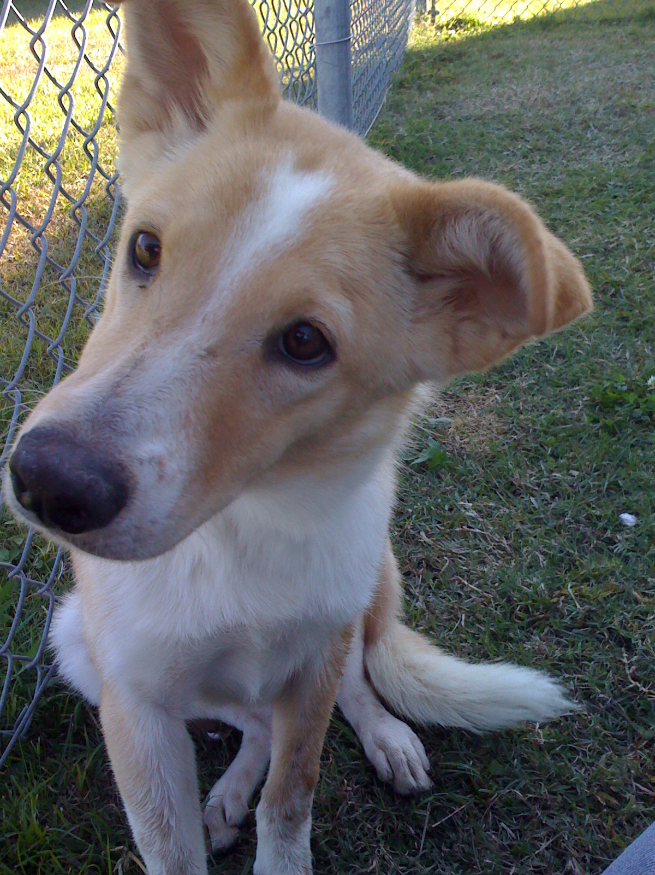
NSAL Adoption Number: |  | BT-10-11-12
Shelter/Rescue Admit Date: |  | 10-11-08
Number of Pups in Litter: |  | n/a
Sex: |  | Female
Age: |  | 8 mos
Color: |  | Tan/ White
Weight: |  | 24.4
Flea Dip Date:
Worming Date(s): |  | 10-11-08
(State if too young) | Bordatella Vacc Date: | 10-11-08
(State if too young) | DHLPP Vacc Date: | 10-11-08
(State if too young) | Rabies Vacc Date: | 12-09-08
Other Treatments or Notes: |  | HW negative
#37
Paste Photo Here → |  | 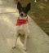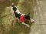
NSAL Adoption Number: |  | RO-09-27-09
Shelter/Rescue Admit Date: |  | 09-27-08
Number of Pups in Litter: |  | n/a
Sex: |  | Male
Age: |  | 1 ½
Color: |  | Black/ White
Weight: |  | 16.2
Flea Dip Date:
Worming Date(s):
(State if too young) | Bordatella Vacc Date: | 09-27-08
(State if too young) | DHLPP Vacc Date: | 09-27-08
(State if too young) | Rabies Vacc Date: | 09-27-08
Other Treatments or Notes: |  | HW negative
#38
Paste Photo Here → |  | 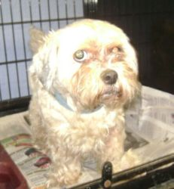
NSAL Adoption Number: |  | EO-12-03-10
Shelter/Rescue Admit Date: |  | 12-03-10
Number of Pups in Litter: |  | n/a
Sex: |  | Female
Age: |  | 4 years
Color: |  | White
Weight: |  | 14.2
Flea Dip Date:
Worming Date(s): |  | 12-03-10
(State if too young) | Bordatella Vacc Date: | 12-03-10
(State if too young) | DHLPP Vacc Date: | 12-03-10
(State if too young) | Rabies Vacc Date: | 12-09-08
Other Treatments or Notes: |  | HW negative
#39
Paste Photo Here → |  | 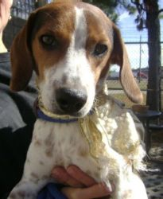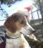
NSAL Adoption Number: |  | EO-12-02-01
Shelter/Rescue Admit Date: |  | 12-02-01
Number of Pups in Litter: |  | n/a
Sex: |  | Male
Age: |  | 9 mos
Color: |  | Tri Brown/White/Black
Weight: |  | 21.7
Flea Dip Date:
Worming Date(s): |  | 12-02-01
(State if too young) | Bordatella Vacc Date: | 12-02-01
(State if too young) | DHLPP Vacc Date: | 12-02-01
(State if too young) | Rabies Vacc Date: | 12-09-08
Other Treatments or Notes: |  | HW negative
#4 0
Paste Photo Here → |  |  |  |  |  |  |  | 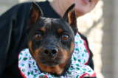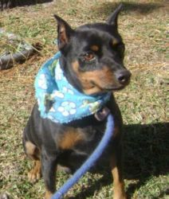
NSAL Adoption Number: |  |  |  |  |  |  |  | EO-11-14-12
Shelter/Rescue Admit Date: |  |  |  |  |  |  |  | 11-14-08
Name: |  |  |  |  |  |  |  | Bubby
Sex: |  |  |  |  |  |  |  | Male
Age: |  |  |  |  |  |  |  | 7 years
Color: |  |  |  |  |  |  |  | Black/ Brown
Weight: |  |  |  |  |  |  |  | 22 lbs
Breed: |  |  |  |  |  |  |  | Mini Pinscher
Worming Date(s): |  |  |  |  |  |  |  | 11-14-08
(State if too young) | Bordatella Vacc Date: |  |  |  |  |  |  | 12-09-08
(State if too young) | DHLPP Vacc Date: |  |  |  |  |  |  | 12-09-08
(State if too young) | Rabies Vacc Date: |  |  |  |  |  |  | 12-09-08
Other Treatments or Notes: |  |  |  |  |  |  |  | Heartworm Negative
#41
Paste Photo Here → |  |  |  |  |  |  |  | 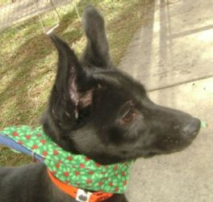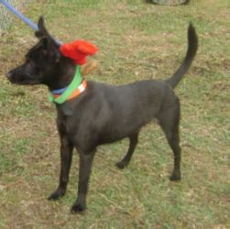
NSAL Adoption Number: |  |  |  |  |  |  |  | WO-10-11-06
Shelter/Rescue Admit Date: |  |  |  |  |  |  |  | 10-11-08
Name: |  |  |  |  |  |  |  | Trinket
Sex: |  |  |  |  |  |  |  | Female
Age: |  |  |  |  |  |  |  | 1 year
Color: |  |  |  |  |  |  |  | Black
Weight: |  |  |  |  |  |  |  | 13.2 lbs
Breed: |  |  |  |  |  |  |  | Skipperke
Worming Date(s): |  |  |  |  |  |  |  | 10-11-08
(State if too young) |  | Bordatella Vacc Date: |  |  |  |  |  | 12-09-08
 |  | DHLPP Vacc Date: |  |  |  |  |  | 12-09-08
 |  | Rabies Vacc Date: |  |  |  |  |  | 12-09-08
Other Treatments or Notes: |  |  |  |  |  |  |  | Heartworm Negative
 |  |  |  |  |  |  |  | 12-09-08
 |  |  |  |  |  |  |  | 12-09-08
 |  |  |  |  |  |  |  | 12-09-08
Other Treatments or Notes:
#9
Paste Photo Here →
NSAL Adoption Number:
Shelter/Rescue Admit Date:
Number of Pups in Litter:
Sex:
Age:
Color:
Weight:
Flea Dip Date:
Worming Date(s):
(State if too young) | Bordatella Vacc Date:
 | DHLPP Vacc Date:
 | Rabies Vacc Date:
Other Treatments or Notes:
#10

