 | TOTAL # PUPS:
 | # OF CARRIERS USED:
 | cc: Data Entry, Grooming, Shelter Medical, Med. Ctr. Mgr.,
 | ORIGINAL COPY: W. McColgan
NSAL ADOPTION
NUMBER
 | COPY AND PASTE PICTURE IN HERE
R-
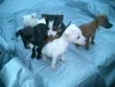
 | 
 | R-
 | R-
 | R-
 | 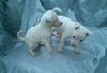
 | 
 | TOTAL # PUPS: 4
 | # OF CARRIERS USED:
 | cc: Data Entry, Grooming, Shelter Medical, Med. Ctr. Mgr.,
 | ORIGINAL COPY: W. McColgan
NSAL ADOPTION
NUMBER
COPY AND PASTE PICTURE IN HERE
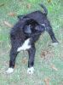
 | R-
 | 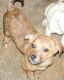
 | R-
 | 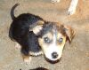
 | R-
 | 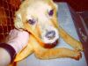
 | TOTAL # PUPS: 2
 | # OF CARRIERS USED:
 | cc: Data Entry, Grooming, Shelter Medical, Med. Ctr. Mgr.,
 | ORIGINAL COPY: W. McColgan
NSAL ADOPTION
NUMBER
 | 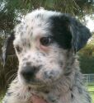
 | R-
 | 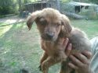
 | TOTAL # PUPS: 1
 | # OF CARRIERS USED:
 | cc: Data Entry, Grooming, Shelter Medical, Med. Ctr. Mgr.,
 | ORIGINAL COPY: W. McColgan
NSAL ADOPTION
NUMBER
COPY AND PASTE PICTURE IN HERE
Tweek

 | TOTAL # PUPS :
 | TOTAL # DOGS:
 | # OF CARRIERS USED:
 | cc: Data Entry, Grooming, Shelter Medical, Med. Ctr. Mgr.,
 | ORIGINAL COPY: W. McColgan
NSAL ADOPTION
NUMBER
 | 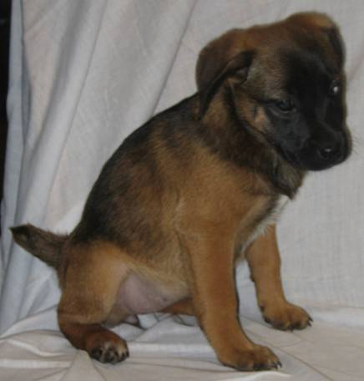
 | 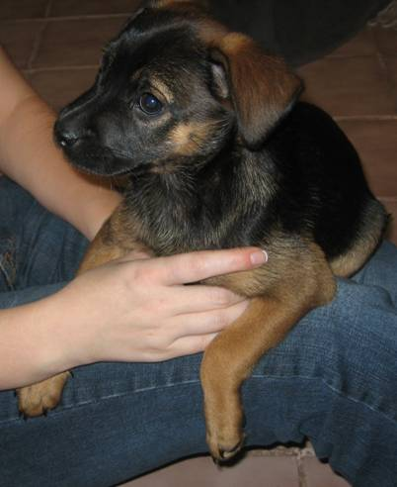
 | 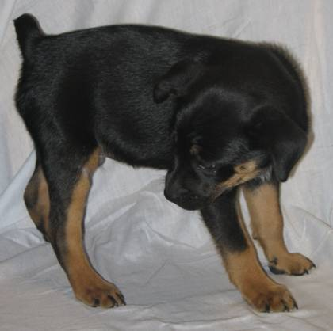
 | R-
 | 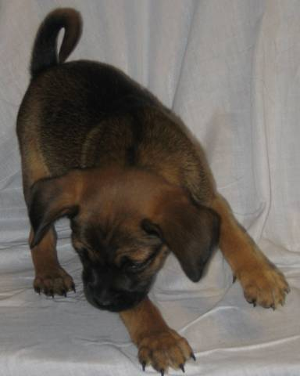
 | R-
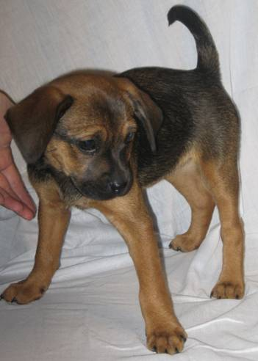
R-No picture
COPY AND PASTE PICTURE IN THIS COLUMN
 | R-
TOTAL # PUPS : |  |  | 8 |  |  |  |  |  |  |  |  |  |  |  |  |  |  |  |  |  |  |  |  |  |  |  |  |  |  |  |  |  |  |  |  |  |  |  |  |  |  |  |  |  |  |  |  |  |  | DATE PREPARED:
TOTAL # DOGS:
# OF CARRIERS USED:
cc: Data Entry, Grooming, Shelter Medical, Med. Ctr. Mgr.,
ORIGINAL COPY: W. McColgan
NSAL ADOPTION
NUMBER
COPY AND PASTE PICTURE IN THIS COLUMN
R-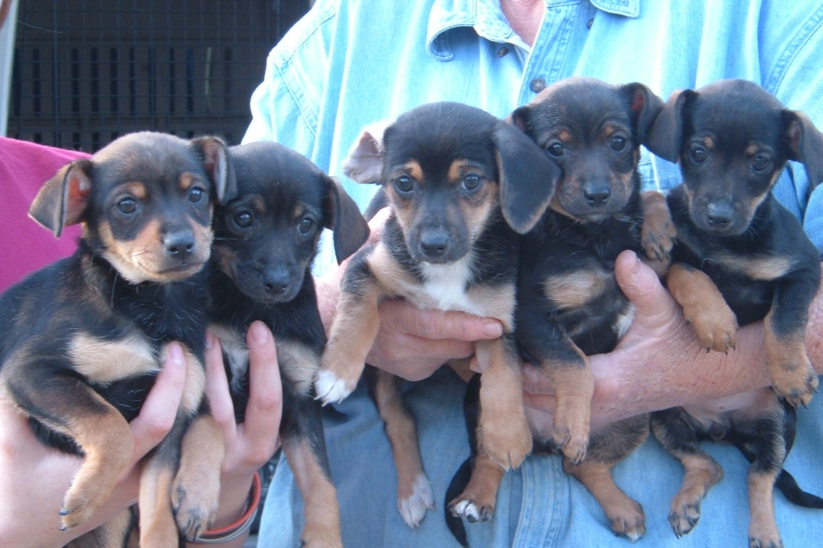
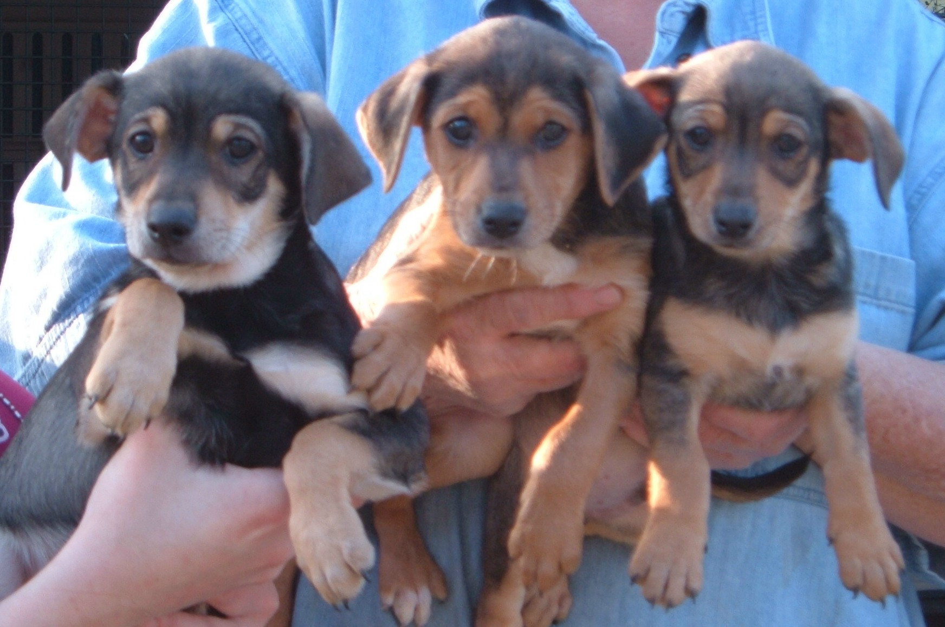
TOTAL # PUPS : |  |  |  |  |  |  |  |  |  |  | 7 |  |  |  |  |  |  |  |  |  |  |  |  |  |  |  |  |  |  |  |  |  |  |  |  |  |  |  |  |  |  |  |  |  |  |  |  |  |  |  |  |  | DATE PREPARED:
TOTAL # DOGS: |  |  |  |  |  |  |  |  |  |  |  |  |  |  |  |  |  |  |  |  |  |  |  |  |  |  |  |  |  |  |  |  |  |  |  |  |  |  |  |  |  |  |  |  |  |  |  |  |  |  |  |  | NSAL ADMIT DATE:
# OF CARRIERS USED: |  |  |  |  |  |  |  |  |  |  | 2 |  |  |  |  |  |  |  |  |  |  |  |  |  |  |  |  |  |  |  |  |  |  |  |  |  |  |  |  |  |  |  |  |  |  |  |  |  |  |  |  |  | NAME, ADDRESS, PHONE, EMAIL AND WEBSITE OF SHELTER, ANIMAL CONTROL, OR RESCUE GROUP ORIGINATING FROM:
cc: Data Entry, Grooming, Shelter Medical, Med. Ctr. Mgr., |  |  |  |  |  |  |  |  |  |  |  |  |  |  |  |  |  |  |  |  |  |  |  |  |  |  |  |  |  |  |  |  |  |  |  |  |  |  |  |  |  |  |  |  |  |  |  |  |  |  |  |  | NAME, ADDRESS, PHONE, EMAIL OF PERSON FILLING OUT THIS FORM:
ORIGINAL COPY: W. McColgan
 |  |  |  |  |  |  |  |  |  |  | IF ADULT DOG PUT Receiving Facility OR ADOPTING PARTY Name, Address, Phone, email, website (PO Box unacceptable) in this column |  |  |  |  |  |  |  |  |  |  |  |  |  |  |  |  |  |  |  |  |  |  |  |  |  |  |  |  |  |  |  |  |  |  |  |  |  |  |  |  |  | VAX DATES
 |  |  |  |  |  |  |  |  |  |  | OR |  |  |  |  |  |  |  |  |  |  |  |  |  |  |  |  |  |  |  |  |  |  |  |  |  |  |  |  |  |  |  |  |  |  |  |  |  |  |  |  |  | STATE IF TOO YOUNG
NSAL ADOPTION  NUMBER |  |  |  | SHELTER OR RESCUE ADMIT  DATE |  |  |  |  |  |  | #PUPS IN LITTER |  |  |  |  |  |  |  |  |  |  |  |  |  | SEX |  |  |  |  |  |  | AGE |  |  |  |  |  | COLOR |  |  |  |  |  |  | WEIGHT |  |  |  |  |  |  | FLEA DIP DATE | BORD.
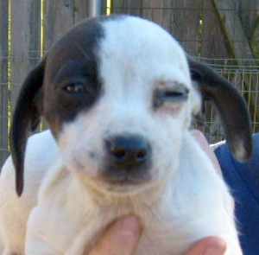 |  |  |  | 12/10/2007
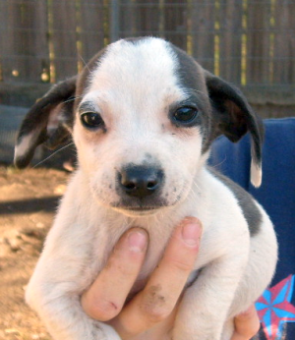 |  |  |  | 12/10/2007
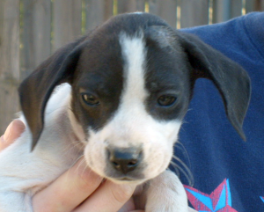 |  |  |  | 12/10/2007
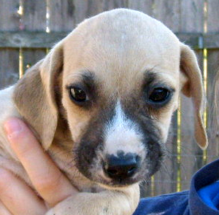 |  |  |  | 12/10/2007
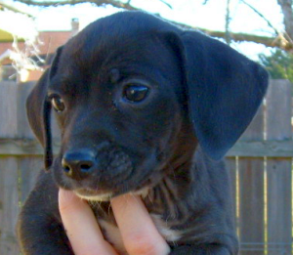 |  |  |  | 12/10/2007
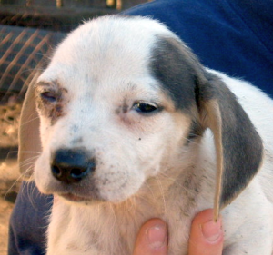 |  |  |  | 12/10/2007
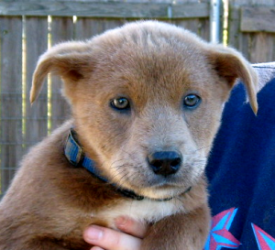 |  |  |  | 12/26/2007
TOTAL # PUPS : |  |  |  |  | 8 |  |  |  |  |  |  |  |  |  |  |  |  |  |  |  |  |  |  |  |  |  |  |  |  |  |  |  |  |  |  |  |  |  |  |  |  |  |  |  |  |  |  |  |  |  | DATE PREPARED:  12/30/07
TOTAL # DOGS:
# OF CARRIERS USED:
cc: Data Entry, Grooming, Shelter Medical, Med. Ctr. Mgr.,
ORIGINAL COPY: W. McColgan

"TAZ"

