TOTAL # PUPS : | 7 |  |  |  |  |  |  |  |  |  |  |  |  | DATE PREPARED: |  | 3/9/08 |  | 3/21/08  resent
TOTAL # DOGS: |  |  |  |  |  |  |  |  |  |  |  |  |  | NSAL ADMIT DATE:
# OF CARRIERS USED: | 4 |  |  |  |  |  |  |  |  |  |  |  |  | NAME, ADDRESS, PHONE, EMAIL AND WEBSITE OF SHELTER, ANIMAL CONTROL, OR RESCUE GROUP ORIGINATING FROM: |  | SAF  1823 Magazine St.  NO,LA  504-671-8235 |  | www.southernanimalfoundation.org
cc: Data Entry, Grooming, Shelter Medical, Med. Ctr. Mgr., |  |  |  |  |  |  |  |  |  |  |  |  |  | NAME, ADDRESS, PHONE, EMAIL OF PERSON FILLING OUT THIS FORM: |  | Deanna Theis SAF |  | animallover@Southern Animal Foundation.org
ORIGINAL COPY: W. McColgan
 |  | IF ADULT DOG PUT Receiving Facility OR ADOPTING PARTY Name, Address, Phone, email, website (PO Box unacceptable) in this column |  |  |  |  |  |  |  |  |  |  |  | VAX DATES |  | VAX DATES |  | VAX DATES
 |  | OR |  |  |  |  |  |  |  |  |  |  |  | STATE IF TOO YOUNG |  | STATE IF TOO YOUNG |  | STATE IF TOO YOUNG |  |  |  |  |  | STATE IF TOO YOUNG FOR RABIES
NSAL ADOPTION  NUMBER | SHELTER OR RESCUE ADMIT  DATE | #PUPS IN LITTER | SEX | AGE |  |  | COLOR |  |  | WEIGHT |  | FLEA DIP DATE |  | BORD. |  | DHL2PP |  | DM |  | WORMING DATE(S) |  |  |  | FECAL RESULTS, RABIES,MEDICAL, ETC. |  |  |  | OTHER TREATMENTS,COXIDIA, ETC WITH ALBON LIQUID
COPY AND PASTE PICTURE IN THIS COLUMN |  | 6
R-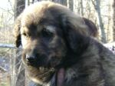 |  | 1 of 6 | F | 7wks |  |  | Blk/tan |  |  | 12lbs |  | 2/23/08 |  | 02/23/08 |  | 02/23/08  03/10/08 |  |  |  | 02/23/08  03/10/08 |  |  |  | Too young |  |  |  | Albon as preventative
R- |  | 2 of 6 | F | 7wks |  |  | Brindle |  |  | 10lbs |  | 2/23/08 |  | 02/23/08 |  | 02/23/08  03/10/08 |  |  |  | 02/23/08  03/10/08 |  |  |  | Too young |  |  |  | Albon as preventative
R-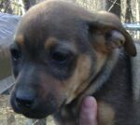 |  | 3 of 6 | F | 7wks |  |  | Blk/tan |  |  | 10 lbs |  | 2/23/08 |  | 02/23/08 |  | 02/23/08  03/10/08 |  |  |  | 02/23/08  03/10/08 |  |  |  | Too young |  |  |  | Albon as preventative
R-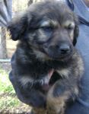 |  | 4 of 6 | M | 7wks |  |  | Blk/tan |  |  | 12lbs |  | 2/23/08 |  | 02/23/08 |  | 02/23/08  03/10/08 |  |  |  | 02/23/08  03/10/08 |  |  |  | Too young |  |  |  | Albon as preventative
R- |  | 5 of 6 | M | 7wks |  |  | Blk/white |  |  | 11lbs |  | 2/23/08 |  | 02/23/08 |  | 02/23/08  03/10/08 |  |  |  | 02/23/08  03/10/08 |  |  |  | Too young |  |  |  | Albon as preventative
 |  | 6 of 6 | M | 7wks |  |  | Tan/Blk |  |  |  |  | 2/23/08 |  | 02/23/08 |  | 02/23/08  03/10/08 |  |  |  | 02/23/08  03/10/08 |  |  |  | Too young |  |  |  | Albon as preventative
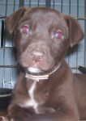 | 3/18/08 | 1 of 1 | 1 | M |  |  | 7W |  |  | CHOC. |  | 5 LBS |  |  |  | TOO YOUNG |  | 3/18/08 |  |  |  |  |  | 3/18/08 |  |  |  | TOO YOUNG FOR RV |  | STRONGID/DRONTAL
TOTAL # PUPS : |  | 4 |  |  |  |  |  |  |  |  |  |  |  | DATE PREPARED: |  |  |  | 20 April 2008
TOTAL # DOGS: |  |  |  |  |  |  |  |  |  |  |  |  |  | NSAL ADMIT DATE:
# OF CARRIERS USED: |  | 1 |  |  |  |  |  |  |  |  |  |  |  | NAME, ADDRESS, PHONE, EMAIL AND WEBSITE OF SHELTER, ANIMAL CONTROL, OR RESCUE GROUP ORIGINATING FROM: |  |  |  |  |  | Brazoria County Sheriff's Office Animal Control
cc: Data Entry, Grooming, Shelter Medical, Med. Ctr. Mgr., |  |  |  |  |  |  |  |  |  |  |  |  |  | NAME, ADDRESS, PHONE, EMAIL OF PERSON FILLING OUT THIS FORM:
ORIGINAL COPY: W. McColgan
 |  | IF ADULT DOG PUT Receiving Facility OR ADOPTING PARTY Name, Address, Phone, email, website (PO Box unacceptable) in this column |  |  |  |  |  |  |  |  |  |  |  | VAX DATES  11 Feb 08 |  | VAX DATES  25 Feb 08 |  | VAX DATES  10? Mar 08
 |  | OR |  |  |  |  |  |  |  |  |  |  |  | STATE IF TOO YOUNG |  | STATE IF TOO YOUNG |  | STATE IF TOO YOUNG |  |  |  |  |  | STATE IF TOO YOUNG FOR RABIES
NSAL ADOPTION  NUMBER | SHELTER OR RESCUE ADMIT  DATE | #PUPS IN LITTER | SEX | AGE |  |  | COLOR |  |  | WEIGHT  15-25 lbs |  | FLEA DIP DATE |  | BORD. |  | DHL2PP |  | DM |  | WORMING DATE(S)  strongid |  |  |  | FECAL RESULTS, RABIES,MEDICAL, ETC. |  |  |  | OTHER TREATMENTS,COXIDIA, ETC WITH ALBON LIQUID
COPY AND PASTE PICTURE IN THIS COLUMN | 29 Dec 07 | 4 | 1m  3f | 11 wks |  |  | 6 black  1 brown |  |  | 15-20 lbs |  | Advantage  Next week |  | Next week |  | 4 boosters each as of next wk |  |  |  | 2-26-08  3-05-08  3-19-08  3-27-08 |  |  |  | Rabies next week, followup fecal same time
R-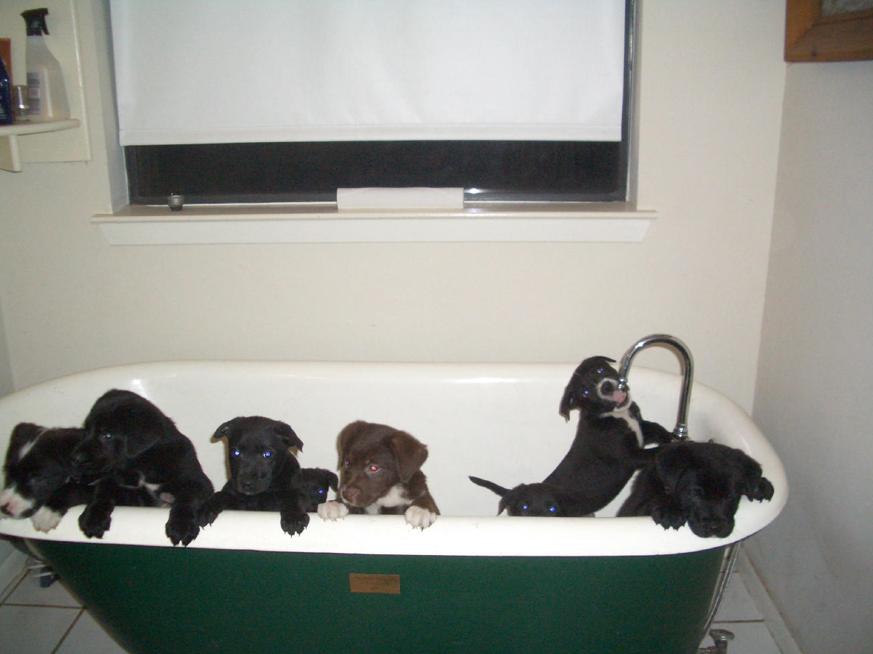
TOTAL # PUPS : | 5 |  |  |  |  |  |  |  |  |  |  |  |  | DATE PREPARED: |  | 3/9/08
TOTAL # DOGS: | 0 |  |  |  |  |  |  |  |  |  |  |  |  | NSAL ADMIT DATE:
# OF CARRIERS USED: | Whatever fits |  |  |  |  |  |  |  |  |  |  |  |  | NAME, ADDRESS, PHONE, EMAIL AND WEBSITE OF SHELTER, ANIMAL CONTROL, OR RESCUE GROUP ORIGINATING FROM:
cc: Data Entry, Grooming, Shelter Medical, Med. Ctr. Mgr., |  |  |  |  |  |  |  |  |  |  |  |  |  | NAME, ADDRESS, PHONE, EMAIL OF PERSON FILLING OUT THIS FORM:
ORIGINAL COPY: W. McColgan
 |  | IF ADULT DOG PUT Receiving Facility OR ADOPTING PARTY Name, Address, Phone, email, website (PO Box unacceptable) in this column |  |  |  |  |  |  |  |  |  |  |  | VAX DATES |  | VAX DATES |  | VAX DATES
 |  | OR |  |  |  |  |  |  |  |  |  |  |  | STATE IF TOO YOUNG |  | STATE IF TOO YOUNG |  | STATE IF TOO YOUNG |  |  |  |  |  | STATE IF TOO YOUNG FOR RABIES
NSAL ADOPTION  NUMBER | SHELTER OR RESCUE ADMIT  DATE | #PUPS IN LITTER | SEX | AGE |  |  | COLOR |  |  | WEIGHT |  | FLEA DIP DATE |  | BORD. |  | DHL2PP |  | DM |  | WORMING DATE(S) |  |  |  | FECAL RESULTS, RABIES,MEDICAL, ETC. |  |  |  | OTHER TREATMENTS,COXIDIA, ETC WITH ALBON LIQUID
COPY AND PASTE PICTURE IN THIS COLUMN
R-BW COOPER Church #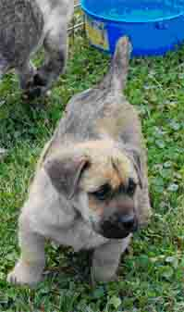1 | 2/15 | 5 | M | 8 wks |  |  | Tan/Grey |  |  | 12 |  | n/a |  | 2/18 |  | 2/18  3/28 |  |  |  | 2/18  3/28 |  |  |  | Treated 2/18 |  |  |  | Ivermectin and antibiotics for Skin last treatment 3/9 MUCH improvement  Getting 2nd set of shots tomorrow 3/10
R-BW COOPER Church #2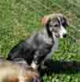 | 2/15 | 5 | M | 8 wks |  |  | Blk/Brown/White |  |  | 18 |  | n/a |  | 2/18 |  | 2/18  3/28 |  |  |  | 2/18  3/28 |  |  |  | Treated 2/18 |  |  |  | Ivermectin and antibiotics for Skin last treatment 3/9 MUCH improvement  Getting 2nd set of shots tomorrow 3/10
R-BW COOPER Church #3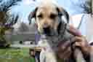 | 2/15 | 5 | M | 8 wks |  |  | Tan |  |  | 16 |  | n/a |  | 2/18 |  | 2/18  3/28 |  |  |  | 2/18  3/28 |  |  |  | Treated 2/18 |  |  |  | Ivermectin and antibiotics for Skin last treatment 3/9 MUCH improvement  Getting 2nd set of shots tomorrow 3/10
R-BW COOPER Church #4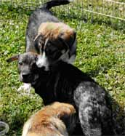 | 2/15 | 5 | M | 8 wks |  |  | Blk/Tan/White |  |  | 15 |  | n/a |  | 2/18 |  | 2/18  3/28 |  |  |  | 2/18 |  |  |  | Treated 2/18 |  |  |  | Ivermectin and antibiotics for Skin last treatment 3/9 MUCH improvement  Getting 2nd set of shots tomorrow 3/10
R-BW COOPER Church #5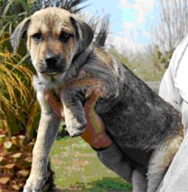 | 2/15 | 5 | M | 8 wks |  |  | Tan |  |  | 16 |  | n/a |  | 2/18 |  | 2/18  3/28 |  |  |  | 2/18  3/28 |  |  |  | Treated 2/18 |  |  |  | Ivermectin and antibiotics for Skin last treatment 3/9 MUCH improvement  Getting 2nd set of shots tomorrow 3/10
TOTAL # PUPS : |  | 2 |  |  |  |  |  |  |  |  |  |  |  | DATE PREPARED:
TOTAL # DOGS: |  |  |  |  |  |  |  |  |  |  |  |  |  | NSAL ADMIT DATE:
# OF CARRIERS USED: |  | 2 |  |  |  |  |  |  |  |  |  |  |  | NAME, ADDRESS, PHONE, EMAIL AND WEBSITE OF SHELTER, ANIMAL CONTROL, OR RESCUE GROUP ORIGINATING FROM: |  |  |  | East Baton Rouge Parish Animal Control |  |  |  |  |  | http://www.brgov.com/dept/animal/
cc: Data Entry, Grooming, Shelter Medical, Med. Ctr. Mgr., |  |  |  |  |  |  |  |  |  |  |  |  |  | NAME, ADDRESS, PHONE, EMAIL OF PERSON FILLING OUT THIS FORM:
ORIGINAL COPY: W. McColgan
 |  | IF ADULT DOG PUT Receiving Facility OR ADOPTING PARTY Name, Address, Phone, email, website (PO Box unacceptable) in this column |  |  |  |  |  |  |  |  |  |  |  | VAX DATES |  | VAX DATES |  | VAX DATES
 |  | OR |  |  |  |  |  |  |  |  |  |  |  | STATE IF TOO YOUNG |  | STATE IF TOO YOUNG |  | STATE IF TOO YOUNG |  |  |  |  |  | STATE IF TOO YOUNG FOR RABIES
NSAL ADOPTION  NUMBER | SHELTER OR RESCUE ADMIT  DATE | #PUPS IN LITTER | SEX | AGE |  |  | COLOR |  |  | WEIGHT |  | FLEA DIP DATE |  | BORD. |  | DHL2PP |  | DM |  | WORMING DATE(S) |  |  |  | FECAL RESULTS, RABIES,MEDICAL, ETC. |  |  |  | OTHER TREATMENTS,COXIDIA, ETC WITH ALBON LIQUID
COPY AND PASTE PICTURE IN THIS COLUMN
R-
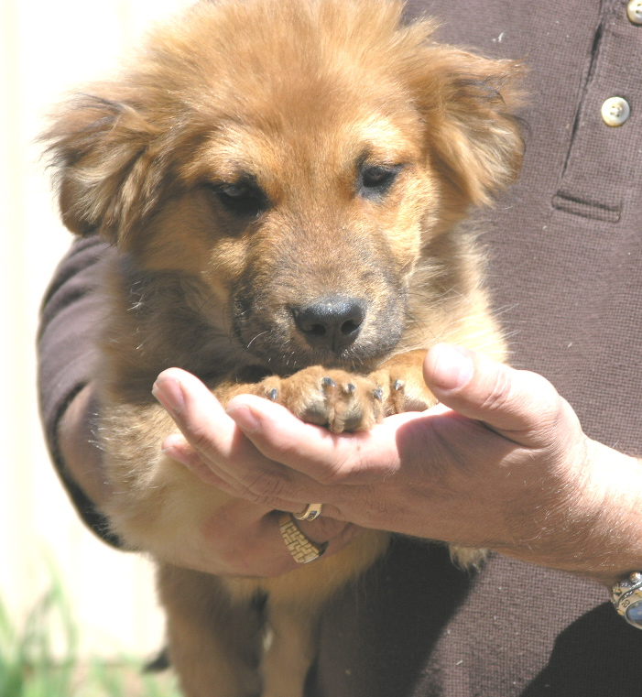 | 02/12/08 | 2 | M | 12 wks. |  |  | Brown |  |  | 13 lbs. |  | 2/12, 3/12 |  |  |  | 2/18 |  |  |  | 2/12, 2/19,  (Interceptor)
R-
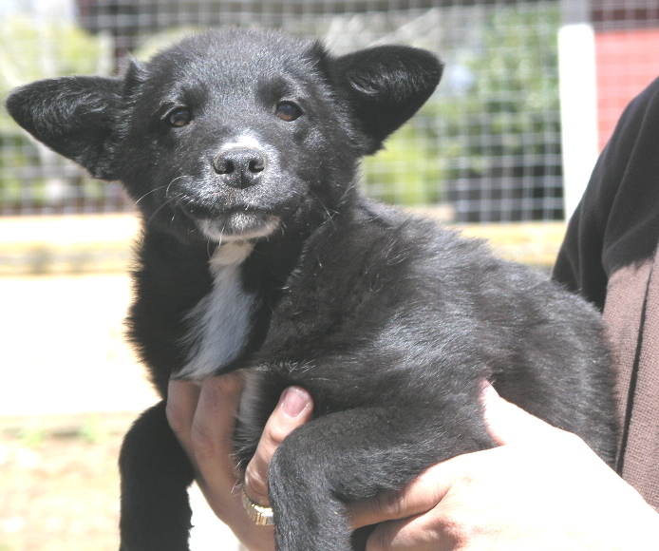 | 02/12/08 | 2 | F | 12 wks. |  |  | Black w/white |  |  | 13 lbs. |  | 2/12, 3/12 |  |  |  | 2/18 |  |  |  | 2/12, 2/19  (Interceptor)
TOTAL # PUPS : |  |  |  |  |  |  |  |  |  |  |  |  |  | DATE PREPARED:  3-12-08
TOTAL # DOGS:  1 ADULT,  NAME: CHANCE |  |  |  |  |  |  |  |  |  |  |  |  |  | NSAL ADMIT DATE:
# OF CARRIERS USED: |  |  |  |  |  |  |  |  |  |  |  |  |  | NAME, ADDRESS, PHONE, EMAIL AND WEBSITE OF SHELTER, ANIMAL CONTROL, OR RESCUE GROUP ORIGINATING FROM:  st. martin parish animal control
cc: Data Entry, Grooming, Shelter Medical, Med. Ctr. Mgr., |  |  |  |  |  |  |  |  |  |  |  |  |  | NAME, ADDRESS, PHONE, EMAIL OF PERSON FILLING OUT THIS FORM:
ORIGINAL COPY: W. McColgan
 |  | IF ADULT DOG PUT Receiving Facility OR ADOPTING PARTY Name, Address, Phone, email, website (PO Box unacceptable) in this column  Jill tuffley  201 Osgood hill rd.,  essex jct., vt 05452  802-872-1867 802598-4354  [jillmckenzie2004@yahoo.com] |  |  |  |  |  |  |  |  |  |  |  | VAX DATES |  | VAX DATES |  | VAX DATES
 |  | OR |  |  |  |  |  |  |  |  |  |  |  | STATE IF TOO YOUNG |  | STATE IF TOO YOUNG |  | STATE IF TOO YOUNG |  |  |  |  |  | STATE IF TOO YOUNG FOR RABIES
NSAL ADOPTION  NUMBER | SHELTER OR RESCUE ADMIT  DATE  2 months | #PUPS IN LITTER | SEX  MALE | AGE  ABOUT  4 YEARS |  |  | COLOR  BRINDLE |  |  | WEIGHT  ABOUT  90 LBS. |  | FLEA DIP DATE |  | BORD. |  | DHL2PP |  | DM |  | WORMING DATE(S) |  |  |  | FECAL RESULTS, RABIES,MEDICAL, ETC. |  |  |  | OTHER TREATMENTS,COXIDIA, ETC WITH ALBON LIQUID
COPY AND PASTE PICTURE IN THIS COLUMN
R-  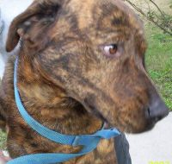  R-Chance | Jones Creek Animal Hosp.  1/08-3/08  for HW TX;  St. Martin AC  For 2 mths prior  Id: 366839  Fran Borge0 pulled from St Martin Parish ACOs |  | M/N | Est.4yrs |  |  | Brindle |  |  | 66.2# |  | Monthly tx w/ TopSpotPlus  Last done 3/3/08 |  | 1/18/08  TRANSPORT COSTS PRE PAID |  | 1/18/08 |  | N/A |  | HeartgardPlus  Monthly  Last given 3/3/08 |  |  |  | 3 yr Rabies  given 1/9/08 |  |  |  | Immiticide split tx  B/t 1/17-2/12/08;  Praziquantel for tapes 2/14/08;  Clindamycin for kennel cough 2/28/08(no cough in over 9 days)  Neutered 3/12/08
TOTAL # PUPS : |  | 0 |  |  |  |  |  |  |  |  |  |  |  |  | DATE PREPARED: |  |  |  | 3/13/08
TOTAL # DOGS: |  | 1 |  |  |  |  |  |  |  |  |  |  |  |  | NSAL ADMIT DATE:
# OF CARRIERS USED: |  | 1 |  |  |  |  |  |  |  |  |  |  |  |  | NAME, ADDRESS, PHONE, EMAIL AND WEBSITE OF SHELTER, ANIMAL CONTROL, OR RESCUE GROUP ORIGINATING FROM: |  |  |  | Jones Creek Animal Hospital
cc: Data Entry, Grooming, Shelter Medical, Med. Ctr. Mgr., |  |  |  |  |  |  |  |  |  |  |  |  |  |  | NAME, ADDRESS, PHONE, EMAIL OF PERSON FILLING OUT THIS FORM:
ORIGINAL COPY: W. McColgan
 |  | IF ADULT DOG PUT Receiving Facility OR ADOPTING PARTY Name, Address, Phone, email, website (PO Box unacceptable) in this column |  |  |  |  |  |  |  |  |  |  |  |  | VAX DATES |  | VAX DATES |  | VAX DATES
 |  | OR |  |  |  |  |  |  |  |  |  |  |  |  | STATE IF TOO YOUNG |  | STATE IF TOO YOUNG |  | STATE IF TOO YOUNG |  |  |  |  |  |  |  | STATE IF TOO YOUNG FOR RABIES
NSAL ADOPTION  NUMBER | SHELTER OR RESCUE ADMIT  DATE | #PUPS IN LITTER | SEX |  | AGE |  |  |  | COLOR |  | WEIGHT |  | FLEA DIP DATE |  | BORD. |  | DHL2PP |  | DM |  | WORMING DATE(S) |  |  |  |  |  | FECAL RESULTS, RABIES,MEDICAL, ETC. |  | OTHER TREATMENTS,COXIDIA, ETC WITH ALBON LIQUID
COPY AND PASTE PICTURE IN THIS 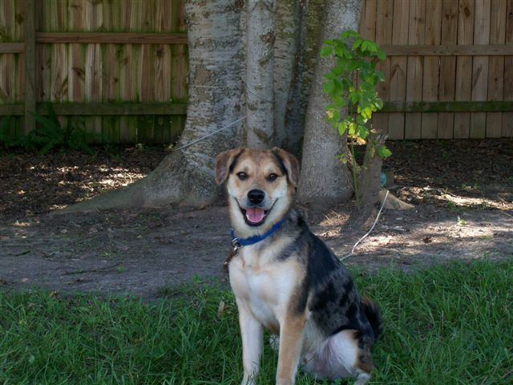COLUMN | Jones Creek  Animal Hosp.  12/06 – 3/08 |  | M/N |  | 3 yr |  |  |  | Black & Tan |  | 55# |  | Monthly tx w/ TopSpotPlus  Last done 3/03/08 |  | 1/3/08  TRANSPORT COSTS PRE PAID |  | 1/3/08 |  | N/A |  | HeartgardPlus  Monthly  Last given 3/3/08 |  |  |  |  |  | 3 yr Rabies  given 1/3/08 |  | Fecal/occult neg  1/3/08
TOTAL # PUPS : | 0 |  |  |  |  |  |  |  |  |  |  |  |  | DATE PREPARED: |  | 3-27-2008
TOTAL # DOGS: | 1 |  |  |  |  |  |  |  |  |  |  |  |  | NSAL ADMIT DATE:
# OF CARRIERS USED: | 1 |  |  |  |  |  |  |  |  |  |  |  |  | NAME, ADDRESS, PHONE, EMAIL AND WEBSITE OF SHELTER, ANIMAL CONTROL, OR RESCUE GROUP ORIGINATING FROM:
cc: Data Entry, Grooming, Shelter Medical, Med. Ctr. Mgr., |  | Been groomed, vac., and medicated for skin allergies and infection.  Heartworm Positive |  |  |  |  |  |  |  |  |  |  |  | NAME, ADDRESS, PHONE, EMAIL OF PERSON FILLING OUT THIS FORM:
ORIGINAL COPY: W. McColgan
 |  | IF ADULT DOG PUT Receiving Facility OR ADOPTING PARTY Name, Address, Phone, email, website (PO Box unacceptable) in this column |  |  |  |  |  |  |  |  |  |  |  | VAX DATES  3-27-2008 DA2PLCPV |  | VAX DATES |  | VAX DATES |  | Rabies  3-27-2008
 |  | OR |  |  |  |  |  |  |  |  |  |  |  | STATE IF TOO YOUNG |  | STATE IF TOO YOUNG |  | STATE IF TOO YOUNG |  |  |  |  |  | STATE IF TOO YOUNG FOR RABIES
NSAL ADOPTION  NUMBER | SHELTER OR RESCUE ADMIT  DATE | #PUPS IN LITTER | SEX | AGE |  |  | COLOR |  |  | WEIGHT |  | FLEA DIP DATE |  | BORD. |  | DHL2PP |  | DM |  | WORMING DATE(S) |  |  |  | FECAL RESULTS, RABIES,MEDICAL, ETC.
COPY AND PASTE PICTURE IN THIS COLUMN |  |  | Female | 2 years |  |  | white |  |  | 77  pounds |  |  |  |  |  |  |  |  |  | De-wormed  Panacur 3 days  3-25—27-2008 |  |  |  | Shaved and Medicated bath  3-25-2008
R-JANIE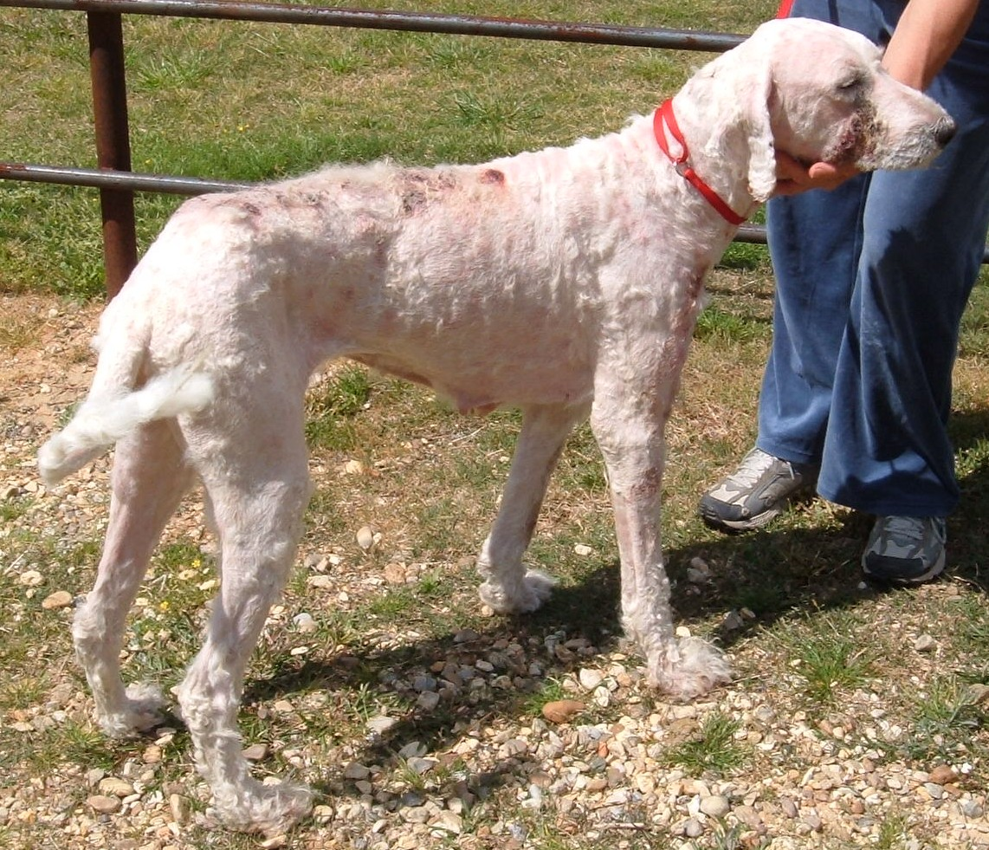
TOTAL # PUPS : |  |  |  |  |  |  |  |  |  |  |  |  |  | DATE PREPARED: |  |  |  | 3/31/2008
TOTAL # DOGS: |  | 5 |  |  |  |  |  |  |  |  |  |  |  | NSAL ADMIT DATE:
# OF CARRIERS USED: |  | 5 |  |  |  |  |  |  |  |  |  |  |  | NAME, ADDRESS, PHONE, EMAIL AND WEBSITE OF SHELTER, ANIMAL CONTROL, OR RESCUE GROUP ORIGINATING FROM:
cc: Data Entry, Grooming, Shelter Medical, Med. Ctr. Mgr., |  |  |  |  |  |  |  |  |  |  |  |  |  | NAME, ADDRESS, PHONE, EMAIL OF PERSON FILLING OUT THIS FORM:
ORIGINAL COPY: W. McColgan
 |  | IF ADULT DOG PUT Receiving Facility OR ADOPTING PARTY Name, Address, Phone, email, website (PO Box unacceptable) in this column |  |  |  |  |  |  |  |  |  |  |  | VAX DATES |  | VAX DATES |  | VAX DATES
 |  | OR |  |  |  |  |  |  |  |  |  |  |  | STATE IF TOO YOUNG |  | STATE IF TOO YOUNG |  | STATE IF TOO YOUNG |  |  |  |  | STATE IF TOO YOUNG FOR RABIES
NSAL ADOPTION  NUMBER | SHELTER OR RESCUE ADMIT  DATE | #PUPS IN LITTER | SEX |  |  | AGE |  | COLOR |  | WEIGHT |  | FLEA DIP DATE |  | BORD. |  | DHL2PP |  | DM |  |  |  | WORMING DATE(S) |  |  |  | FECAL RESULTS, RABIES,MEDICAL, ETC. |  | OTHER TREATMENTS,COXIDIA, ETC WITH ALBON LIQUID
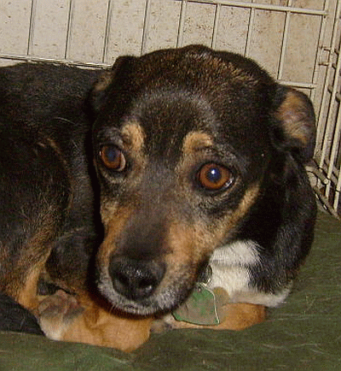 | 8/20/2007  Rosco |  | Male |  |  | 2 ½ years |  | Blk/Tan |  | 18 lbs |  | 3/11/2008 |  | 3/31/2008 |  | 8/29/2007 |  |  |  |  |  | 3/31/2008
R-
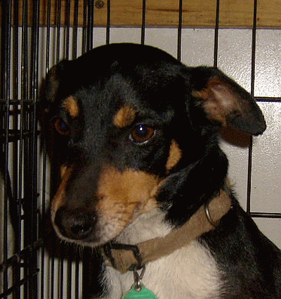 | 3/5/2008  Cain |  | Male |  |  | 3 years |  | Tri-Color |  | 16 lbs |  | 3/11/2008 |  | 3/10/2008 |  | 3/10/2008 |  |  |  |  |  | 3/31/2008
R-
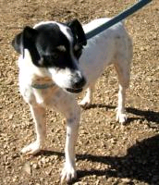 | 7/3/2007  Phoebe |  | Female |  |  | 4 years |  | Blk/Wht |  | 14 lbs |  | 3/11/2008 |  | 3/31/2008 |  | 7/3/2007 |  |  |  |  |  | 3/31/2008
R-
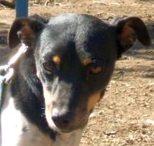 | 12/12/2007  Pennie |  | Female |  |  | 2 years |  | Tri-Color |  | 20 lbs |  | 3/31/2008 |  | 12/12/2007 |  | 12/12/2007 |  |  |  |  |  | 3/31/2008
R-  | 2/16/2008  J.J. |  | Male |  |  | 5 years |  | Blk/Tan |  | 24 lbs |  | 3/31/2008 |  | 3/20/2008 |  | 3/20/2008 |  |  |  |  |  | 3/31/2008
R-

