Katrina Lifeline Database
Please fill out carefully and completely!
Total Number of Puppies:15
Total Number of Adult Dogs:19
Total Number of Carriers/Crates Used:
Date Prepared:04-20-2009
Your Information - Person completing this form
Name:
Address:
Phone number:
Email:
Sending Shelter/Organization Information - Where were the animal(s) taken from?
Name:
Address:
Phone number:
Email:
Website:
Receiving Shelter/Organization Information - Where are the animal(s) going?
Note: if going to North Shore Animal League leave this part blank
Name:
Address:
Phone Number:
Email:
Website:
Puppy or Dog Information
#1
Morrell |  | 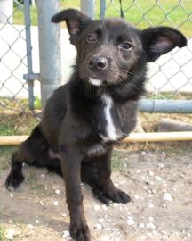
NSAL Adoption Number: |  | WO-04-11-08
Shelter/Rescue Admit Date: |  | 04-11-09
Number of Pups in Litter: |  | 0
Sex: |  | M
Age: |  | 5 months
Color: |  | Black/White
Weight: |  | 16 lb
Flea Dip Date:
Worming Date(s): |  | 04-11-09
(State if too young) | Bordatella Vacc Date: | 04-11-09
(State if too young) | DHLPP Vacc Date: | 04-11-09
(State if too young) | Rabies Vacc Date: | 04-20-09
Other Treatments or Notes:
#3
Dante |  | 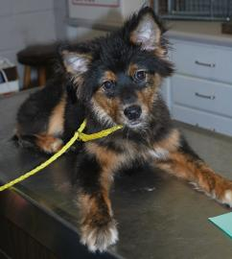
NSAL Adoption Number: |  | WO-04-11-07
Shelter/Rescue Admit Date: |  | 04-11-09
Number of Pups in Litter: |  | 0
Sex: |  | Male
Age: |  | 4 months
Color: |  | Black/ Brown
Weight: |  | 13 lbs
Flea Dip Date:
Worming Date(s): |  | 04-11-07
(State if too young) | Bordatella Vacc Date: | 04-11-07
(State if too young) | DHLPP Vacc Date: | 04-11-07
(State if too young) | Rabies Vacc Date: | 04-20-09
Other Treatments or Notes:
#4
Freida |  | 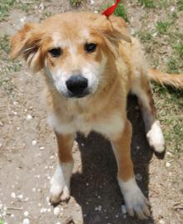
NSAL Adoption Number: |  | BT-03-23-02
Shelter/Rescue Admit Date: |  | 03-23-09
Number of Pups in Litter: |  | 0
Sex: |  | F
Age: |  | 4 months
Color: |  | Brown/ White
Weight: |  | 23 lbs
Flea Dip Date:
Worming Date(s): |  | 03-23-09
(State if too young) | Bordatella Vacc Date: | 03-23-09
(State if too young) | DHLPP Vacc Date: | 03-23-09
(State if too young) | Rabies Vacc Date: | 04-20-09
Other Treatments or Notes:
#5
Ted |  | 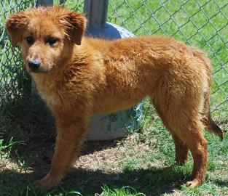
NSAL Adoption Number: |  | BT-03-23-07
Shelter/Rescue Admit Date: |  | 03-23-09
Number of Pups in Litter: |  | 0
Sex: |  | M
Age: |  | 4 months
Color: |  | Red
Weight: |  | 20 lbs
Flea Dip Date:
Worming Date(s): |  | 03-23-09
(State if too young) | Bordatella Vacc Date: | 03-23-09
(State if too young) | DHLPP Vacc Date: | 03-23-09
(State if too young) | Rabies Vacc Date: | 04-20-09
Other Treatments or Notes:
#6
Thaddeus |  | 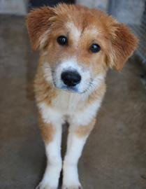
NSAL Adoption Number: |  | BT-03-23-08
Shelter/Rescue Admit Date: |  | 03-23-09
Number of Pups in Litter: |  | 0
Sex: |  | M
Age: |  | 4 months
Color: |  | Red/White
Weight: |  | 20 lbs
Flea Dip Date:
Worming Date(s): |  | 03-23-09
(State if too young) | Bordatella Vacc Date: | 03-23-09
(State if too young) | DHLPP Vacc Date: | 03-23-09
(State if too young) | Rabies Vacc Date: | 04-20-09
Other Treatments or Notes:
#7
Jadi |  | 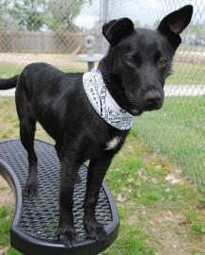
NSAL Adoption Number: |  | WO-03-16-07
Shelter/Rescue Admit Date: |  | 03-16-09
Number of Pups in Litter: |  | 0
Sex: |  | F
Age: |  | F
Color: |  | Black/White
Weight: |  | 16 lbs
Flea Dip Date:
Worming Date(s): |  | 03-16-09
(State if too young) | Bordatella Vacc Date: | 03-16-09
(State if too young) | DHLPP Vacc Date: | 03-16-09
(State if too young) | Rabies Vacc Date: | 04-20-09
Other Treatments or Notes:
#8
BJ |  | 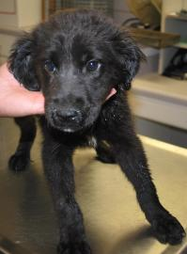
NSAL Adoption Number: |  | WO-03-30-10
Shelter/Rescue Admit Date: |  | 03-30-09
Number of Pups in Litter: |  | 0
Sex: |  | M
Age: |  | 2 months
Color: |  | Black/White
Weight: |  | 13
Flea Dip Date:
Worming Date(s): |  | 03-30-09
(State if too young) | Bordatella Vacc Date: | 03-30-09
(State if too young) | DHLPP Vacc Date: | 03-30-09
(State if too young) | Rabies Vacc Date: | 04-20-09
Other Treatments or Notes:
#9
Lily |  | 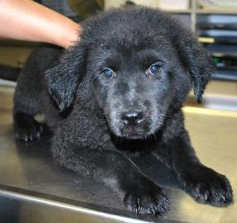
NSAL Adoption Number: |  | RC-03-27-09
Shelter/Rescue Admit Date: |  | 03-27-09
Number of Pups in Litter: |  | 0
Sex: |  | F
Age: |  | 3 months
Color: |  | Black
Weight: |  | 13 lbs
Flea Dip Date:
Worming Date(s): |  | 03-27-09
 | Bordatella Vacc Date: | 03-27-09
 | DHLPP Vacc Date: | 03-27-09
 | Rabies Vacc Date: | 04-20-09
Other Treatments or Notes:
#10
Destiny |  | 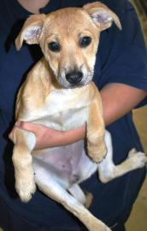
NSAL Adoption Number: |  | WO-04-09-05
Shelter/Rescue Admit Date: |  | 04-09-05
Number of Pups in Litter: |  | 0
Sex: |  | F
Age: |  | 3 months
Color: |  | Tan
Weight: |  | 16 lbs
Flea Dip Date:
Worming Date(s):
(State if too young) | Bordatella Vacc Date: | 04-09-05
(State if too young) | DHLPP Vacc Date: | 04-09-05
(State if too young) | Rabies Vacc Date: | 04-09-05
Other Treatments or Notes:
#11
Tessa |  | 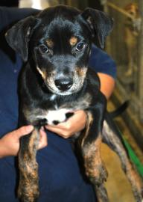
NSAL Adoption Number: |  | RC-04-01-07
Shelter/Rescue Admit Date: |  | 04-01-09
Number of Pups in Litter: |  | 0
Sex: |  | F
Age: |  | 3 months
Color: |  | Black/White
Weight: |  | 14 lbs
Flea Dip Date:
Worming Date(s): |  | 04-01-09
(State if too young) | Bordatella Vacc Date: | 04-01-09
(State if too young) | DHLPP Vacc Date: | 04-01-09
(State if too young) | Rabies Vacc Date: | 04-20-09
Other Treatments or Notes:
#12
Brownie |  | 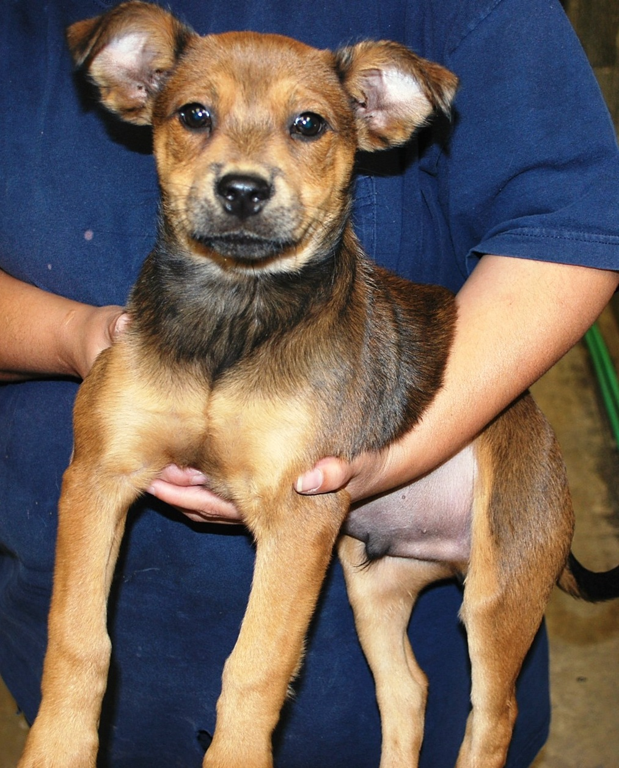
NSAL Adoption Number: |  | RC-04-13-05
Shelter/Rescue Admit Date: |  | 04-13-09
Number of Pups in Litter: |  | 0
Sex: |  | Male
Age: |  | 3 months
Color: |  | Brown/Black
Weight: |  | 14 lbs
Flea Dip Date:
Worming Date(s): |  | 04-13-09
(State if too young) | Bordatella Vacc Date: | 04-13-09
(State if too young) | DHLPP Vacc Date: | 04-13-09
(State if too young) | Rabies Vacc Date: | 04-20-09
Other Treatments or Notes:

Puppy or Dog Information
#13
Rat |  |  |  |  |  | 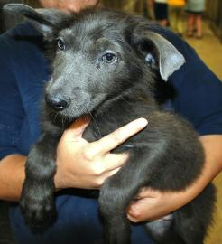
NSAL Adoption Number: |  |  |  |  |  | WO-03-19-05
Shelter/Rescue Admit Date: |  |  |  |  |  | 03-19-09
Number of Pups in Litter: |  |  |  |  |  | 0
Sex: |  |  |  |  |  | F
Age: |  |  |  |  |  | 3 months
Color: |  |  |  |  |  | Black/Grey
Weight: |  |  |  |  |  | 16 lbs
Flea Dip Date:
Worming Date(s): |  |  |  |  |  | 03-19-09
(State if too young) |  |  | Bordatella Vacc Date: |  |  | 03-19-09
 |  |  | DHLPP Vacc Date: |  |  | 03-19-09
 |  |  | Rabies Vacc Date: |  |  | 04-27-09
Other Treatments or Notes:
#14
Dory |  |  |  |  |  | 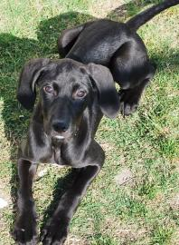
NSAL Adoption Number: |  |  |  |  |  | WO-03-19-02
Shelter/Rescue Admit Date: |  |  |  |  |  | 03-19-09
Number of Pups in Litter: |  |  |  |  |  | 0
Sex: |  |  |  |  |  | F
Age: |  |  |  |  |  | 3 months
Color: |  |  |  |  |  | Black
Weight: |  |  |  |  |  | 16.40 lbs
Flea Dip Date:
Worming Date(s): |  |  |  |  |  | 03-19-09
(State if too young) |  |  | Bordatella Vacc Date: |  |  | 03-19-09
 |  |  | DHLPP Vacc Date: |  |  | 03-19-09
 |  |  | Rabies Vacc Date: |  |  | 04-27-09
Other Treatments or Notes:
#15
Bella |  |  |  |  |  | 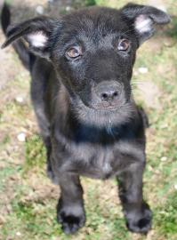
NSAL Adoption Number: |  |  |  |  |  | WO-03-19-06
Shelter/Rescue Admit Date: |  |  |  |  |  | 03-19-09
Number of Pups in Litter: |  |  |  |  |  | 0
Sex: |  |  |  |  |  | F
Age: |  |  |  |  |  | 3 months
Color: |  |  |  |  |  | Black
Weight: |  |  |  |  |  | 10.6 lbs
Flea Dip Date:
Worming Date(s): |  |  |  |  |  | 03-19-09
(State if too young) |  |  | Bordatella Vacc Date: |  |  | 03-19-09
 |  |  | DHLPP Vacc Date: |  |  | 03-19-09
 |  |  | Rabies Vacc Date: |  |  | 04-27-09
Other Treatments or Notes:
#16
Soldier |  |  |  |  |  | 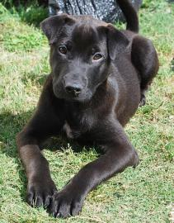
NSAL Adoption Number: |  |  |  |  |  | WO-03-23-08
Shelter/Rescue Admit Date: |  |  |  |  |  | 03-23-09
Number of Pups in Litter: |  |  |  |  |  | 0
Sex: |  |  |  |  |  | M
Age: |  |  |  |  |  | 3 months
Color: |  |  |  |  |  | Black
Weight: |  |  |  |  |  | 14.8 lbs
Flea Dip Date:
Worming Date(s): |  |  |  |  |  | 03-23-09
(State if too young) |  |  | Bordatella Vacc Date: |  |  | 03-23-09
 |  |  | DHLPP Vacc Date: |  |  | 03-23-09
 |  |  | Rabies Vacc Date: |  |  | 04-27-09
Other Treatments or Notes:
#17
Tess |  |  |  |  |  | 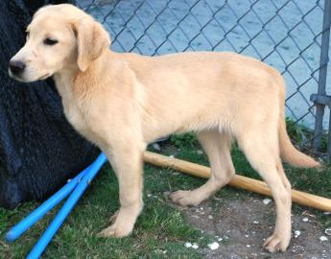
NSAL Adoption Number: |  |  |  |  |  | RO-04-01-06
Shelter/Rescue Admit Date: |  |  |  |  |  | 04-01-09
Number of Pups in Litter: |  |  |  |  |  | 0
Sex: |  |  |  |  |  | F
Age: |  |  |  |  |  | F
Color: |  |  |  |  |  | Tan
Weight: |  |  |  |  |  | 16.6 lbs
Flea Dip Date:
Worming Date(s): |  |  |  |  |  | 04-01-09
(State if too young) |  |  | Bordatella Vacc Date: |  |  | 04-01-09
 |  |  | DHLPP Vacc Date: |  |  | 04-01-09
 |  |  | Rabies Vacc Date: |  |  | 04-27-09
Other Treatments or Notes:
#18
Tiffany |  |  |  |  |  | 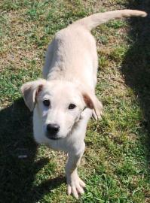
NSAL Adoption Number: |  |  |  |  |  | RO-04-01-04
Shelter/Rescue Admit Date: |  |  |  |  |  | 04-01-09
Number of Pups in Litter: |  |  |  |  |  | 0
Sex: |  |  |  |  |  | F
Age: |  |  |  |  |  | 3 months
Color: |  |  |  |  |  | Tan
Weight: |  |  |  |  |  | 15.6 lbs
Flea Dip Date:
Worming Date(s): |  |  |  |  |  | 04-01-09
(State if too young) |  |  | Bordatella Vacc Date: |  |  | 04-01-09
 |  |  | DHLPP Vacc Date: |  |  | 04-01-09
 |  |  | Rabies Vacc Date: |  |  | 04-27-09
Other Treatments or Notes:
#19
Tina |  |  |  |  |  | 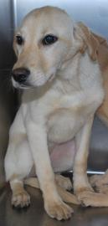
NSAL Adoption Number: |  |  |  |  |  | RO-04-01-03
Shelter/Rescue Admit Date: |  |  |  |  |  | 04-01-09
Number of Pups in Litter: |  |  |  |  |  | 04-01-09
Sex: |  |  |  |  |  | F
Age: |  |  |  |  |  | 3 months
Color: |  |  |  |  |  | Tan
Weight: |  |  |  |  |  | 17 lbs
Flea Dip Date:
Worming Date(s): |  |  |  |  |  | 04-01-09
(State if too young) |  |  | Bordatella Vacc Date |  |  | 04-01-09
 |  |  | DHLPP Vacc Date: |  |  | 04-01-09
 |  |  | Rabies Vacc Date: |  |  | 04-27-09
Other Treatments or Notes:
#20
Terry |  |  |  |  |  | 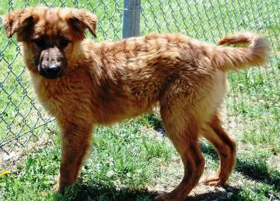
NSAL Adoption Number: |  |  |  |  |  | BT-03-23-04
Shelter/Rescue Admit Date: |  |  |  |  |  | 03-23-09
Number of Pups in Litter: |  |  |  |  |  | 0
Sex: |  |  |  |  |  | M
Age: |  |  |  |  |  | 4 months
Color: |  |  |  |  |  | Red
Weight: |  |  |  |  |  | 20 lbs
Flea Dip Date:
Worming Date(s): |  |  |  |  |  | 03-23-09
(State if too young) |  |  | Bordatella Vacc Date |  |  | 03-23-09
 |  |  | DHLPP Vacc Date: |  |  | 03-23-09
 |  |  | Rabies Vacc Date: |  |  | 04-27-09
Other Treatments or Notes:
#21
Toby |  |  |  |  |  | 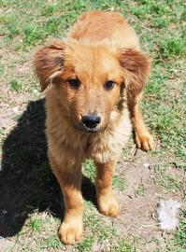
NSAL Adoption Number: |  |  |  |  |  | BT-03-23-05
Shelter/Rescue Admit Date: |  |  |  |  |  | 03-23-09
Number of Pups in Litter: |  |  |  |  |  | 0
Sex: |  |  |  |  |  | M
Age: |  |  |  |  |  | 4 months
Color: |  |  |  |  |  | Red
Weight: |  |  |  |  |  | 12.2 lbs
Flea Dip Date:
Worming Date(s): |  |  |  |  |  | 03-23-09
(State if too young) |  |  | Bordatella Vacc Date: |  |  | 03-23-09
 |  |  | DHLPP Vacc Date: |  |  | 03-23-09
 |  |  | Rabies Vacc Date: |  |  | 04-27-09
Other Treatments or Notes:
#22
Paste Photo Here → |  |  |  |  |  | 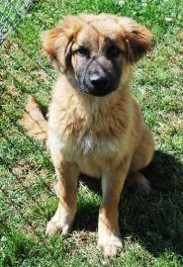
NSAL Adoption Number: |  |  |  |  |  | BT-03-23-03
Shelter/Rescue Admit Date: |  |  |  |  |  | 03-23-09
Number of Pups in Litter: |  |  |  |  |  | 0
Sex: |  |  |  |  |  | M
Age: |  |  |  |  |  | 4 months
Color: |  |  |  |  |  | Brown/White
Weight: |  |  |  |  |  | 22 lbs
Flea Dip Date:
Worming Date(s): |  |  |  |  |  | 03-23-09
(State if too young) |  |  | Bordatella Vacc Date: |  |  | 03-23-09
 |  |  | DHLPP Vacc Date: |  |  | 03-23-09
 |  |  | Rabies Vacc Date: |  |  | 04-27-09
Other Treatments or Notes:
Puppy or Dog Information
Pebbles
NSAL Adoption Number:
Shelter/Rescue Admit Date:
Number of Pups in Litter:
Sex:
Age:
Color:
Weight:
Flea Dip Date:
Worming Date(s):
(State if too young) |  | Bordatella Vacc Date:
 |  | DHLPP Vacc Date:
 |  | Rabies Vacc Date:
Other Treatments or Notes:
Diego |  |  |  |  | 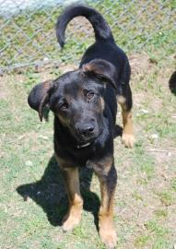
NSAL Adoption Number: |  |  |  |  | WO-03-24-01
Shelter/Rescue Admit Date: |  |  |  |  | 03-24-09
Number of Pups in Litter: |  |  |  |  | 0
Sex: |  |  |  |  | M
Age: |  |  |  |  | 4 mos
Color: |  |  |  |  | Black/Brown
Weight: |  |  |  |  | 20.2 lbs
Flea Dip Date:
Worming Date(s): |  |  |  |  | 03-24-09
(State if too young) |  | Bordatella Vacc Date: |  |  | 03-24-09
 |  | DHLPP Vacc Date: |  |  | 03-24-09
 |  | Rabies Vacc Date: |  |  | 04-27-09
Other Treatments or Notes:
#25
#26
Cosmo |  |  |  |  | 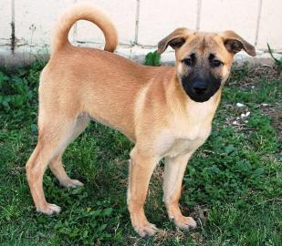
NSAL Adoption Number: |  |  |  |  | TB-03-24-07
Shelter/Rescue Admit Date: |  |  |  |  | 03-24-09
Number of Pups in Litter: |  |  |  |  | 0
Sex: |  |  |  |  | F
Age: |  |  |  |  | 2 mos
Color: |  |  |  |  | Tan/Black
Weight: |  |  |  |  | 7.2 lbs
Flea Dip Date:
Worming Date(s): |  |  |  |  | 03-24-09
(State if too young) |  | Bordatella Vacc Date: |  |  | 03-24-09
 |  | DHLPP Vacc Date: |  |  | 03-24-09
 |  | Rabies Vacc Date: |  |  | 04-27-09
Other Treatments or Notes:
#27
Milkshake |  |  |  |  | 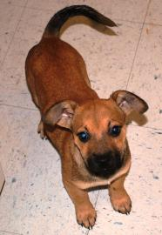
NSAL Adoption Number: |  |  |  |  | TB-03-24-08
Shelter/Rescue Admit Date: |  |  |  |  | 03-24-09
Number of Pups in Litter: |  |  |  |  | 0
Sex: |  |  |  |  | M
Age: |  |  |  |  | 2 mos
Color: |  |  |  |  | Tan/Black
Weight: |  |  |  |  | 10 lbs
Flea Dip Date:
Worming Date(s): |  |  |  |  | 03-24-09
(State if too young) |  | Bordatella Vacc Date: |  |  | 03-24-09
 |  | DHLPP Vacc Date: |  |  | 03-24-09
 |  | Rabies Vacc Date: |  |  | 04-27-09
Other Treatments or Notes:
#28
Sweetpea |  |  |  |  | 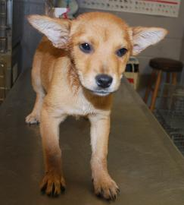
NSAL Adoption Number: |  |  |  |  | WO-03-14-03
Shelter/Rescue Admit Date: |  |  |  |  | 03-14-09
Number of Pups in Litter: |  |  |  |  | 0
Sex: |  |  |  |  | F
Age: |  |  |  |  | 2 mos
Color: |  |  |  |  | Tan
Weight: |  |  |  |  | 10.2 lbs
Flea Dip Date:
Worming Date(s): |  |  |  |  | 03-14-09
(State if too young) |  | Bordatella Vacc Date: |  |  | 03-14-09
 |  | DHLPP Vacc Date: |  |  | 03-14-09
 |  | Rabies Vacc Date: |  |  | 04-27-09
Other Treatments or Notes:
#29
Bandit |  |  |  |  | 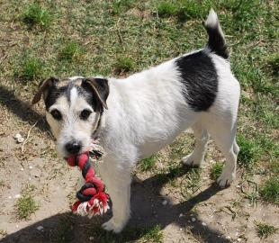
NSAL Adoption Number: |  |  |  |  | WO-04-06-06
Shelter/Rescue Admit Date: |  |  |  |  | 04-06-09
Number of Pups in Litter: |  |  |  |  | 0
Sex: |  |  |  |  | M
Age: |  |  |  |  | 8 yrs
Color: |  |  |  |  | White/Black/Brown
Weight: |  |  |  |  | 17.4 lbs
Flea Dip Date:
Worming Date(s): |  |  |  |  | 04-06-09
(State if too young) |  | Bordatella Vacc Date: |  |  | 04-06-09
 |  | DHLPP Vacc Date: |  |  | 04-06-09
 |  | Rabies Vacc Date: |  |  | 04-27-09
Other Treatments or Notes:
#30
Callie |  |  |  |  | 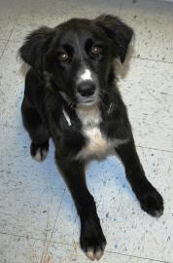
NSAL Adoption Number: |  |  |  |  | WO-03-31-03
Shelter/Rescue Admit Date: |  |  |  |  | 03-31-09
Number of Pups in Litter: |  |  |  |  | 0
Sex: |  |  |  |  | F
Age: |  |  |  |  | 4 mos
Color: |  |  |  |  | Black/White
Weight: |  |  |  |  | 21.4 lbs
Flea Dip Date:
Worming Date(s): |  |  |  |  | 03-31-09
(State if too young) |  | Bordatella Vacc Date: |  |  | 03-31-09
 |  | DHLPP Vacc Date: |  |  | 03-31-09
 |  | Rabies Vacc Date: |  |  | 04-27-09
Other Treatments or Notes:
#31
Tia |  |  |  |  | 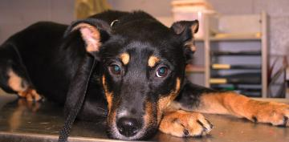
NSAL Adoption Number: |  |  |  |  | RC-03-24-01
Shelter/Rescue Admit Date: |  |  |  |  | 03-24-09
Number of Pups in Litter: |  |  |  |  | 0
Sex: |  |  |  |  | F
Age: |  |  |  |  | 4 mos
Color: |  |  |  |  | Black/Brown
Weight: |  |  |  |  | 24.6
Flea Dip Date:
Worming Date(s): |  |  |  |  | 03-24-09
(State if too young) |  | Bordatella Vacc Date: |  |  | 03-24-09
 |  | DHLPP Vacc Date: |  |  | 03-24-09
 |  | Rabies Vacc Date: |  |  | 04-27-09
Other Treatments or Notes:
#32
Taffy |  |  |  |  | 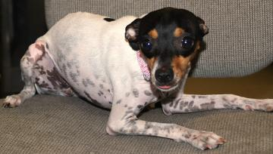
NSAL Adoption Number: |  |  |  |  | WO-04-18-05
Shelter/Rescue Admit Date: |  |  |  |  | 04-18-09
Number of Pups in Litter: |  |  |  |  | 0
Sex: |  |  |  |  | F
Age: |  |  |  |  | 1 year
Color: |  |  |  |  | White/Black
Weight: |  |  |  |  | 6.25 lbs
Flea Dip Date:
Worming Date(s): |  |  |  |  | 04-18-09
(State if too young) |  | Bordatella Vacc Date: |  |  | 04-18-09
 |  | DHLPP Vacc Date: |  |  | 04-18-09
 |  | Rabies Vacc Date: |  |  | 04-27-09
Other Treatments or Notes:
#33
Fe Fe |  |  |  |  | 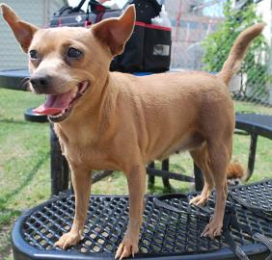
NSAL Adoption Number: |  |  |  |  | SS-03-31-01
Shelter/Rescue Admit Date: |  |  |  |  | 03-31-09
Number of Pups in Litter: |  |  |  |  | 0
Sex: |  |  |  |  | F
Age: |  |  |  |  | 8 yrs
Color: |  |  |  |  | Tan
Weight: |  |  |  |  | 15 lbs
Flea Dip Date:
Worming Date(s): |  |  |  |  | 03-31-09
(State if too young) |  | Bordatella Vacc Date: |  |  | 03-31-09
 |  | DHLPP Vacc Date: |  |  | 03-31-09
 |  | Rabies Vacc Date: |  |  | 04-27-09
Other Treatments or Notes:
#34
Coco |  |  |  |  | 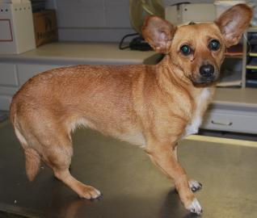
NSAL Adoption Number: |  |  |  |  | WO-04-14-27
Shelter/Rescue Admit Date: |  |  |  |  | 04-14-09
Number of Pups in Litter: |  |  |  |  | 0
Sex: |  |  |  |  | F
Age: |  |  |  |  | 1y11m
Color: |  |  |  |  | Tan/White
Weight: |  |  |  |  | 13 lbs
Flea Dip Date:
Worming Date(s): |  |  |  |  | 04-14-09
(State if too young) |  | Bordatella Vacc Date: |  |  | 04-14-09
 |  | DHLPP Vacc Date: |  |  | 04-14-09
 |  | Rabies Vacc Date: |  |  | 04-27-09
Other Treatments or Notes:
Katrina Lifeline Database
Please fill out carefully and completely!
Total Number of Puppies: 4
Total Number of Adult Dogs: 2
Total Number of Carriers/Crates Used: 3
Date Prepared: April 10, 2009
Your Information - Person completing this form
Name:
Address:
Phone number:
Email:
Sending Shelter/Organization Information - Where were the animal(s) taken from?
Name:
Address:
Phone number:
Email:
Website:
Receiving Shelter/Organization Information - Where are the animal(s) going?
Note: if going to North Shore Animal League leave this part blank
Name:
Address:
Phone Number:
Email:
Website:
Puppy or Dog Information
#35
Paste Photo Here → |  |  |  |  |  | 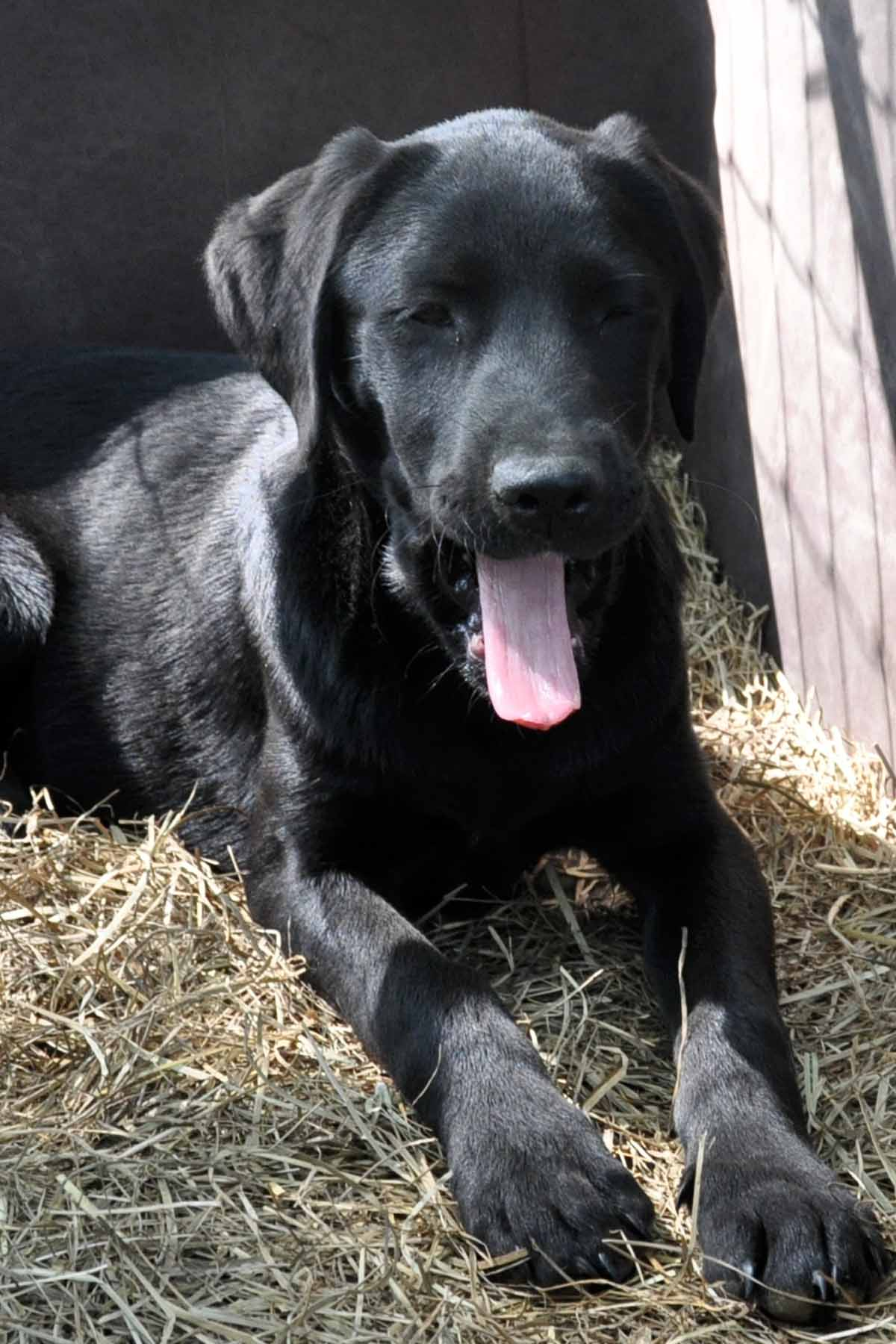
NSAL Adoption Number:
Shelter/Rescue Admit Date: |  |  |  |  |  | March 20, 2009
Number of Pups in Litter: |  |  |  |  |  | Six
Sex: |  |  |  |  |  | Female
Age: |  |  |  |  |  | 13 weeks (on 4/10)
Color: |  |  |  |  |  | Black
Weight: |  |  |  |  |  | 18#
Flea Dip Date: |  |  |  |  |  | March 20, 2009
Worming Date(s): |  |  |  |  |  | March 20-22/repeating April 11-13, 2009
(State if too young) |  |  | Bordatella Vacc Date: |  |  | March 20/repeating 4/11/09
 |  |  | DHLPP Vacc Date: |  |  | March 20/repeating 4/11/09
 |  |  | Rabies Vacc Date: |  |  | To be administered during licensing w/vet
Other Treatments or Notes: |  |  |  |  |  | Black Labrador retriever. Socialization, foster care ongoing at this time by FAWS volunteers.
#36
Paste Photo Here → |  |  |  |  |  | 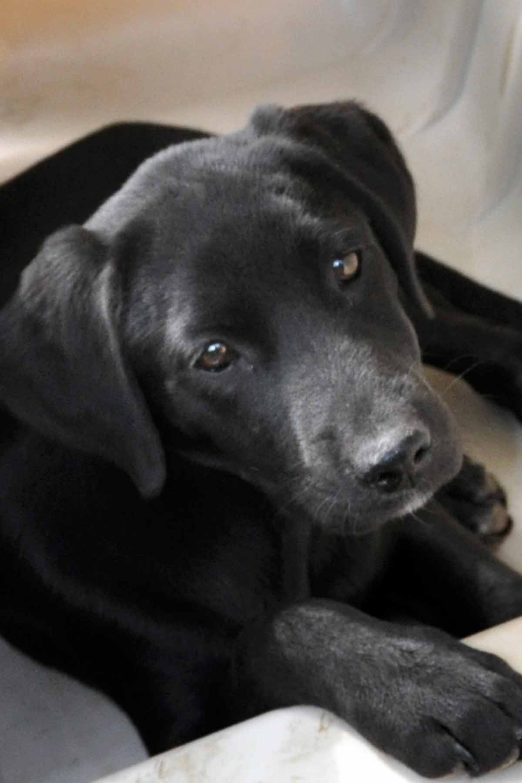
NSAL Adoption Number:
Shelter/Rescue Admit Date: |  |  |  |  |  | March 20, 2009
Number of Pups in Litter: |  |  |  |  |  | Six
Sex: |  |  |  |  |  | Female
Age: |  |  |  |  |  | 13 weeks (on 4/10)
Color: |  |  |  |  |  | Black
Weight: |  |  |  |  |  | 19#
Flea Dip Date: |  |  |  |  |  | March 20, 2009
Worming Date(s): |  |  |  |  |  | March 20-22/repeating April 11-13, 2009
(State if too young) |  |  | Bordatella Vacc Date: |  |  | March 20/repeating 4/11/09
 |  |  | DHLPP Vacc Date: |  |  | March 20/repeating 4/11/09
 |  |  | Rabies Vacc Date: |  |  | To be administered during licensing w/vet
Other Treatments or Notes: |  |  |  |  |  | Black Labrador retriever. Socialization, foster care ongoing at this time by FAWS volunteers.
#37
Paste Photo Here → |  |  |  |  |  | 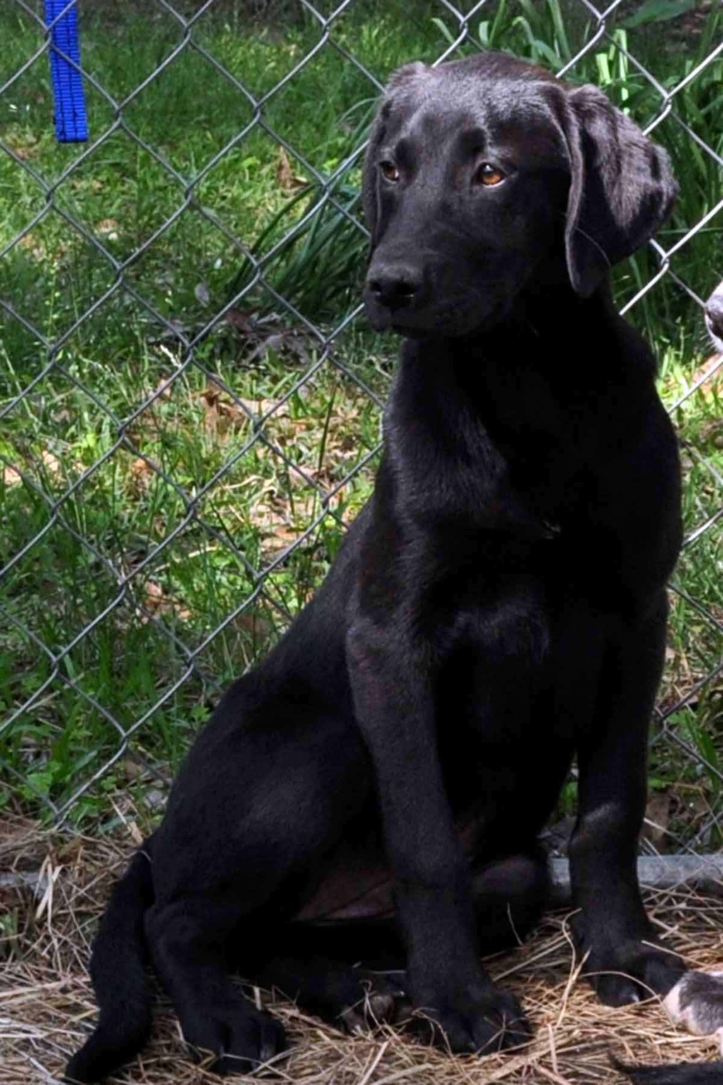
NSAL Adoption Number:
Shelter/Rescue Admit Date: |  |  |  |  |  | March 20, 2009
Number of Pups in Litter: |  |  |  |  |  | Six
Sex: |  |  |  |  |  | Female
Age: |  |  |  |  |  | 13 weeks (on 4/10)
Color: |  |  |  |  |  | Black
Weight: |  |  |  |  |  | 21#
Flea Dip Date: |  |  |  |  |  | March 20, 2009
Worming Date(s): |  |  |  |  |  | March 20-22/repeating April 11-13, 2009
(State if too young) |  |  | Bordatella Vacc Date: |  |  | March 20/repeating 4/11/09
 |  |  | DHLPP Vacc Date: |  |  | March 20/repeating 4/11/09
 |  |  | Rabies Vacc Date: |  |  | To be administered during licensing w/vet
Other Treatments or Notes: |  |  |  |  |  | Black Labrador retriever. Socialization, foster care ongoing at this time by FAWS volunteers.
#38
Paste Photo Here → |  |  |  |  |  | 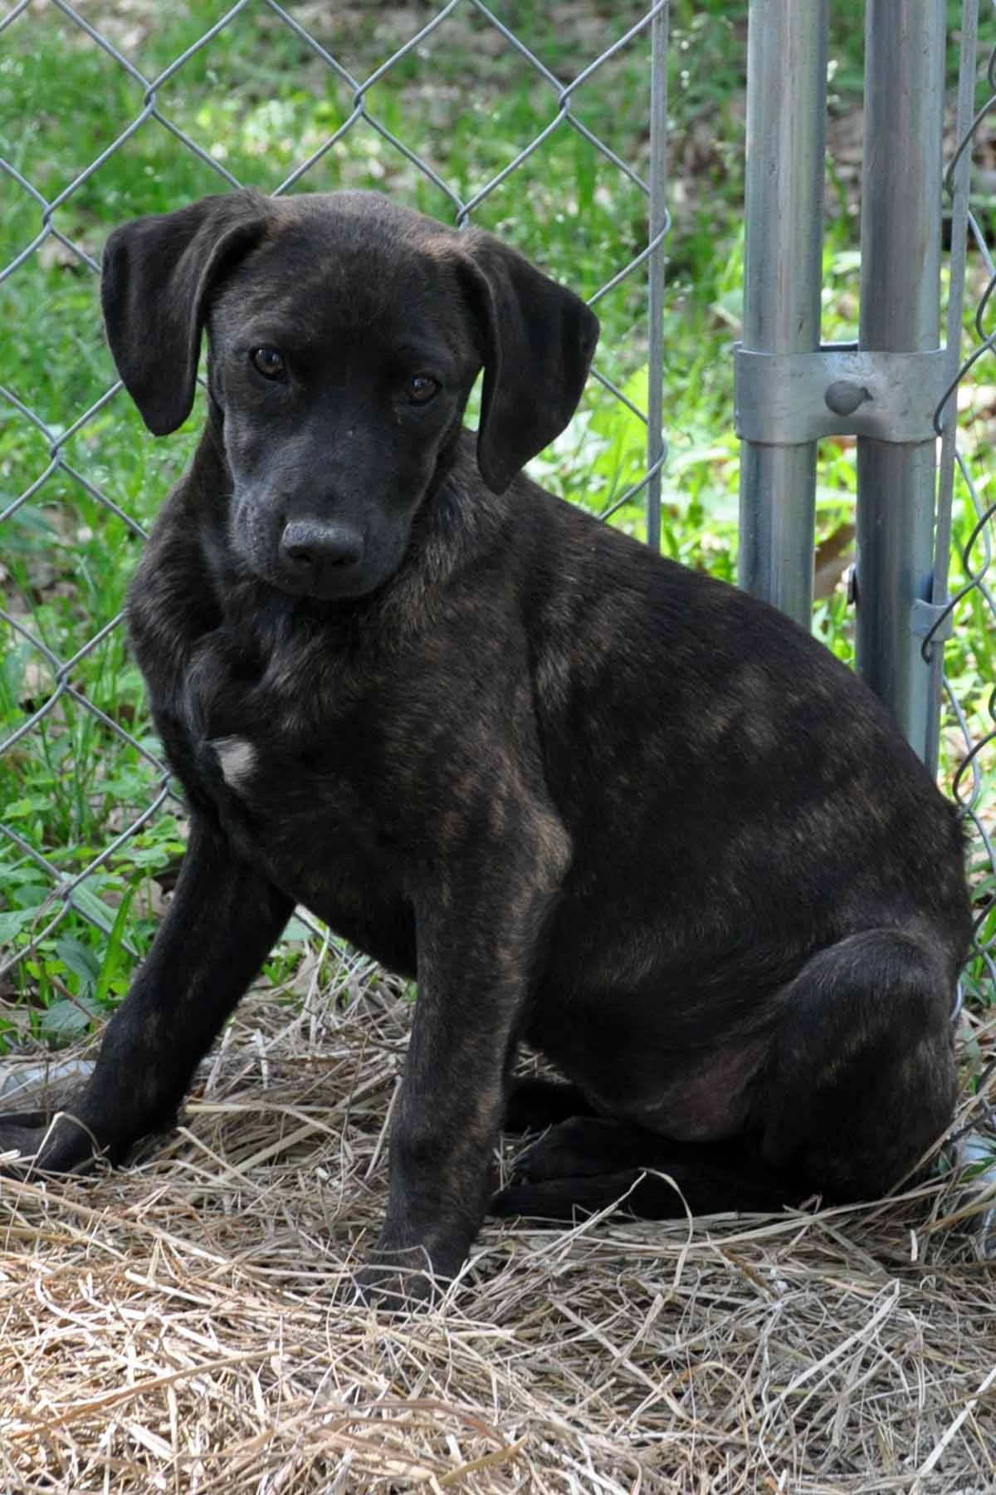
NSAL Adoption Number:
Shelter/Rescue Admit Date: |  |  |  |  |  | March 20, 2009
Number of Pups in Litter: |  |  |  |  |  | Eight
Sex: |  |  |  |  |  | Female
Age: |  |  |  |  |  | 12 weeks (on 4/10)
Color: |  |  |  |  |  | Brindle
Weight: |  |  |  |  |  | 15#
Flea Dip Date: |  |  |  |  |  | March 20, 2009
Worming Date(s): |  |  |  |  |  | March 20-22/repeating April 11-13, 2009
(State if too young) |  |  | Bordatella Vacc Date: |  |  | March 20, 2009/repeating 4/11/09
 |  |  | DHLPP Vacc Date: |  |  | March 20, 2009/repeating 4/11/09
 |  |  | Rabies Vacc Date: |  |  | To be administered during licensing by vet.
Other Treatments or Notes: |  |  |  |  |  | Catahoula Cur/Yellow Lab mix; Socialization and foster care ongoing at this time by FAWS volunteers.
#39
Paste Photo Here → |  |  |  |  |  | 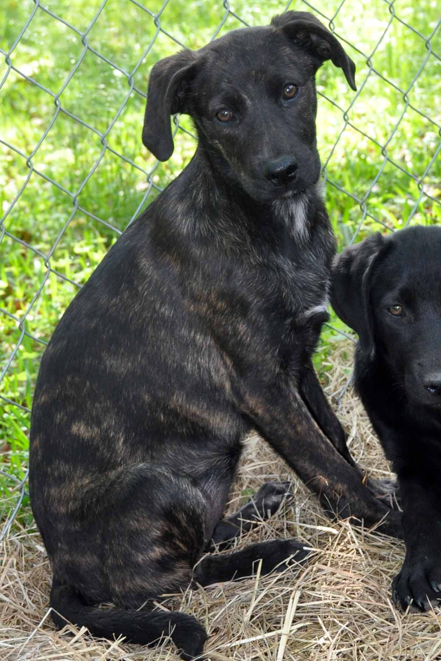
NSAL Adoption Number:
Shelter/Rescue Admit Date: |  |  |  |  |  | March 20, 2009
Number of Pups in Litter: |  |  |  |  |  | Eight
Sex: |  |  |  |  |  | Female
Age: |  |  |  |  |  | 12 weeks (on 4/10)
Color: |  |  |  |  |  | Brindle
Weight: |  |  |  |  |  | 17#
Flea Dip Date: |  |  |  |  |  | March 20, 2009
Worming Date(s): |  |  |  |  |  | March 20-22/repeating April 11-13, 2009
(State if too young) |  |  | Bordatella Vacc Date: |  |  | March 20, 2009/repeating 4/11/09
 |  |  | DHLPP Vacc Date: |  |  | March 20, 2009/repeating 4/11/09
 |  |  | Rabies Vacc Date: |  |  | To be administered during licensing by vet.
Other Treatments or Notes: |  |  |  |  |  | Catahoula Cur/Yellow Lab mix; Socialization and foster care ongoing at this time by FAWS volunteers.
#40
Paste Photo Here → |  |  |  |  |  | 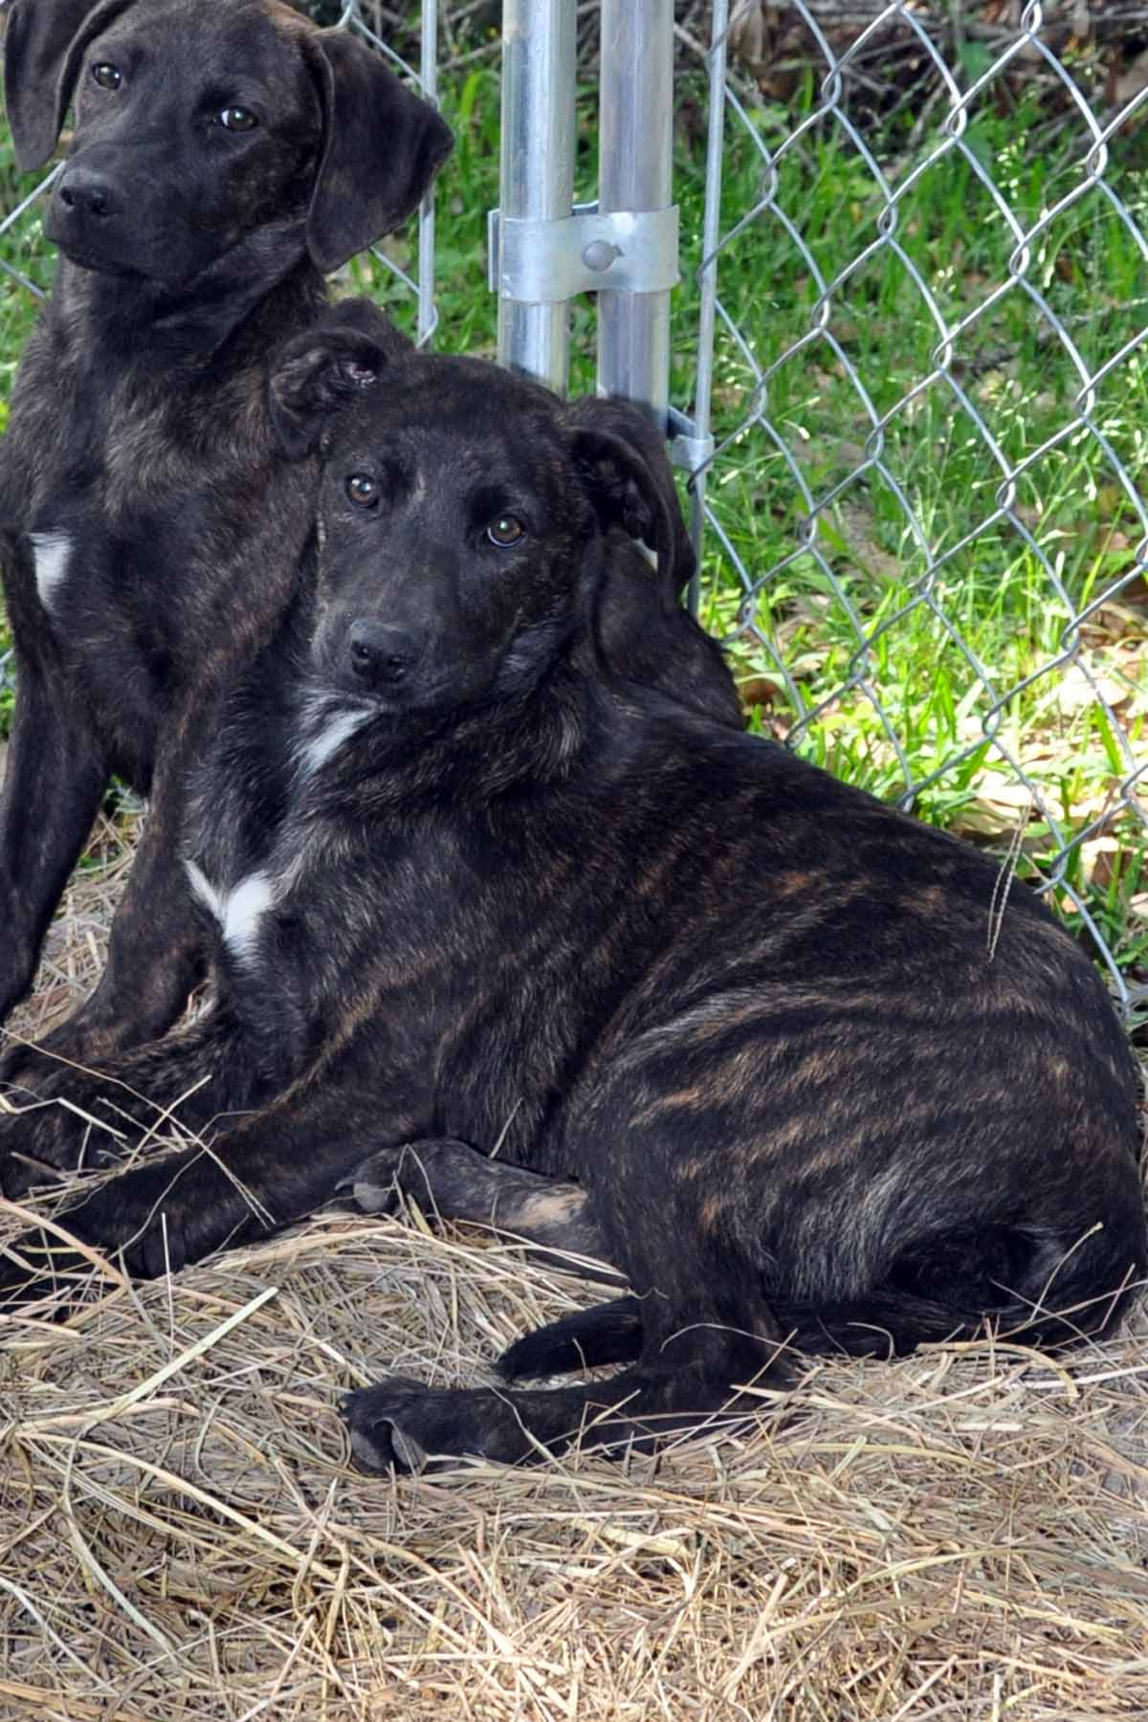
NSAL Adoption Number:
Shelter/Rescue Admit Date: |  |  |  |  |  | March 20, 2009
Number of Pups in Litter: |  |  |  |  |  | Eight
Sex: |  |  |  |  |  | Female
Age: |  |  |  |  |  | 12 weeks (on 4/10)
Color: |  |  |  |  |  | Brindle w/white chest & paws
Weight: |  |  |  |  |  | 21#
Flea Dip Date: |  |  |  |  |  | March 20, 2009
Worming Date(s): |  |  |  |  |  | March 20-22/repeating April 11-13, 2009
(State if too young) |  |  | Bordatella Vacc Date: |  |  | March 20, 2009/repeating 4/11/09
 |  |  | DHLPP Vacc Date: |  |  | March 20, 2009/repeating 4/11/09
 |  |  | Rabies Vacc Date: |  |  | To be administered during licensing by vet.
Other Treatments or Notes: |  |  |  |  |  | Catahoula cur/Yellow Lab mix; Socialization and foster care ongoing at this time by FAWS volunteers.
Katrina Lifeline Database
Please fill out carefully and completely!
Total Number of Puppies:1
Total Number of Adult Dogs:1
Total Number of Carriers/Crates Used:1
Date Prepared:4/21/09
Your Information - Person completing this form
Name:
Address:
Phone number:
Email:
Sending Shelter/Organization Information - Where were the animal(s) taken from?
Name:
Address:
Phone number:
Email:
Website:
Receiving Shelter/Organization Information - Where are the animal(s) going?
Note: if going to North Shore Animal League leave this part blank
Name:
Address:
Phone Number:
Email:
Website:
Puppy or Dog Information
#41
Paste Photo Here → |  |  |  | 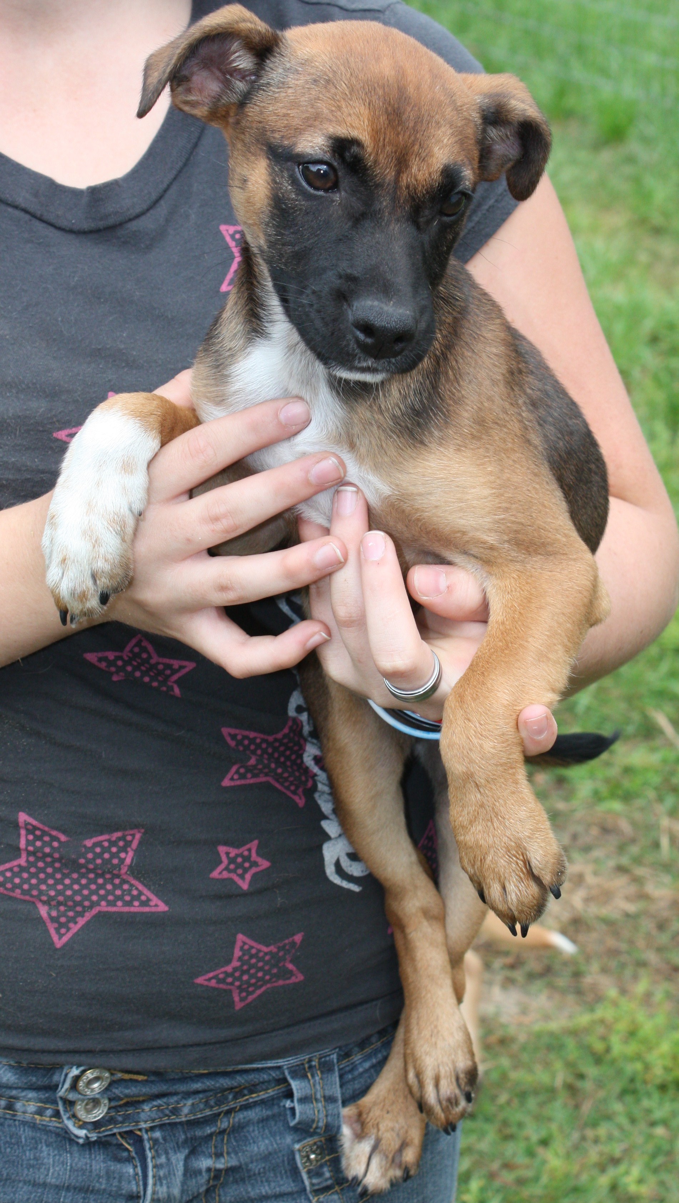
NSAL Adoption Number:
Shelter/Rescue Admit Date: |  |  |  | 3/26/09
Number of Pups in Litter: |  |  |  | n/a
Sex: |  |  |  | female
Age: |  |  |  | 3 months
Color: |  |  |  | Tan w/black mouth
Weight: |  |  |  | 10 lbs.
Flea Dip Date:
Worming Date(s): |  |  |  | 3/29/09
(State if too young) | Bordatella Vacc Date:
(State if too young) | DHLPP Vacc Date: |  |  | 4/16/09
(State if too young) | Rabies Vacc Date: |  |  | 4/14/09
Other Treatments or Notes:
#42
Paste Photo Here → |  |  |  | 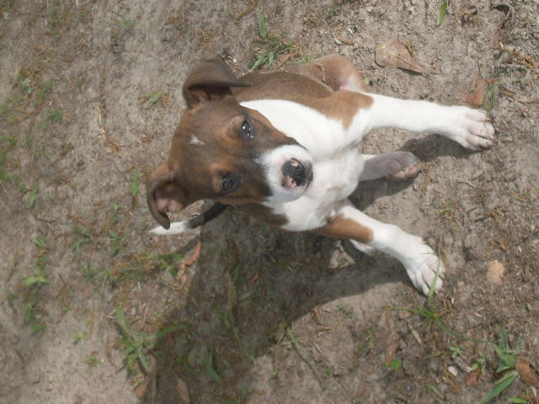
NSAL Adoption Number:
Shelter/Rescue Admit Date: |  |  |  | 3/12/09
Number of Pups in Litter: |  |  |  | n/a
Sex: |  |  |  | female
Age: |  |  |  | 4 months
Color: |  |  |  | White and brown
Weight: |  |  |  | 15 lbs.
Flea Dip Date:
Worming Date(s): |  |  |  | 3/22/09
(State if too young) | Bordatella Vacc Date:
(State if too young) | DHLPP Vacc Date: |  |  | 3/20/09, 4/14/09
(State if too young) | Rabies Vacc Date: |  |  | 4/14/09
Other Treatments or Notes:
Katrina Lifeline Database
Please fill out carefully and completely!
Total Number of Puppies:
Total Number of Adult Dogs:
Total Number of Carriers/Crates Used:
Date Prepared:
Your Information - Person completing this form
Name:
Address:
Phone number:
Email:
Sending Shelter/Organization Information - Where were the animal(s) taken from?
Name:
Address:
Phone number:
Email:
Website:
#40
Brownie |  |  |  |  | 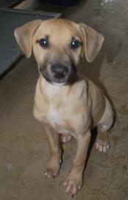
NSAL Adoption Number: |  |  |  |  | TB-04-11-02
Shelter/Rescue Admit Date: |  |  |  |  | 04-11-09
Number of Pups in Litter:
Sex: |  |  |  |  | M
Age: |  |  |  |  | 3 months
Color: |  |  |  |  | Tan/White
Weight: |  |  |  |  | 11.20
Flea Dip Date:
Worming Date(s): |  |  |  |  | 04-11-09
(State if too young) |  | Bordatella Vacc Date: |  |  | 04-11-09
 |  | DHLPP Vacc Date: |  |  | 04-11-09
 |  | Rabies Vacc Date: |  |  | 04-29-09
Other Treatments or Notes:
#41
Tory |  |  |  |  | 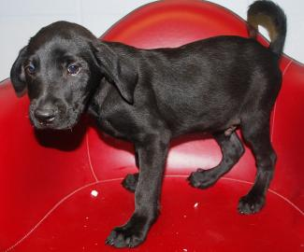
NSAL Adoption Number: |  |  |  |  | TB-04-07-09
Shelter/Rescue Admit Date: |  |  |  |  | 04-07-09
Number of Pups in Litter:
Sex: |  |  |  |  | M
Age: |  |  |  |  | 2 months
Color: |  |  |  |  | Black
Weight: |  |  |  |  | 6 lbs
Flea Dip Date:
Worming Date(s): |  |  |  |  | 04-07-09
(State if too young) |  | Bordatella Vacc Date: |  |  | 04-07-09
 |  | DHLPP Vacc Date: |  |  | 04-07-09
 |  | Rabies Vacc Date: |  |  | 04-29-09
Other Treatments or Notes:
#42
Lori |  |  |  |  | 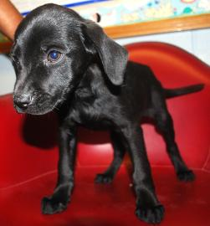
NSAL Adoption Number: |  |  |  |  | WO-04-07-010
Shelter/Rescue Admit Date: |  |  |  |  | 04-07-09
Number of Pups in Litter:
Sex: |  |  |  |  | F
Age: |  |  |  |  | 2 months
Color: |  |  |  |  | Black
Weight: |  |  |  |  | 5 lbs
Flea Dip Date:
Worming Date(s): |  |  |  |  | 04-07-09
(State if too young) |  | Bordatella Vacc Date: |  |  | 04-07-09
 |  | DHLPP Vacc Date: |  |  | 04-07-09
 |  | Rabies Vacc Date: |  |  | 04-29-09
Other Treatments or Notes:
#43
Rory |  |  |  |  | 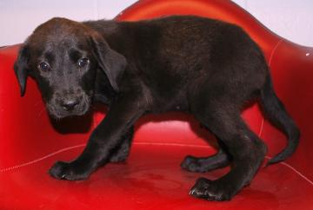
NSAL Adoption Number: |  |  |  |  | WO-04-07-11
Shelter/Rescue Admit Date: |  |  |  |  | 04-07-09
Number of Pups in Litter:
Sex: |  |  |  |  | M
Age: |  |  |  |  | 2 months
Color: |  |  |  |  | Black
Weight: |  |  |  |  | 6 lbs
Flea Dip Date:
Worming Date(s): |  |  |  |  | 04-07-09
(State if too young) |  | Bordatella Vacc Date: |  |  | 04-07-09
 |  | DHLPP Vacc Date: |  |  | 04-07-09
 |  | Rabies Vacc Date: |  |  | 04-29-09
Other Treatments or Notes:
Paste Photo Here →
NSAL Adoption Number:
Shelter/Rescue Admit Date:
Number of Pups in Litter:
Sex:
Age:
Color:
Weight:
Flea Dip Date:
Worming Date(s):
(State if too young) |  |  | Bordatella Vacc Date:
 |  |  | DHLPP Vacc Date:
 |  |  | Rabies Vacc Date:
Other Treatments or Notes:
#12

