TOTAL MAXIMUM NUMBER OF PUPS 35
TOTAL # PUPS: | ELEVEN
# OF CARRIERS USED: | 4
cc: Data Entry, Grooming, Shelter Medical, Med. Ctr. Mgr.,
ORIGINAL COPY: W. McColgan
 |  |  |  |  |  |  |  | VAX DATES
 |  |  |  |  |  |  |  | TOO YOUNG
NSAL ADOPTION  NUMBER | SHELTER ADMIT  DATE | #PUPS IN LITTER | SEX | AGE | COLOR | WEIGHT | FLEA DIP DATE | BORD. |  | DHL2PP |  | DM |  | WORMING DATE(S) |  | FECAL RESULTS, RABIES,MEDICAL, ETC. |  | EACH DOG TREATED FOR COXIDIA WITH ALBON LIQUID 9/1
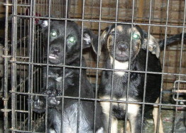
R-PAULIE
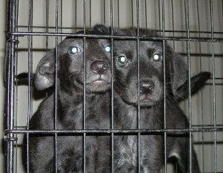
R-EMMA
R-JACK
RPETEY
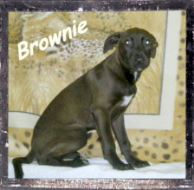
R-BROWNIE
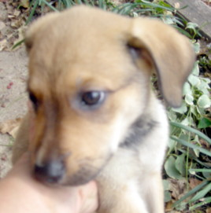
DUSTY
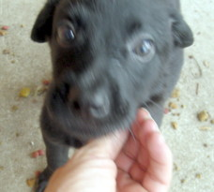
MIDNIGHT
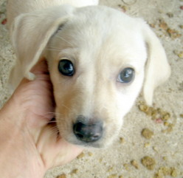
SUNSHINE
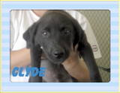
R-CLYDE
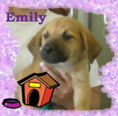
R-EMILY
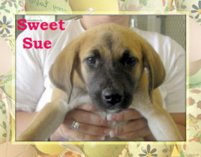
R-SUE
 |  |  |  |  |  |  |  |  |  |  |  |  |  |  |  | FECAL RESULTS, RABIES,MEDICAL, ETC.
TOTAL # PUPS: | TEN
# OF CARRIERS USED:
cc: Data Entry, Grooming, Shelter Medical, Med. Ctr. Mgr.,
ORIGINAL COPY: W. McColgan
 |  |  |  |  |  |  |  | VAX DATES
 |  |  |  |  |  |  |  | TOO YOUNG
NSAL ADOPTION  NUMBER | SHELTER ADMIT  DATE | #PUPS IN LITTER | SEX | AGE | COLOR | WEIGHT | FLEA DIP DATE | BORD. |  | DHL2PP |  | DM |  | WORMING DATE(S) |  | FECAL RESULTS, RABIES,MEDICAL, ETC. |  | EACH DOG TREATED FOR COXIDIA WITH ALBON LIQUID 9/1
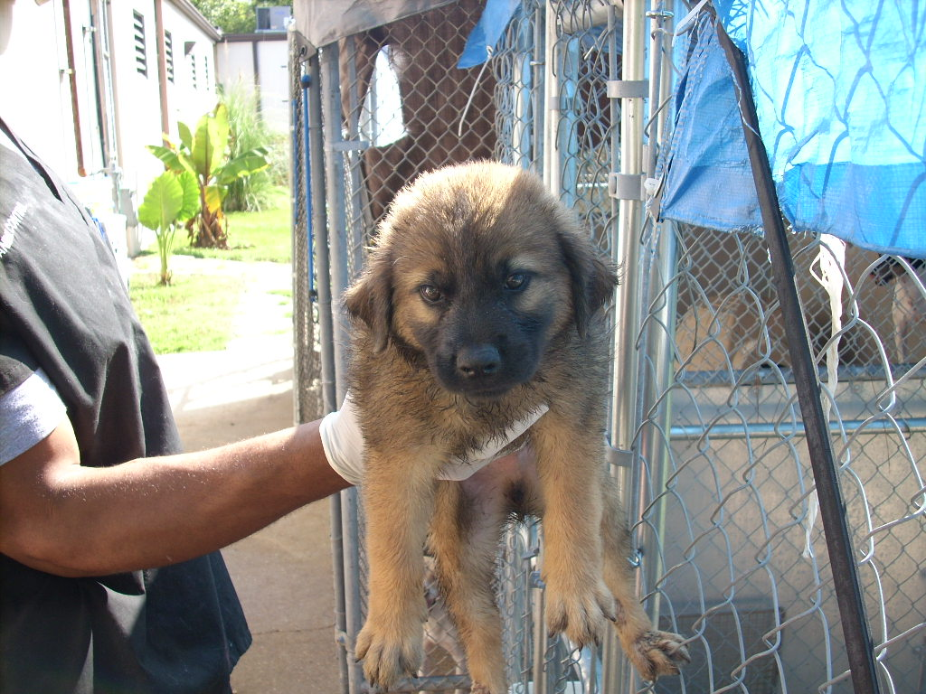
R-
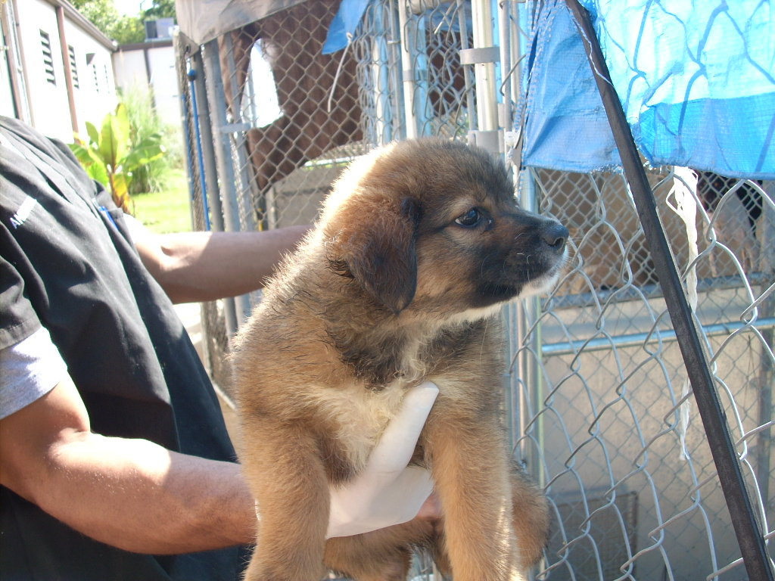
R-
R-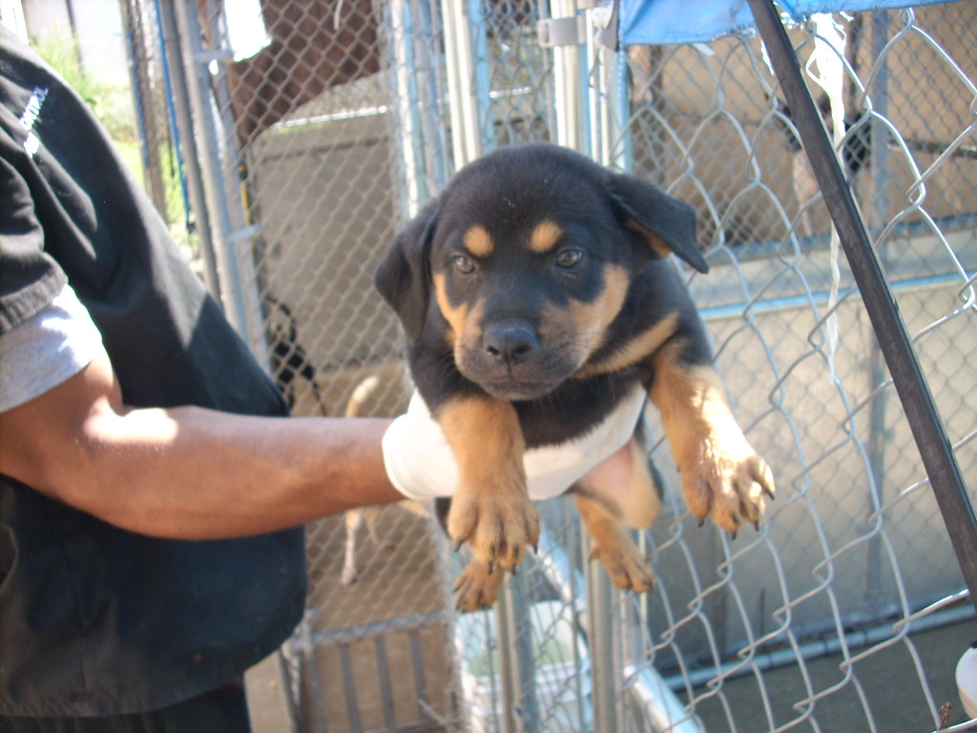
R-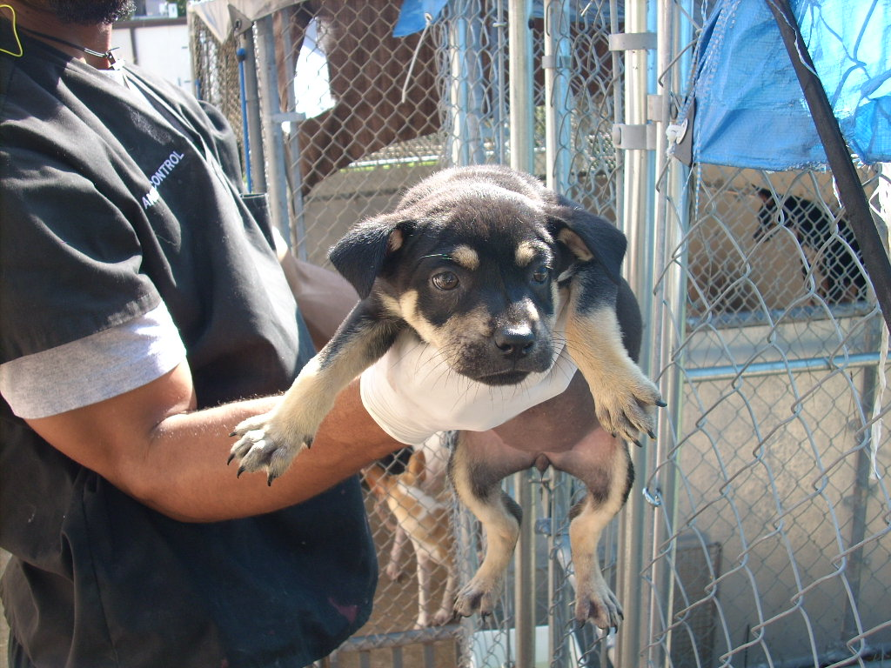
R-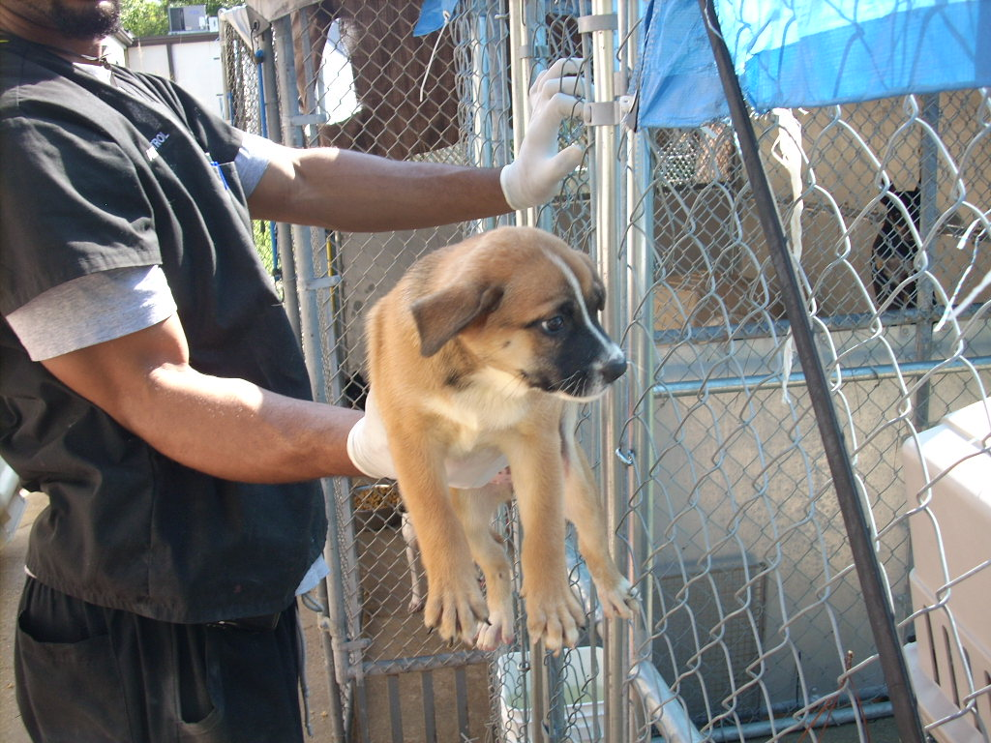
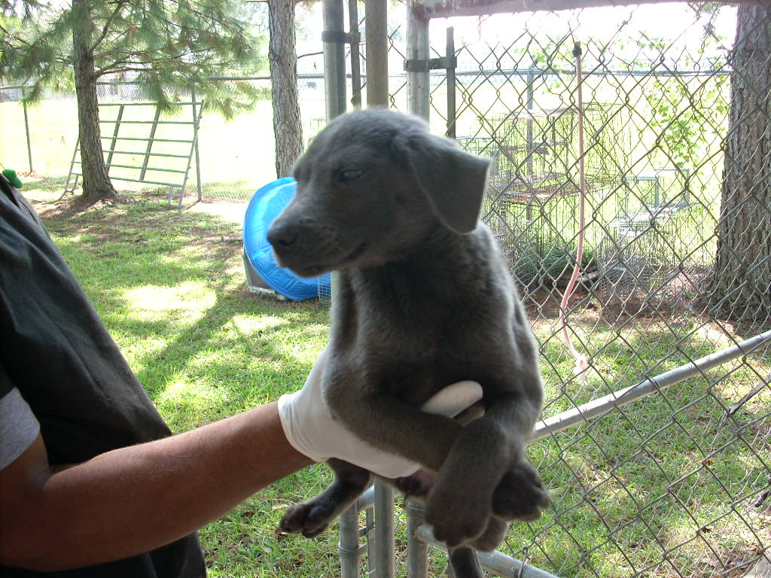
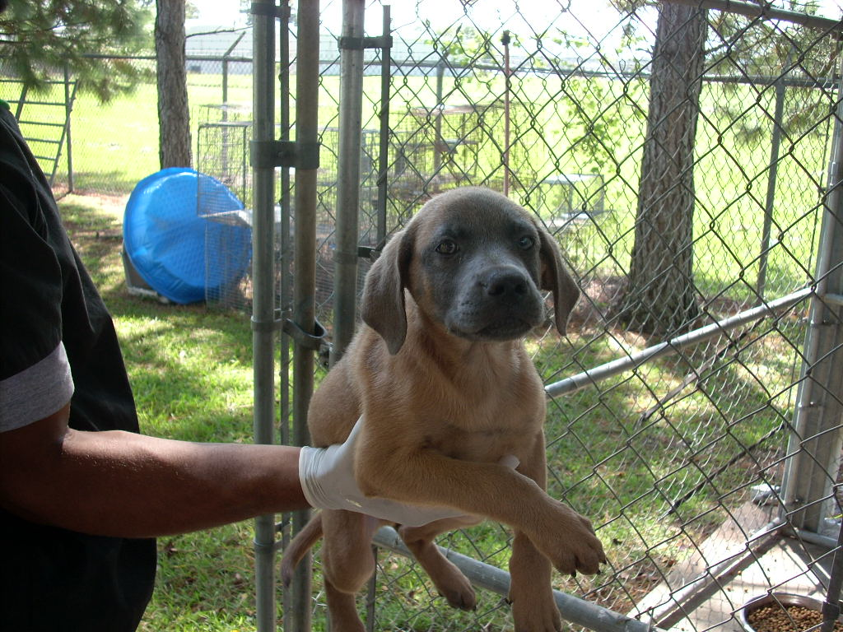
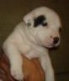
TOTAL # PUPS:
# OF CARRIERS USED:
cc: Data Entry, Grooming, Shelter Medical, Med. Ctr. Mgr., |  |  |  |  |  |  |  | NAME, ADDRESS, PHONE, EMAIL OF PERSON FILLING OUT THIS FORM: |  |  |  | Judy Wheaton  14 Stacy Drive  Picayune, MS 39466  601-749-4783  bayoudogs@bayoudogs.net
ORIGINAL COPY: W. McColgan
 |  |  |  |  |  |  |  | VAX DATES
 |  |  |  |  |  |  |  | TOO YOUNG
NSAL ADOPTION  NUMBER | SHELTER ADMIT  DATE | #PUPS IN LITTER | SEX | AGE | COLOR | WEIGHT | FLEA DIP DATE | BORD. |  | DHL2PP |  | DM |  | WORMING DATE(S)
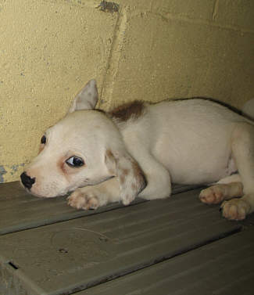
Hi, I am Peter - a Jack Russel mix
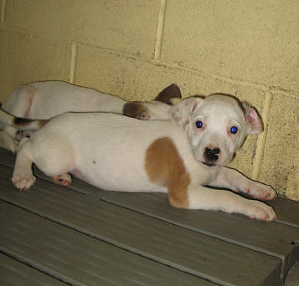
Hi, I am Paul- a Jack Russel mix
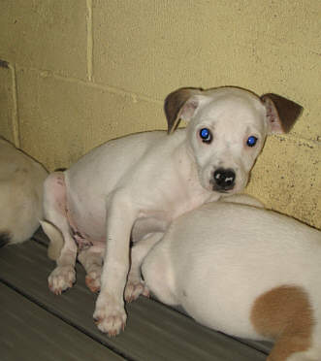
Hi, I am Mary - a Jack Russel mix
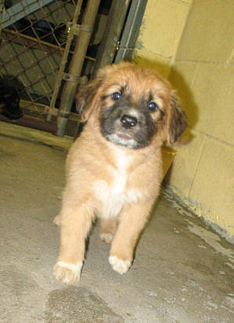
Hi, I am Turnip - a Lab Mix
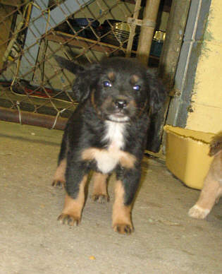
Hi, I am Celery - a Lab Mix
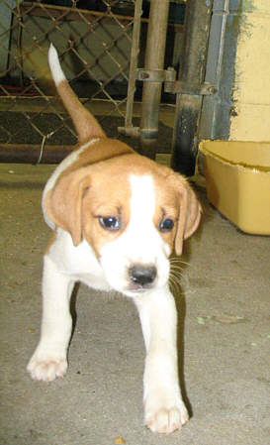
Hi, I am Sprout - a Lab Mix
TOTAL # PUPS:
# OF CARRIERS USED:
cc: Data Entry, Grooming, Shelter Medical, Med. Ctr. Mgr.,
ORIGINAL COPY: W. McColgan
NSAL ADOPTION
NUMBER
COPY AND PASTE PICTURE IN HERE
R-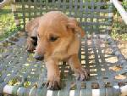
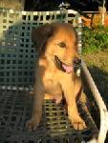-
R-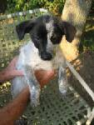
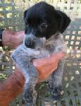-
R-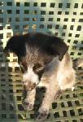
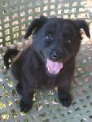
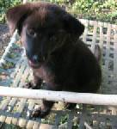
TOTAL # PUPS:
# OF CARRIERS USED:
cc: Data Entry, Grooming, Shelter Medical, Med. Ctr. Mgr.,
ORIGINAL COPY: W. McColgan
NSAL ADOPTION
NUMBER
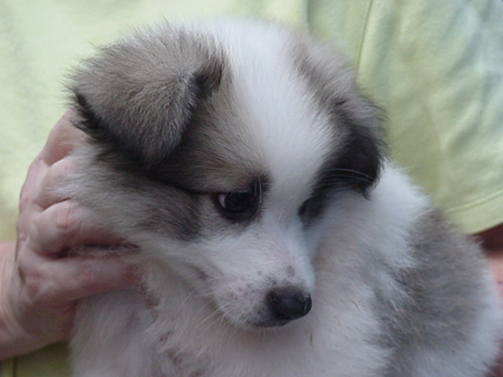

My name is Dylan

