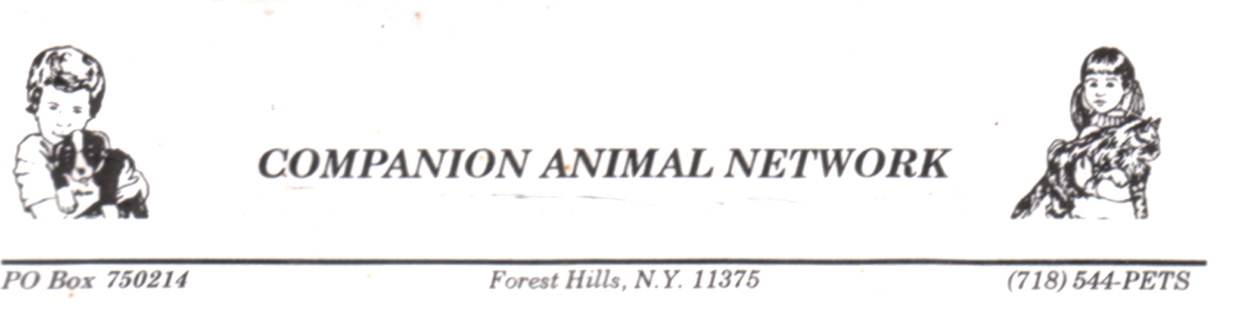

www.CompanionAnimalNetworkTV.org

EMERGENCY AUTHORIZATION OF GUARDIANSHIP

1) This agreement is in effect until the signatory revokes it in writing.

2) Companion Animal Network (“CAN”), represented by Garo Alexanian or his representative, is hereby authorized to take custody and control of my dog(s)/cat(s), _____________________________________.

3) If my dog(s)/cat(s) is in the control of the animal control agency of the City of New York, “New York City Animal Care and Control,” I hereby authorize them to release my dog to CAN, Mr. Alexanian or his representative.

4) I am not giving up ownership of any animal(s) and CAN agrees to return my animals(s) to my custody upon my request.

Agreed to by: _________________________(Print name) ______________________________(email)

_______________________ ____________ __________________________________________
Signature Date Address
(h)_________________(cell)_______________(w)_____________

