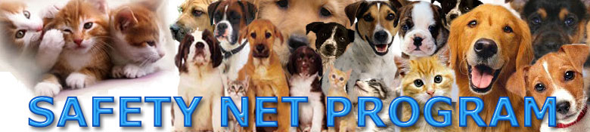

FREE SERVICES TO HELP YOU KEEP YOUR ANIMAL FRIEND
(only for Animal Care & Control referred clients)

If you are considering surrendering your dog or cat friend because of behavioral issues, allergies or asthma, landlord or neighbor issues, domestic violence, going into the hospital, or for any other reason New York City Animal Care & Control has ways to help you get through this difficulty without giving up your animal friend. It is called the Safety Net Program.

Most of these services are free, yes FREE! All we ask is that you agree to work with our Safety Net coordinators and follow their recommendations and give it a good faith effort to see if things work out. All that is required is a phone call, which will usually last about 30 minutes, providing some personal information about your situation, and give our Safety Net coordinator’s recommendations a real effort…even if you don’t think there is little or no chance that it will work for you.

After your cooperation with Safety Net call New York City’s Animal Care & Control’s customer service at 212-788-4000 and give them your A # and P # and tell them the results of your cooperation with Safety Net.. THIS IS VERY VERY IMPORTANT SO YOU CAN CONTINUE TO RECEIVE LOW COST AND FREE SERVICES IN THE FUTURE

The following are some common situations and how Safety Net would solve them for you and your animal friend:

You have been served with eviction papers due to non-payment of rent

Safety Net will give you procedural information and put you in contact with landlord tenant attorneys who specialize in animal cases. Many of these attorneys are willing to represent you for FREE so you are not forced to give up your animal friend. BUT YOU MUST CALL SAFETY NET AS SOON AS YOU ARE SERVED WITH PAPERS. Legal process requires timely action and if you delay or hesitate only by a few days even Safety Net will not be able to help. DO NOT TRY TO NEGOTIATE OR GO TO COURT ALONE WITHOUT CALLING SAFETY NET FIRST.

You have to go into the hospital and you have no one to take care of your pet

Safety Net may be able to provide a FREE volunteer to feed and water your companion animal for a short period of time by visiting your apartment once or twice a day. Or, for longer periods of hospitalization and recuperation you can use Safety Net’s super LOW COST BOARDING for the cost of a sandwich a day Ask for the LOW COST BOARDING information sheet or download it from the Safety Net website at www.718544pets.org.

Your landlord suddenly says you can’t keep your dog or cat anymore

Safety Net has FREE lawyers who will try to negotiate with your landlord (if you have had your animal friend for more than 90 days New York City law gives you the right to keep your pet lifetime EVEN IF YOUR LEASE DOES NOT ALLOW PETS). If your landlord is violating your rights Safety Net will give you information on where to file complaints. No one who has called Safety Net has ever lost a case or had to move!

You or someone who lives with you is allergic or has asthma

Safety Net works with the Allergy and Asthma Center of one of the major area hospitals. Since dog and cat allergies are two of the most UN-common allergies in people we will put you in contact with the Allergy & Asthma Center to get tested, and if medically recommended, get treatment, which Medicaid or Medicare will cover. If treatment is ineffective Safety Net will find a new home for your animal.

Your two dogs are either playing too rough or outright fighting

Safety Net has FREE behavior consultations available, and if necessary, will lend you a dog crate or a doggie-gate or other training tools to use while we help you train your dogs. Call Safety Net at 718-544-PETS to immediately speak with one of our animal behaviorists.

Your cat is urinating or spraying all over the place

If male cats are not fixed they will begin to spray, sometimes after years of not doing so. Safety Net can help you get your male cat fixed for $25. Or perhaps your cat has a urinary infection causing it to urinate outside the litter box. Safety Net has special super low cost veterinarians available to solve the infection. Ask for the LOW COST VETERINARY SERVICES sheet or download it from our website at www.718544pets.org.

Your dog barks when alone, or is too active, or won’t get housebroken or chews things or pulls when walking.

Safety Net has free behavior consultations available, and if necessary, will lend you anti-barking collars, a dog crate or a doggie-gate, spiked collars to prevent pulling and a variety of other training tools while we help you train your dogs. Call Safety Net at 718-544-PETS to immediately speak with one of our animal behaviorists.

