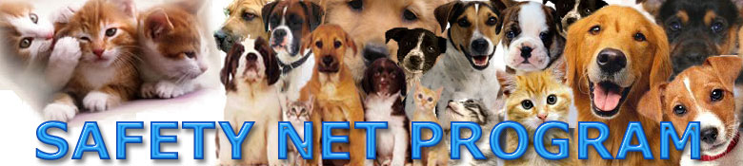

LOW COST BOARDING SERVICES
(for Animal Care & Control referred clients and Mayor’s Alliance rescue groups)

If you are temporarily in a tight situation such as being evicted, moving, a victim of a disaster such as fire, domestic violence and other situations where you want to keep you beautiful companion animal friend but need time to sort things out, Animal Care & Control of New York City may be able to help you. The Safety Net Program has very affordable boarding rates available through participating veterinarians, boarding facilities, and foster homes.

Whereas regular market rates for boarding dogs run between $20 and $40 per day and cats $15 to $30, you can now board your dog or cat for the cost of a sandwich a day. Yes, the cost of a sandwich a day! Safety Net can get you a super low cost boarding rate of only $8 per day for dogs, regardless of the size, and $6 per day for cats. However, in order to be able to provide such a low cost rate our participating veterinarians, boarding kennels, and foster homes must be able to absolutely guarantee that the super low cost boarding fee will be paid on time and that the animal will be reclaimed within a reasonable amount of time. YOU CAN ALWAYS VISIT YOUR ANIMAL FRIEND YOU BOARD IT WITH SAFETY NET.

For this reason a one month deposit is necessary, which is refunded back to you when you reclaim your beloved animal friend. The first month’s boarding payment is made at time of delivery of your animal to our participating veterinarians, boarding kennels, and foster homes. If you do not need an entire month of boarding the unused part of the month’s payment is refunded back to you when you reclaim your beloved animal friend. Both the boarding charge and the deposit can be paid by credit card.

You visit Safety Net’s web site at www.718544pets.org and download the BOARDING CONTRACT or you can pick it up at any of the New York City Animal Care & Control shelters and drop off facilities.

How to get super low-cost boarding y services:

- Either call or go to New York City’s Animal Care & Control shelters, drop off facilities, or customer service and tell them your pet animal needs super low cost boarding services. They will give you a six digit P number and a six digit A number. Write these numbers down.
- Either visit any of the New York City Animal Care & Control shelters or drop off facilities to pick up the Safety Net super low cost BOARDING CONTRACT or download it from the Safety Net web site at www.718544pets.org . Fill it out and call Safety Net at 718-544-PETS.
- You must provide transportation of your lovely animal to the participating veterinarian, boarding kennel, or foster homes OF OUR CHOICE. We must have this flexibility so we can service as many animals as possible. If you do not have a car and cannot arrange transportation with a friend, neighbor, or relative who owns a car, we may be able to pick up the animal for you but there is a $25 charge for that special service.
- After your animal friend has been given to Safety Net for boarding YOU MUST CALL Animal Care & Control of New York City’s customer service at 212-788-4000 and give them your A # and P # and tell them that you are boarding your animal with Safety Net. THIS IS VERY VERY IMPORTANT SO YOU CAN CONTINUE TO RECEIVE SUPER LOW COST AND FREE SERVICES IN THE FUTURE
- Continue to enjoy the companionship of your loveable, loyal, animal friend!

