
You’re Invited . . . . . .
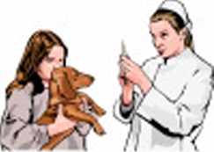
to free training of the latest state-of-the-art
veterinary techniques for Spay & Neutering
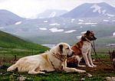
of Armenian dogs and cats

When: October 14-20, 2007
Where: Aren Bert No: 17
Erebouni Area -Yerevan-375025
Armenian Gampr
Who: Veterinarians, veterinary students, those who
seek employment as Veterinary Technician,
animal rescuer, or dog & cat adoptions
Call: 011 718-544-7387 (USA)
093 42 82 69 (Yerevan)
Email: Garo@CompanionAnimalNetworkTV.org
Website: www.CompanionAnimalNetworkTV.org/Armenia.html
Seminar conducted by: Dr. Jennifer Scarlett, DVM, USA
Dr. Christopher Garg, DVM, USA
Jane Townley, Veterinary Technician, USA

A joint project of the Humane Society of the United States’ Rural Area Veterinary Services team and Companion Animal Network, N.Y.

RESERVATIONS REQUIRED
Training is required for employment with Armenia Spay & Neuter Project

